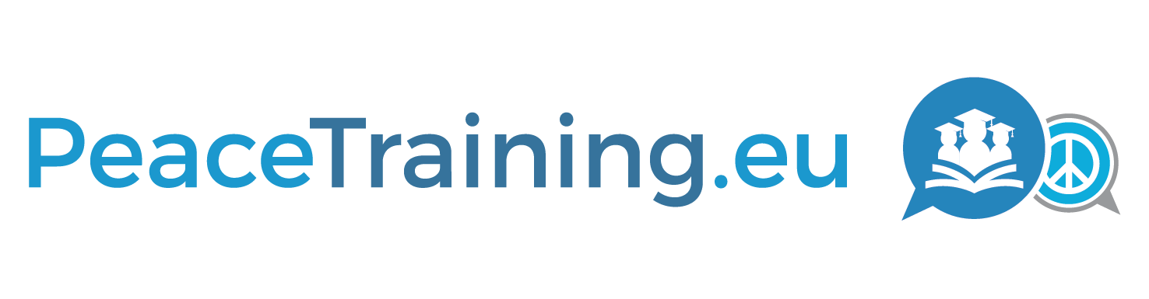
Strengthening the Capabilities and Training Curricula of conflict prevention and peace building personnel with ict-based collaboration and knowledge approaches
D7.2
Dissemination Package One (Additional Report)

Project

Acronym: PeaceTraining.eu
Title: STRENGTHENING THE CAPABILITIES AND TRAINING CURRICULA OF CONFLICT PREVENTION AND PEACE BUILDING PERSONNEL WITH ICT-BASED COLLABORATION AND KNOWLEDGE APPROACHES

Coordinator: SYNYO GmbH

Reference: 700583
Type: Coordination and Support Action
Program: HORIZON 2020
Theme: Conflict prevention and peace building topic 2: Training curricula for Conflict Prevention and Peace Building personnel

Start: 01. September 2016
Duration: 26 months

Website: project.peacetraining.eu

Consortium: SYNYO GmbH (SYNYO), Austria
University of Deusto (UDEUSTO), Spain
University of Marburg (UMR), Germany
Coventry University (COVUNI), United Kingdom
Katholieke Universiteit Leuven (KULEUVEN), Belgium
Institute for Conflict Research (ICR), United Kingdom
Peace Action, Training and Research Institute of Romania (PATRIR), Romania
World Mediation Organization (WMO), Germany
ARGE Bildungsmanagement (ARGE), Austria
Baltic Defence College (BALTDEFCOL), Estonia
Federal Ministry of Interior (BMI), Austria
Kosovar Center for Security Studies (KCSS), Kosovo
Deliverable

Number: D7.2
Title: Project Website, Social Media Channels and Communication Activities
Lead beneficiary: WMO
Work package: WP7
Dissemination level: PU / CO
Nature: Other / Additional Report

Due date: 31.08.2017
Submission date: 31.08.2017

Authors: Roland Wilson, WMO
Daniel Erdmann, WMO

Contributors: Iulia Luca, SYNYO
Bernhard Jäger, SYNYO
Carmen Munteanu, SYNYO
Stela Shiroka, SYNYO

Review: UMR

Acknowledgement: This project has received funding from the European Union’s Horizon 2020 Research and Innovation Programme under Grant Agreement No 700583. | Disclaimer: The content of this publication is the sole responsibility of the authors, and in no way represents the view of the European Commission or its services.

Executive Summary
This report presents the most current information on the primary methods of dissemination, which was implemented as part of the PeaceTraining.eu project. First, a brief introduction is given. Next, an explanation of the Social Media Dissemination Overview and Structure is explained. This is followed by an update on the current dissemination efforts, which includes information about social media channels and communication activities including those on the project’s primary website, Facebook, Twitter and LinkedIn. This is followed by lessons learned and way ahead to continue to improve the dissemination of information related to the Peacetraining.eu. The report finds that the communication plan and methods of dissemination for PeaceTraining.eu are working, and that in the coming months, the results will continue to be positive reaching more organizations and stakeholders and interest groups.

List of Abbreviations

ACP: Advanced Certificate Programme
CPPB: Conflict Prevention and Peacebuilding
ESM: Earned Social Media
ESDC: Employment and Social Development Canada
EU: European Union
FBA: Federal Bar Association
FB: Facebook
KPIs: Key Performance Indicators
OSM: Owned Social Media
PT: Peace Training
ZIF: International Peace Operations

Table of Content

1 Introduction 7
2 Key Performance Indicators (KPIs) 8
Current KPIs and Goals 8
3 Social Media Platforms 9
Background 9
Social Media Activities 10
Social Media Platforms 10
4 Newsletters 20
5 Project Website 29
6 Factsheets 32
7 Conclusion 38

Introduction
This report is on deliverable 7.2 and provides up to date information on the main digital resources and channels, which were implemented as part of the PeaceTraining.eu project in conjunction with the dissemination and social media plans. The report first covers an overview of the various social media platforms. Second, a review of the Key Performance Indicators (KPIs) for this project is given. Third, the report then looks at some of the key social media statistics, based on each platform used. For this, selected screenshots are presented, which illustrate the design, function and various sections and subsections of the sites. Then, the report reviews the social media plan followed by the newsletters produced to date. Finally, the report looks at the lessons learned and provides key recommendations needed to continue to increase the range and depth of stakeholders interested in the PeaceTraining.eu project. The information cut off for this report is 31 July 2017.

Key Performance Indicators (KPIs)
The KPIs were created to provide further direction to the consortium on the dissemination of information. The following graph illustrates the tools of communication and the goals. Of note, the primary means of dissemination focused on the KPIs thus far were newsletter, Facebook, Twitter and LinkedIn. Also, events, workshops and webinars were primarily contained in the newsletters.

Current KPIs and Goals
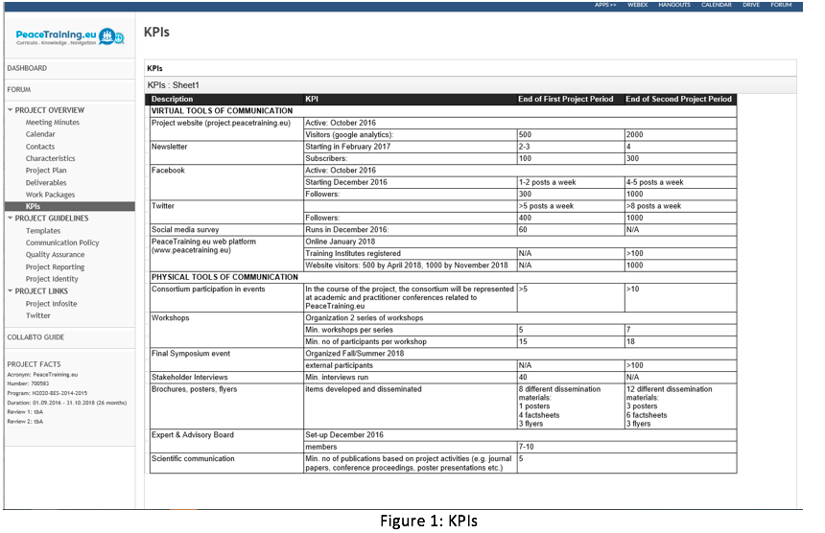Figure 1: KPIs

Social Media Platforms
The following subsections cover the main parts of the social media plan.

Background
This section provides an overview of our Social Media Strategy, giving insights on the concrete steps and parameters, such as target groups, products and information (e.g. factsheets) being disseminated as part of the PeaceTraining.eu project.
We evaluate and explain our marketing activities by reviewing the various analysis reports available on the social media platforms in order to improve our effectiveness and the impact of our content marketing performance. These reports will also form part of deliverables and other documents that prove our strategic activities in the field of social media and dissemination in general.
Owned Social Media (OSM)
When we refer to the social media channels, namely Twitter, Facebook, and LinkedIn, it refers to the Owned Social Media (OSM) activities. OSM traffic is free as it comes from the consortium’s own social media accounts. This is one of the most well-known forms of social media promotions, as these platforms not only share content in our network, but further help create a community of returning visitors, who engage by liking, sharing and commenting on PeaceTraining.eu content. This means, the more useful content that is posted, the more the various contacts get back to the consortium, and share and comment on the content. In order to successfully manage this strategy, it is important to clearly identify and re-identify as needed, the target audience (followers) and to continue to meet their specific interests.
A positive consequence of OSM is the Earned Social Media (ESM) traffic. ESM works for those who share and mention PeaceTraining.eu content they get from other users who share, comment, and ‘like’ the content on a voluntary basis. Similar to word of mouth, these unaffiliated users are promoting the content in their own social media channels, and greatly help the consortium reach an even wider audience. Here, it is obvious that the better and relevant the PeaceTraining.eu content is, the more interactivity will be created – interactivity that also has a direct influence on our Google ranking.
The various social media platforms are continuing to mature, which will be used to build networks with people and organizations that have similar interests. As a method of communication, we have primarily used:
Facebook
Twitter
LinkedIn

Social Media Activities
By organizing what is uploaded on each platform and coordinating this with consortium members, we have been able to prevent situations of redundant posting and excessive re-posting of information. Also, we have continued to keep track of the various worksheet in order to post in a timely manner.
The screenshots below are some of the examples from the social media plan that is used to organize and manage the dissemination of information by the consortium.

Social Media Platforms
The following is an analysis of the usage for each social media platform based on typology including events, training, videos, publications and other academic materials, and PeaceTraining.eu outputs and activities.
Twitter
One of our first goals was to make the best use of each platform. For example, Twitter has a word limit. Due to the word limit, we were only able to convey short important messages to followers. The accessibility was increased because the messages were able to see at a glance.
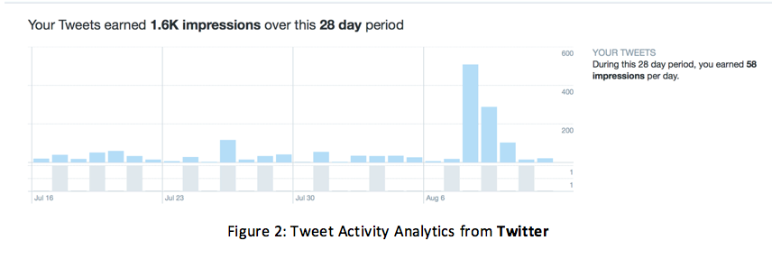Figure 2: Tweet Activity Analytics from Twitter
These are a few of the screenshots showing the Twitter activity:
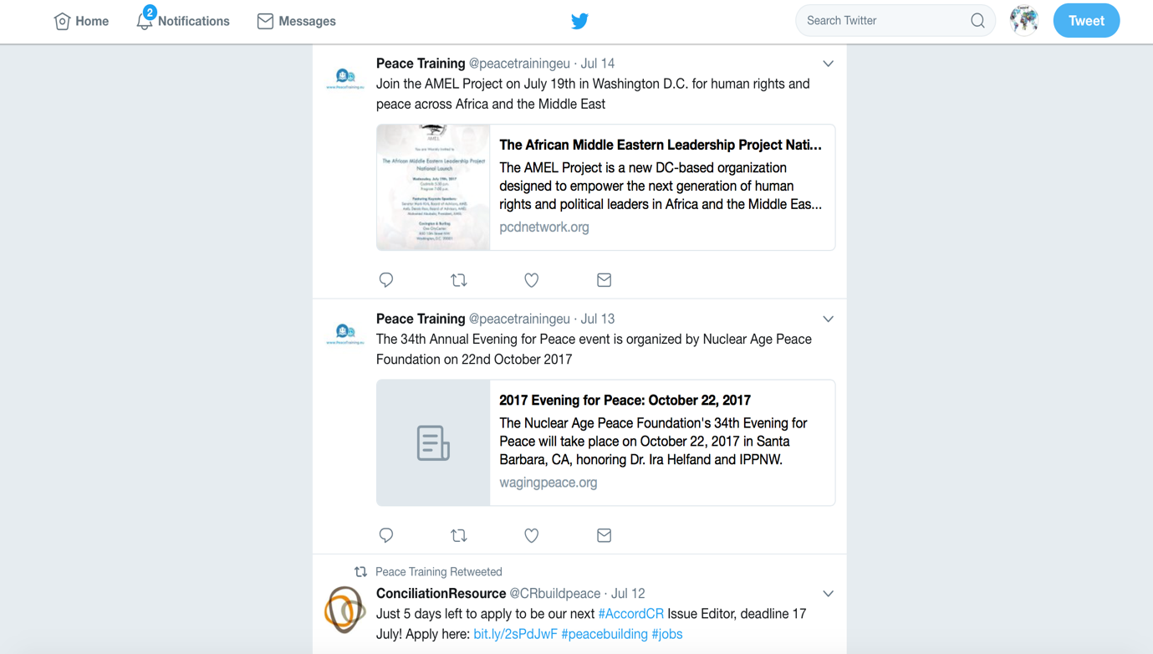Figure 3: Example of Tweet Activities

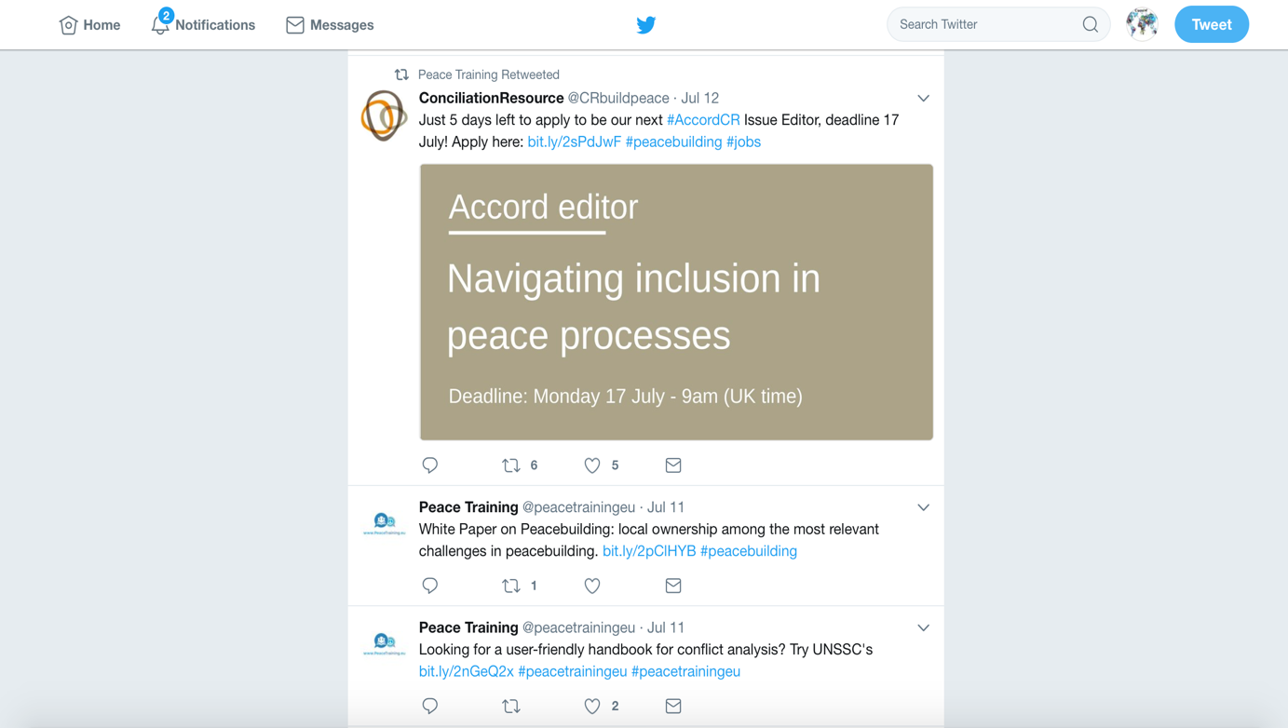Figure 4: Example of Tweet Activities

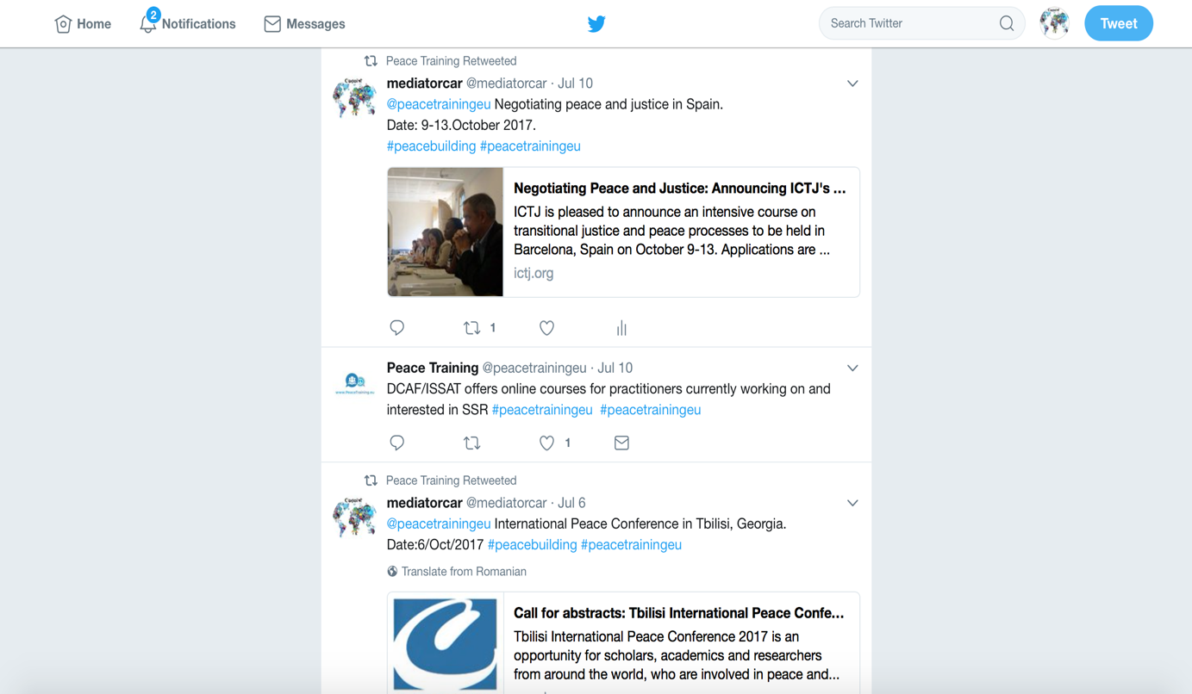Figure 5: Example of Tweet Activities

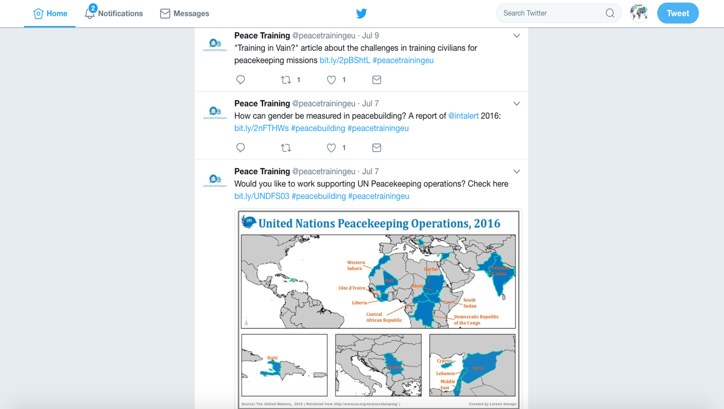Figure 6: Example of Tweet Activities
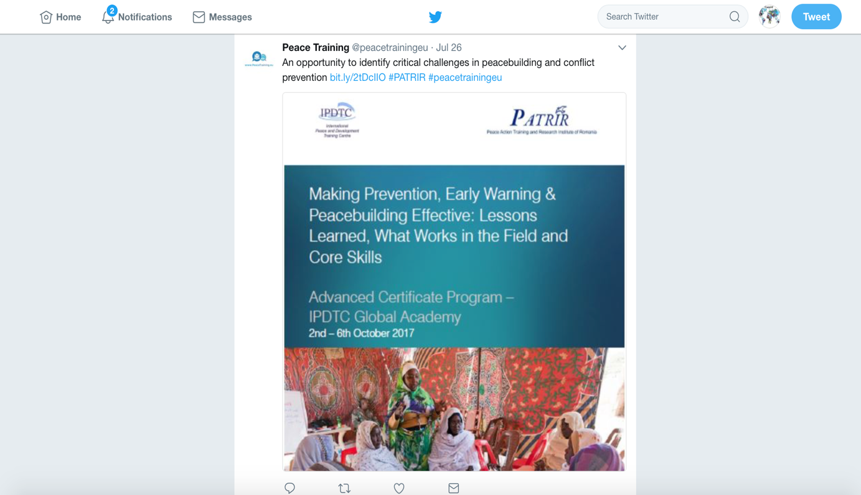 Figure 7: Example of Tweet Activities

Facebook
For Facebook, compared to Twitter, it has been a suitable platform to promote upcoming events, conferences, training and a variety of other activities as well as resource materials (publications), which are related to the project.
These are a few of the screenshots of Facebook posts:
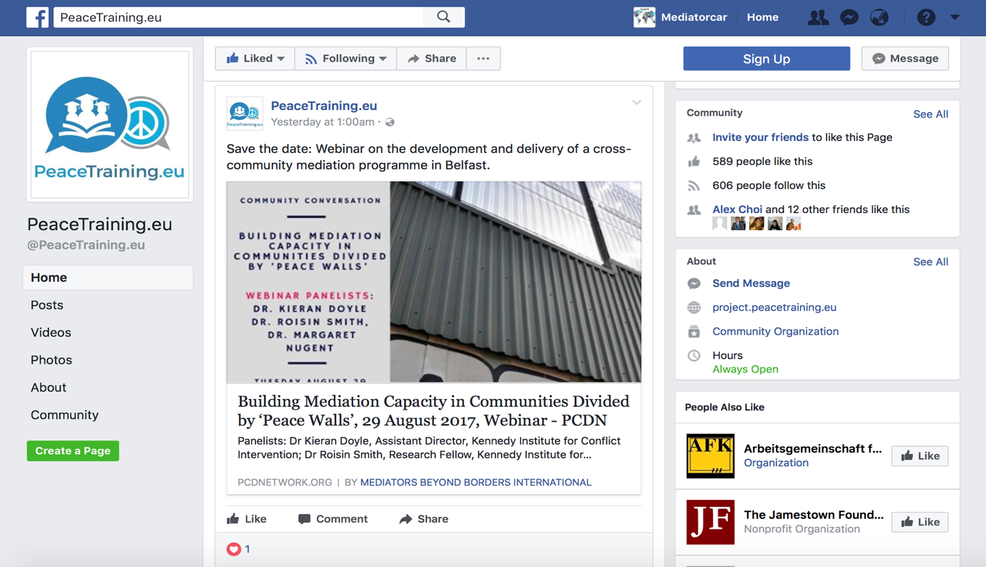Figure 9: Example of Facebook Activities

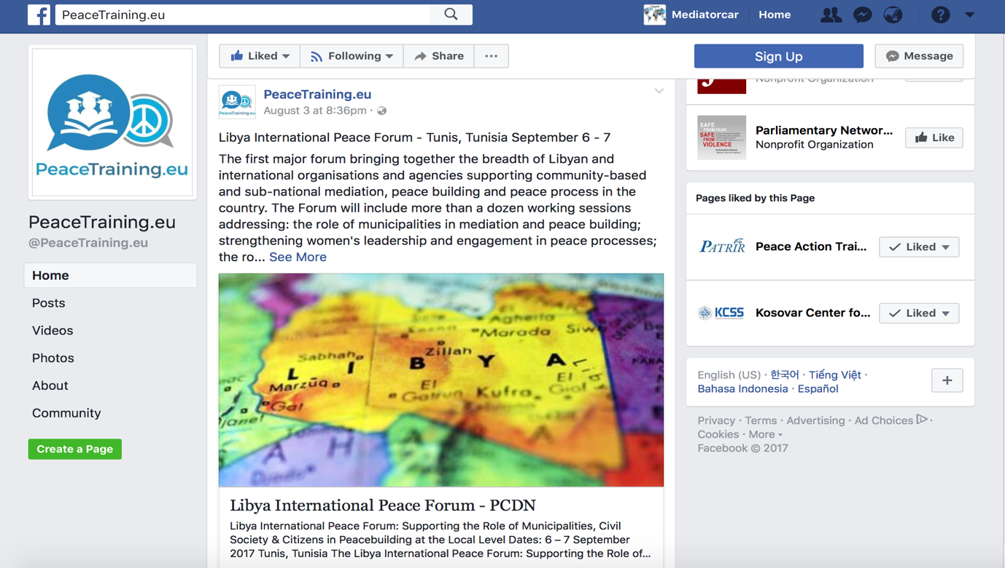Figure 10: Example of Facebook Activities

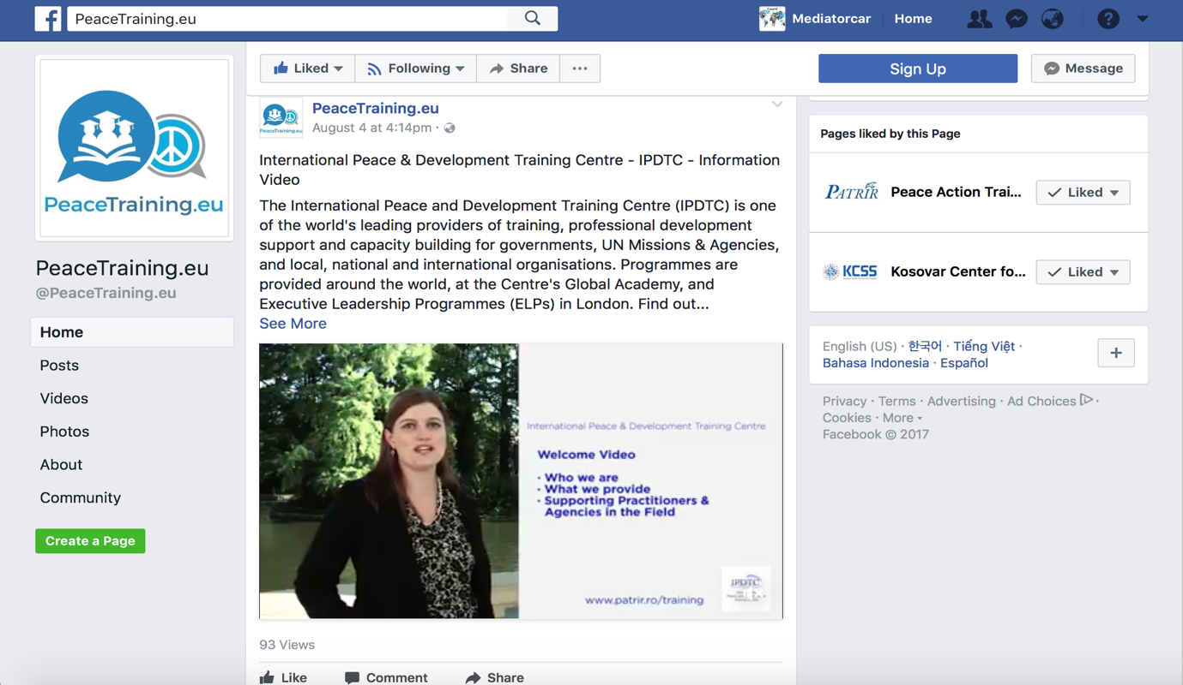Figure 11: Example of Facebook Activities

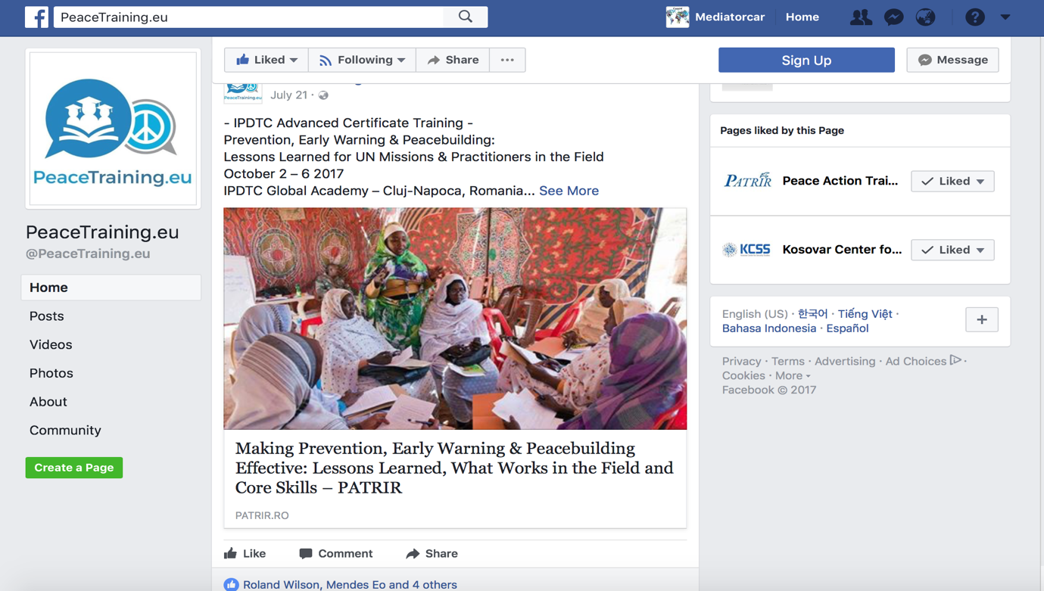Figure 12: Example of Facebook Activities

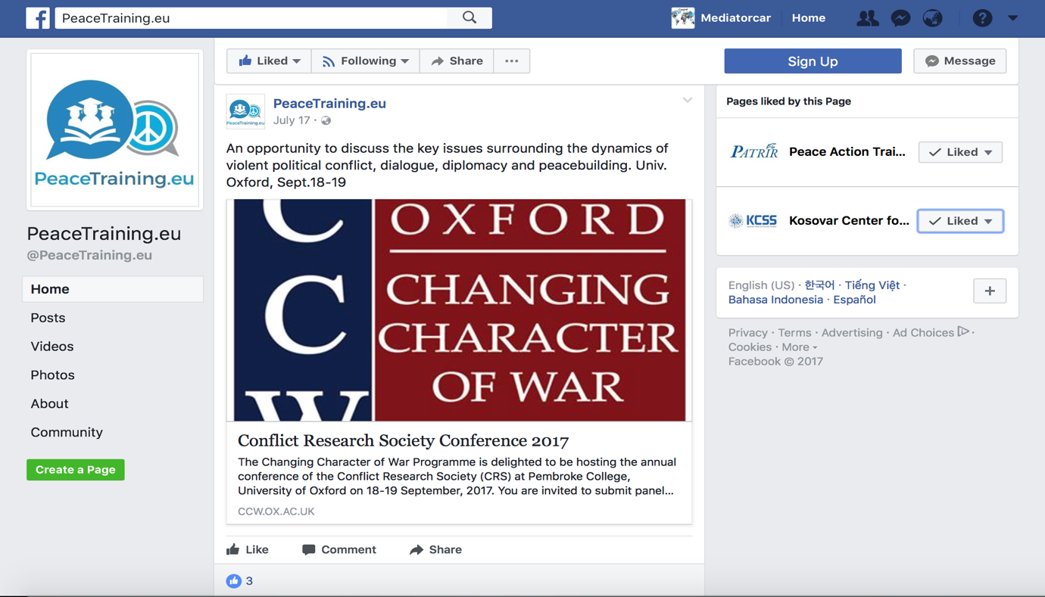Figure 13: Example of Facebook Activities

LinkedIn
Although not contained in the KPIs, we have continued to try to take advantage of the large professional network on LinkedIn. This platform is professionally designed to connect with people and organizations with similar interests and generate the power of the network. By keeping posting on the site, we were able to see the high possibility of getting a selective connection with people and organizations in the field of conflict resolution.
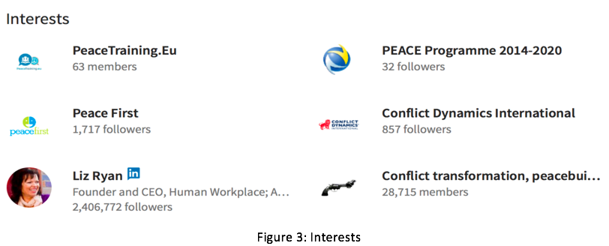
Figure 14: Interests
The materials that we focused on disseminating include articles and events related to conflict resolution and peace training primarily but not inclusively in Europe. Most of the events that we posted on the social media dealt with conflict management strategies, conflict transformation strategies, and methods of mediation, ways to maintain peace and post crisis management.
Instead of having the people interested in these topics going online to search for the articles and events by themselves, we have posted most of the upcoming events and published articles for them.
These are the screenshots from LinkedIn:
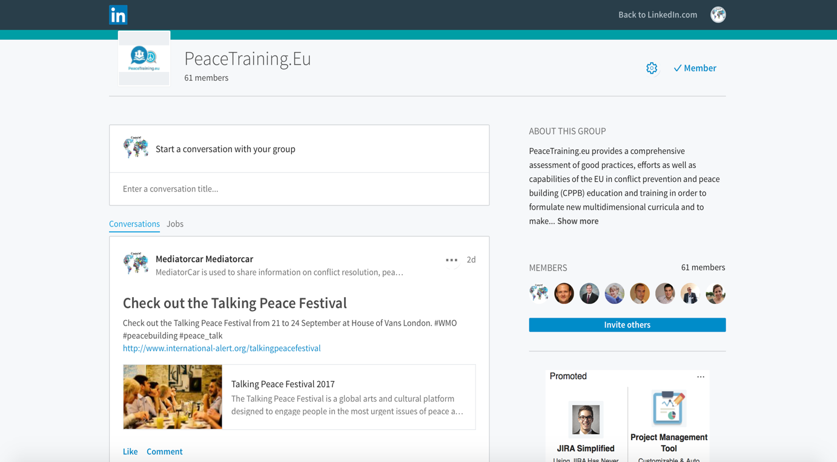Figure 15: Example of LinkedIn Activities

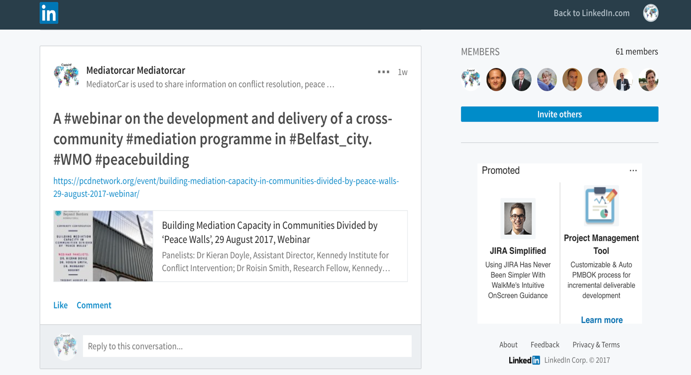Figure 16: Example of LinkedIn Activities

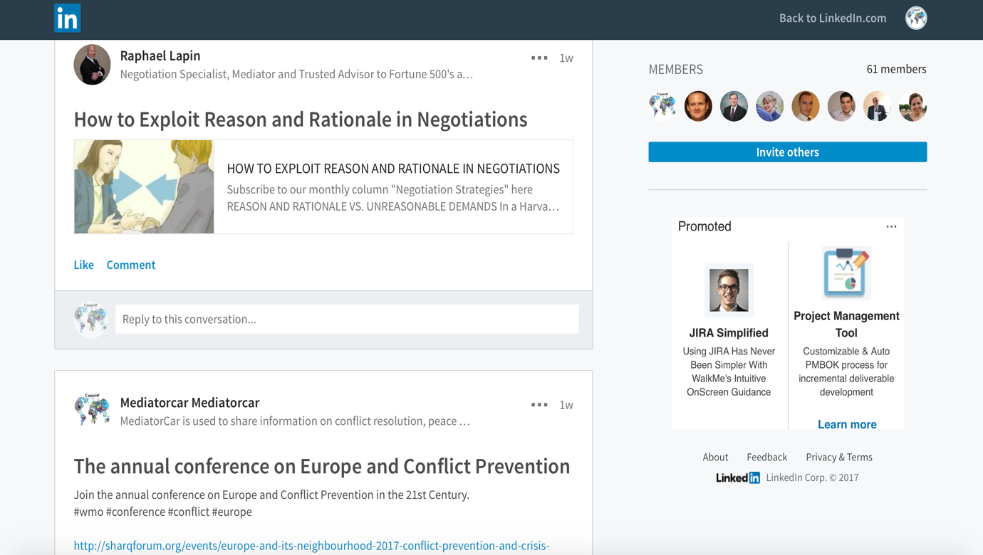Figure 17: Example of LinkedIn Activities

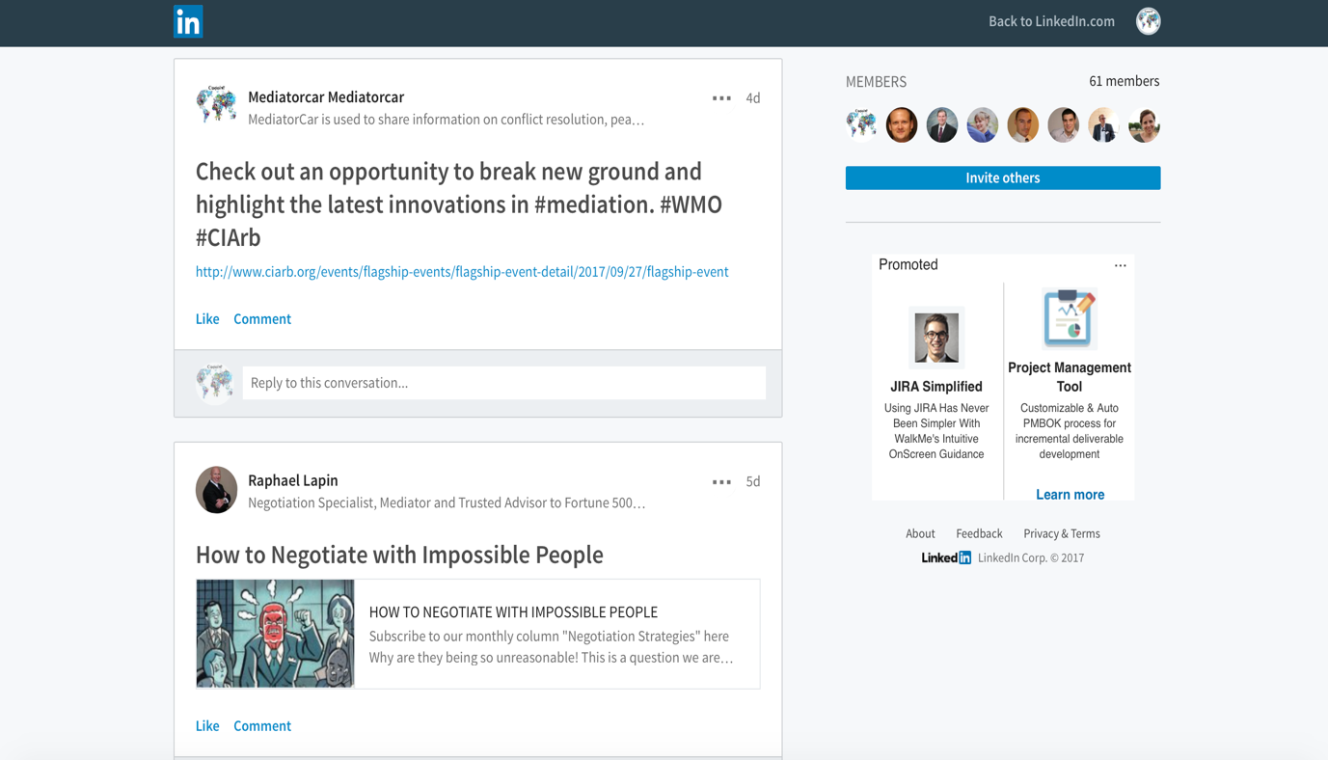Figure 18: Example of LinkedIn Activities

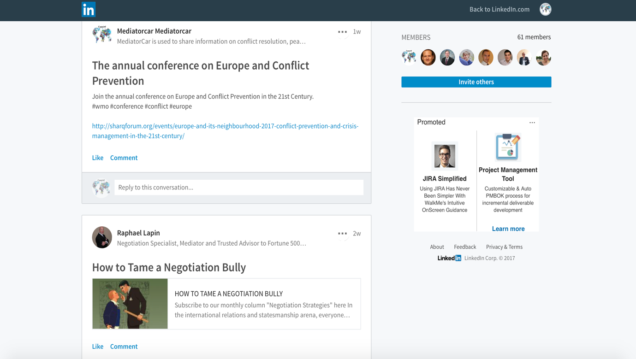Figure 19: Example of LinkedIn Activities

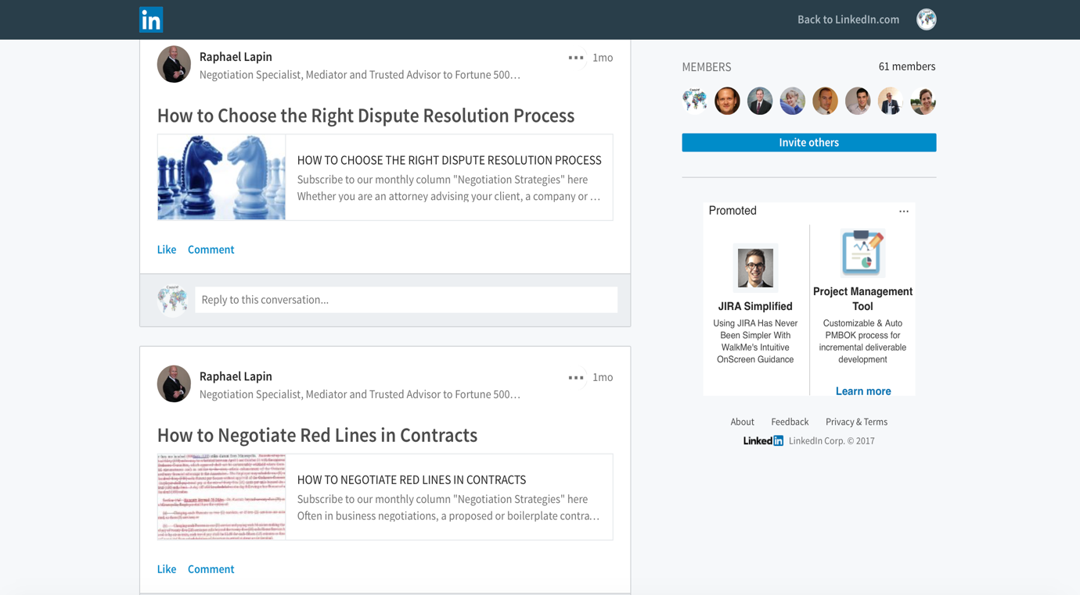Figure 20: Example of LinkedIn Activities
Besides updating the posts, we also tried to focus on inviting and making connections with people and organizations that are interested in the materials that we post. Therefore, we could spread the information widely. Since then, we have constantly been posting at least three times per week. As of the end of July 2017, we have approximately:
- Facebook: 200+ friends, 28 groups, 26 pages of mutual interest
- Twitter: 150+ new following, 25+ followers
- LinkedIn: 6 additional connections

Newsletters
The consortium has produced three increasingly informative newsletters (March, June and July). The newsletters have focused on the latest news from the consortium including information on current and upcoming meetings, workshops and webinars.
Examples of the Newsletters
The newsletters can be found at (http://project.peacetraining.eu/newsletter/). Examples of the newsletters are also provided below:
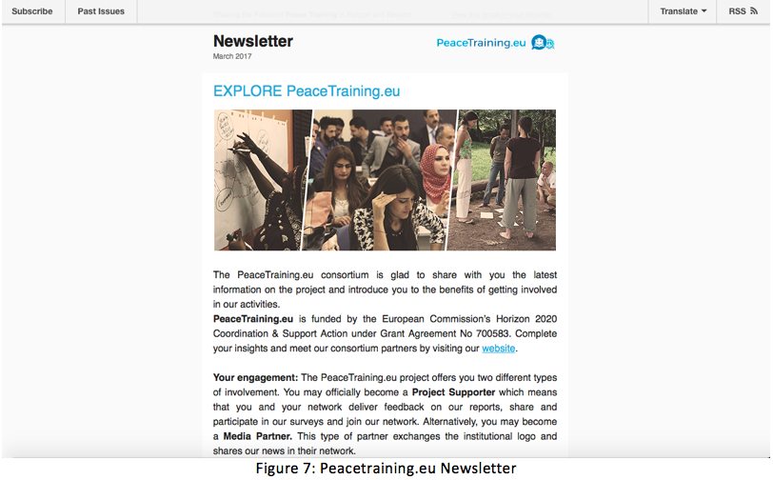Figure 24: Peacetraining.eu Newsletter March Edition

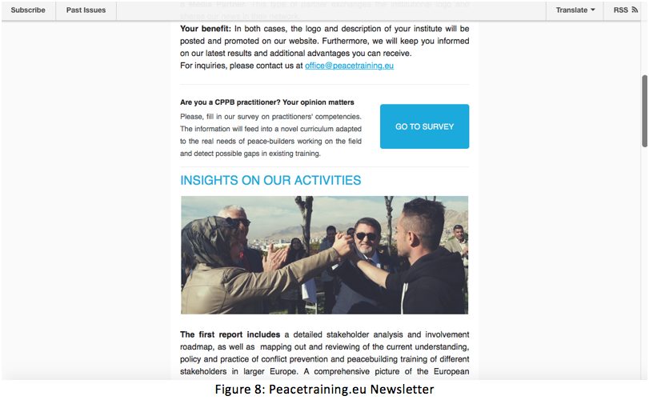Figure 25: Peacetraining.eu Newsletter March Edition

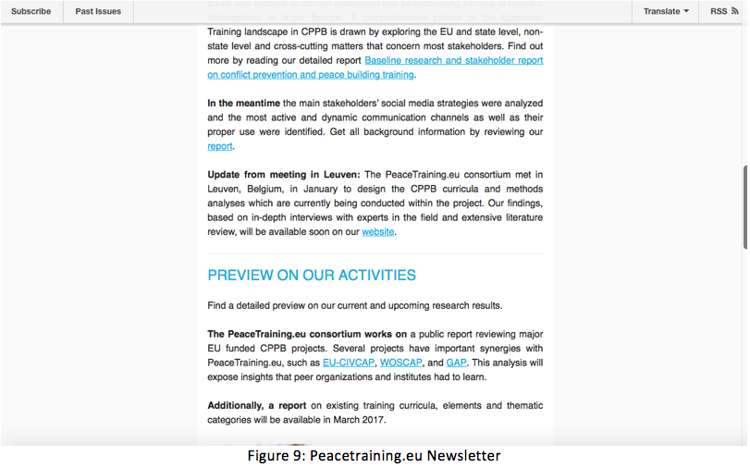Figure 26: Peacetraining.eu Newsletter March Edition

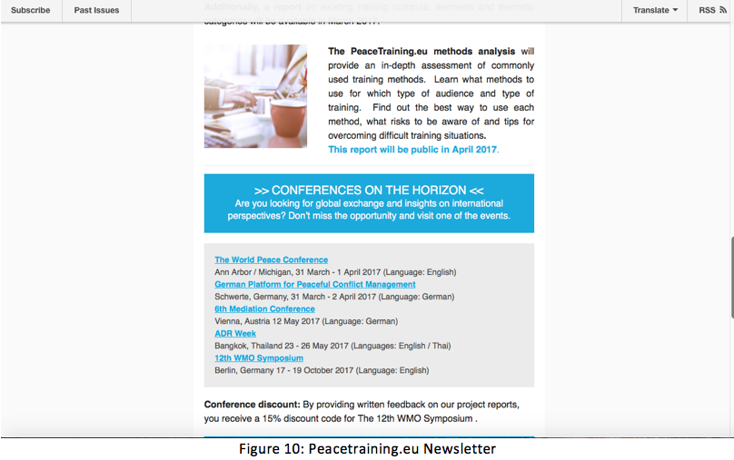Figure 27: Peacetraining.eu Newsletter March Edition

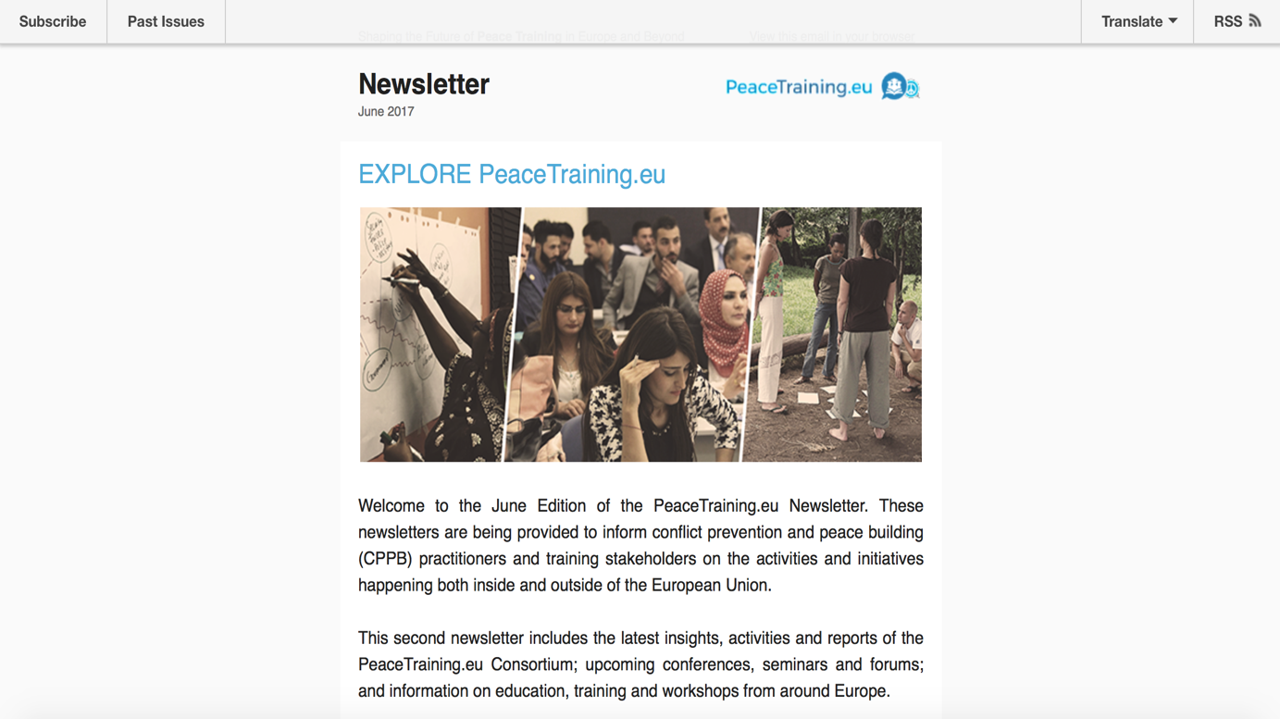Figure 28: Peacetraining.eu Newsletter June Edition

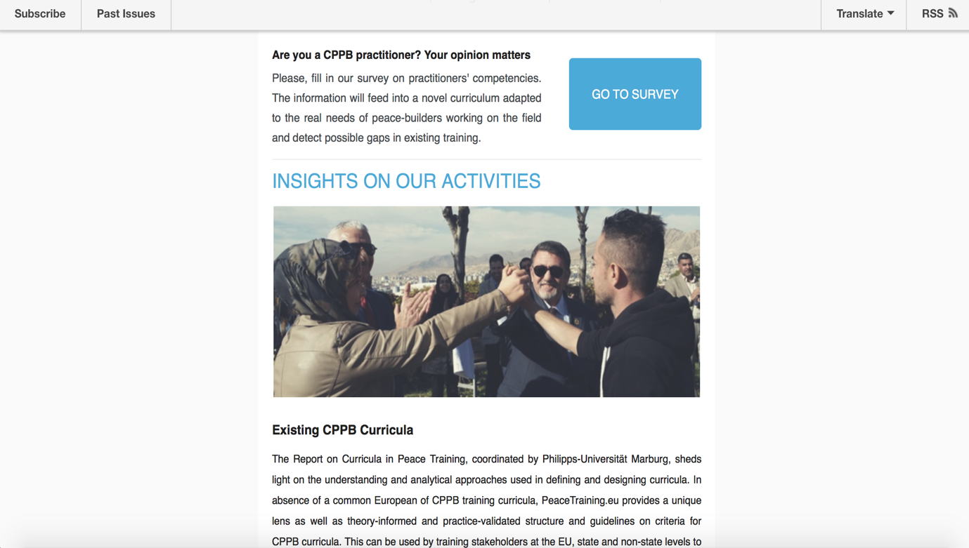Figure 29: Peacetraining.eu Newsletter June Edition

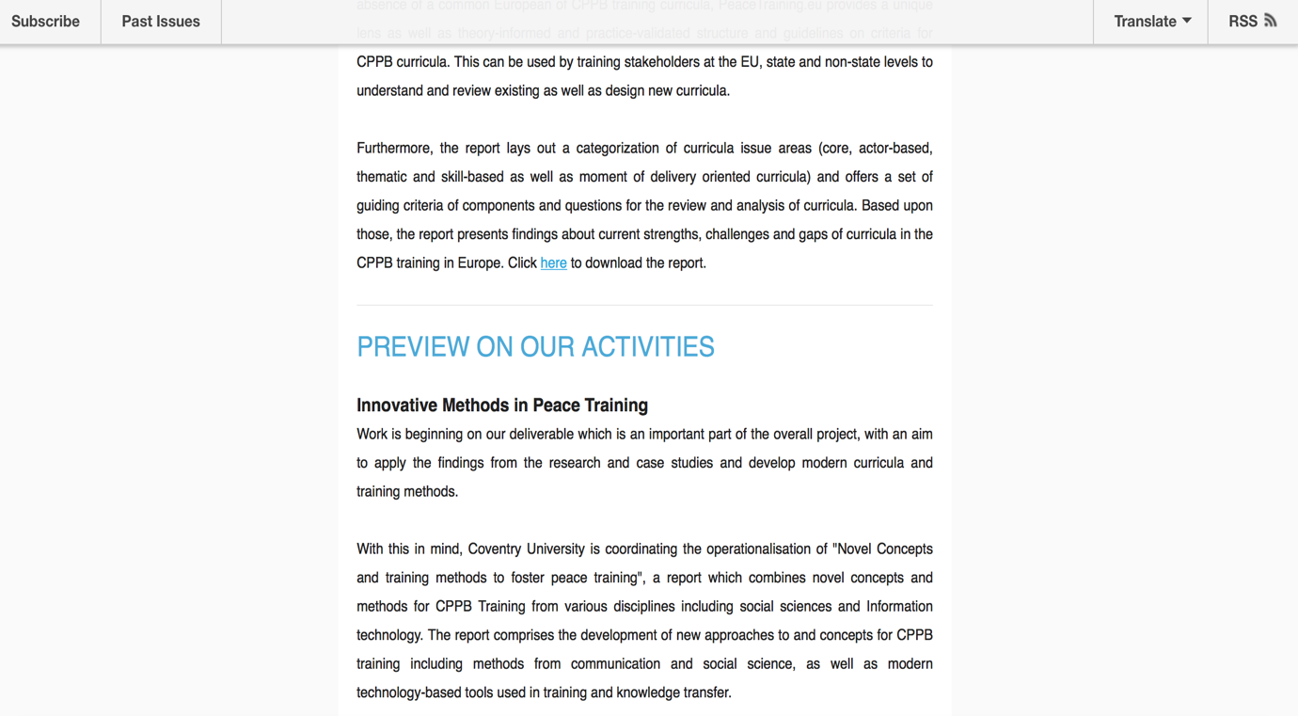Figure 30: Peacetraining.eu Newsletter June Edition

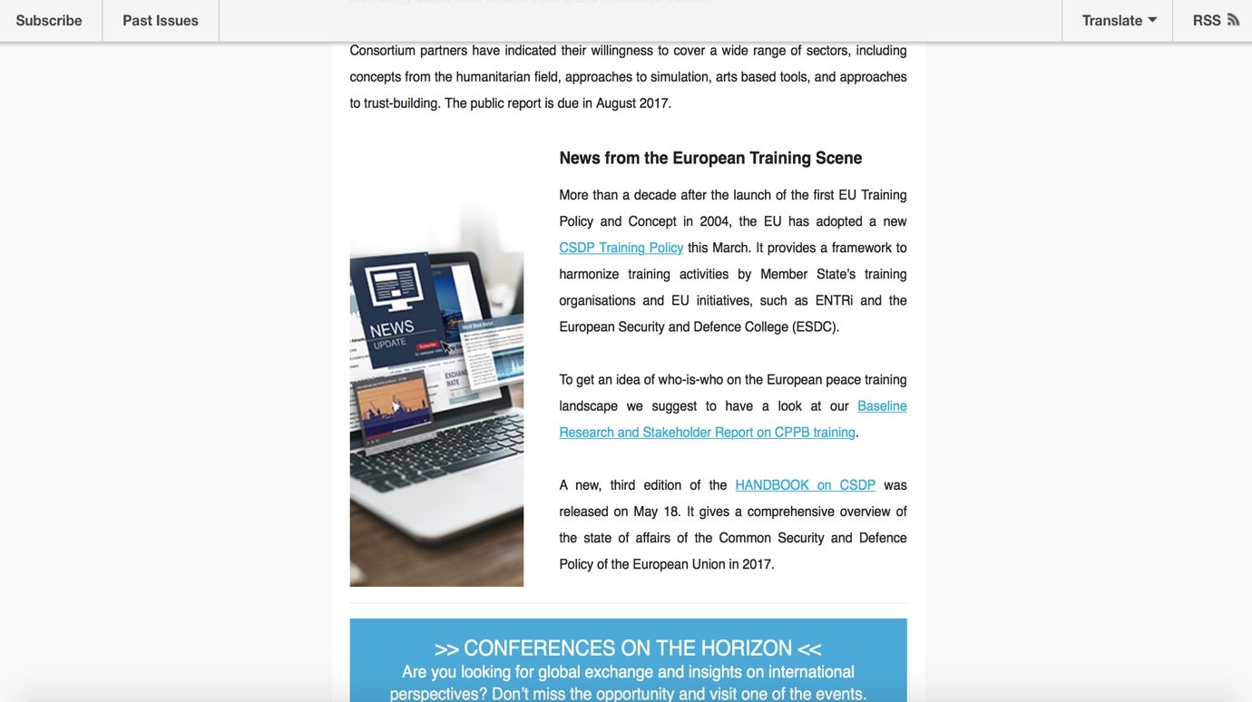Figure 31: Peacetraining.eu Newsletter June Edition

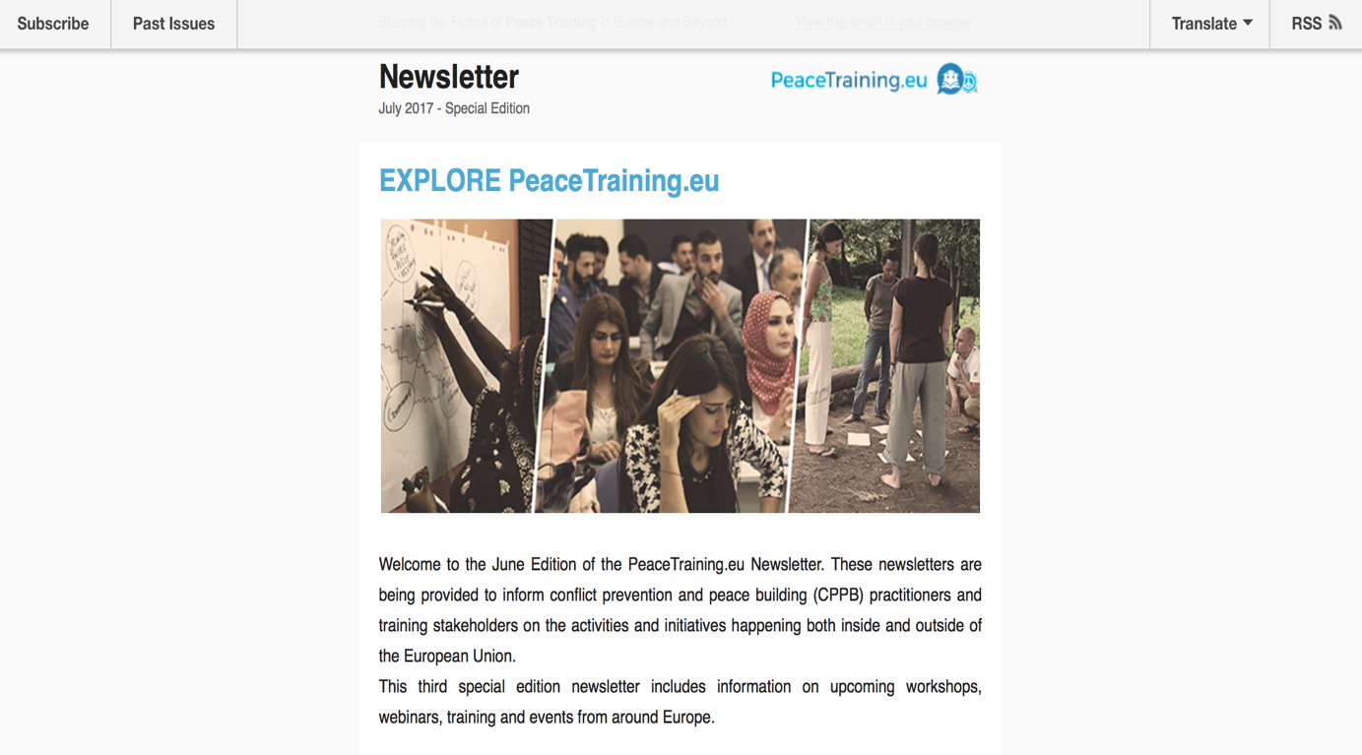Figure 32: Peacetraining.eu Newsletter Special Edition

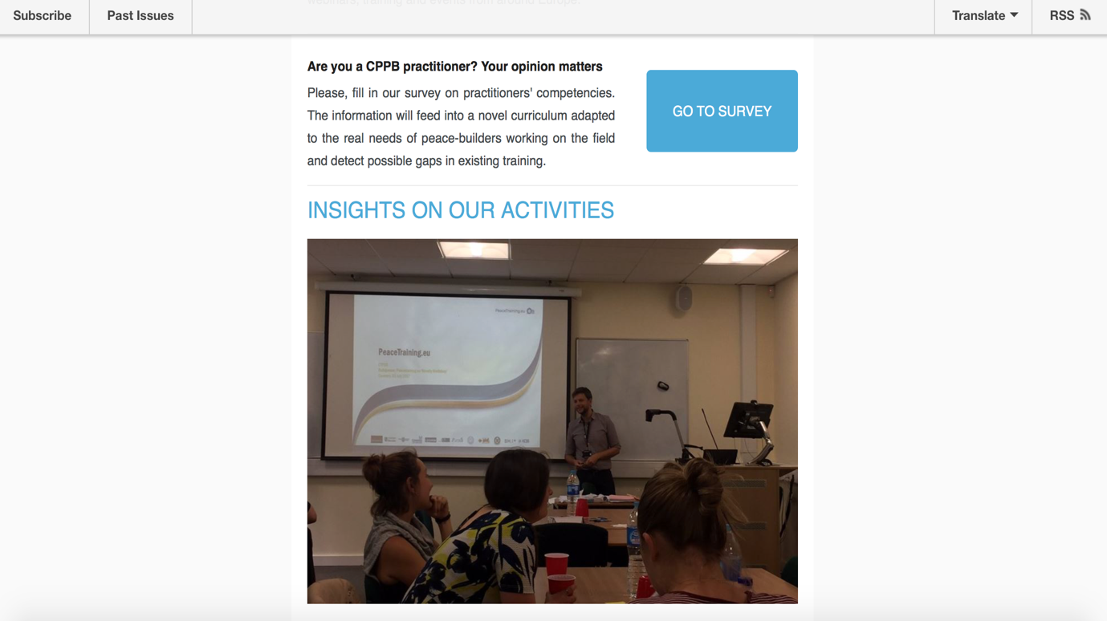 Figure 33: Peacetraining.eu Newsletter Special Edition

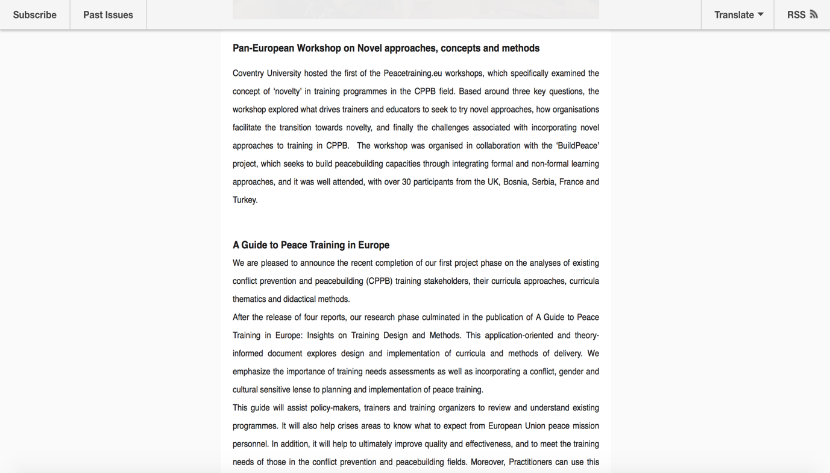 Figure 34: Peacetraining.eu Newsletter Special Edition

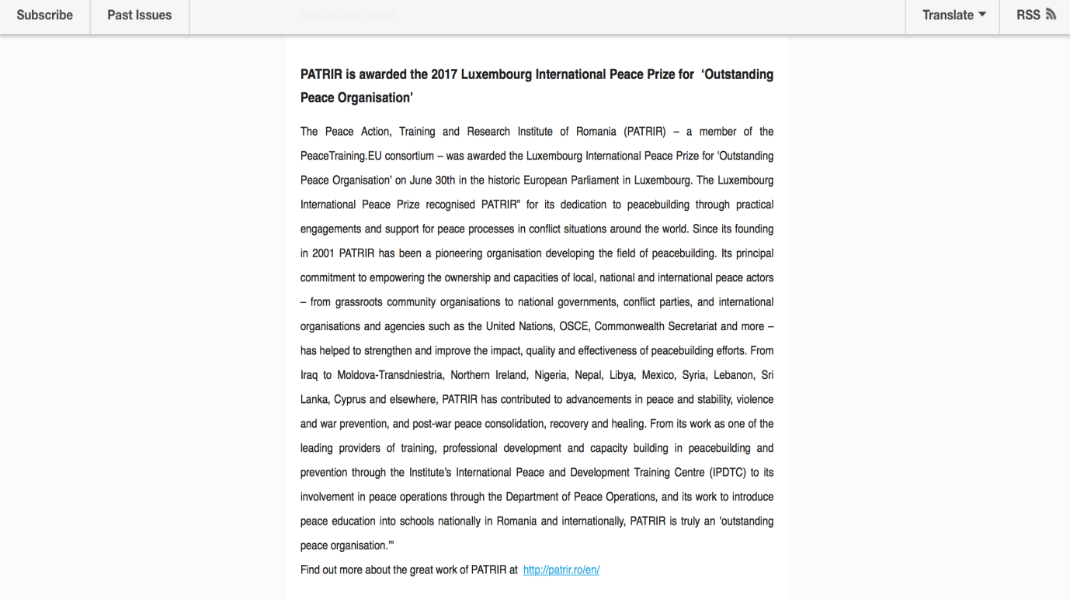 Figure 35: Peacetraining.eu Newsletter Special Edition

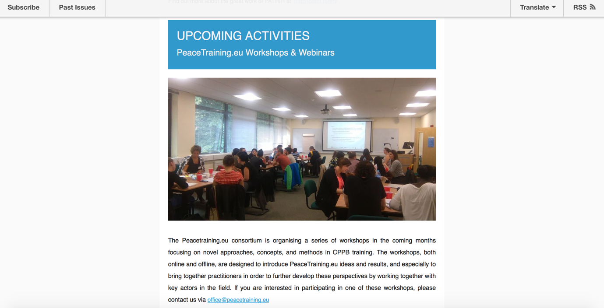 Figure 36: Peacetraining.eu Newsletter Special Edition

Statistics on Newsletters
Although the total number of newsletter subscribers (110) does not yet meet the project ambition, the statistics show that the followers of the newsletter continue to slowly and consistently grow. Detailed statistics from the newsletters are provided below:
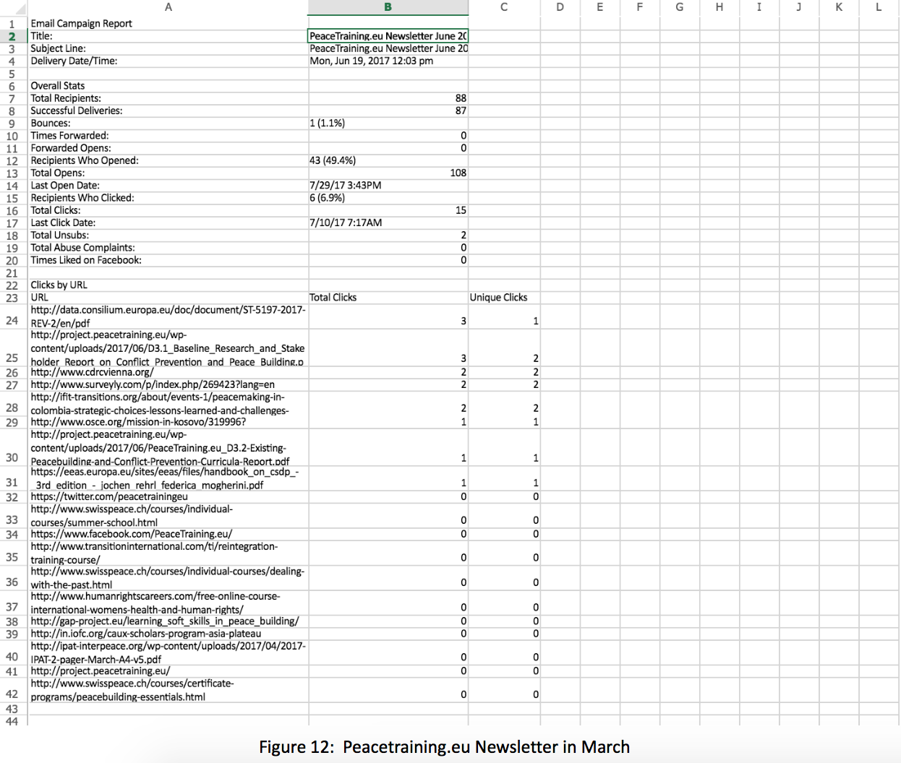Figure 37: Statistics on Peacetraining.eu Newsletter March Edition

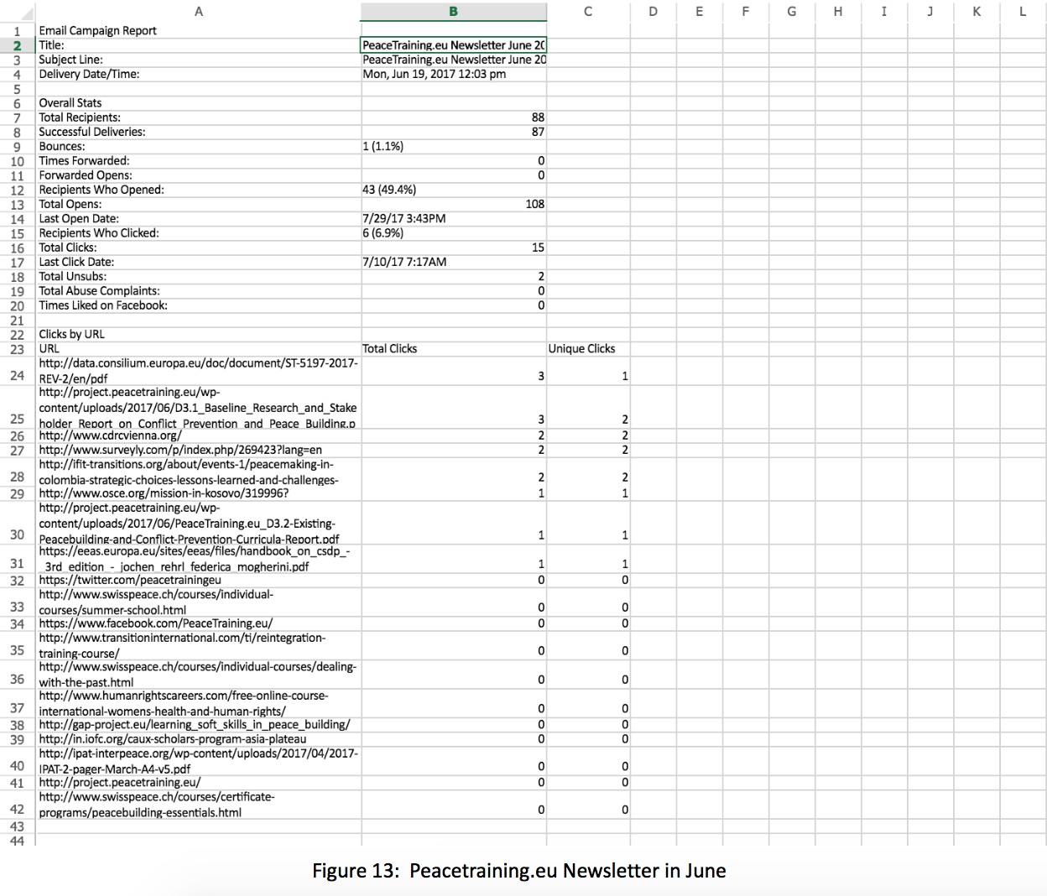Figure 38: Statistics on Peacetraining.eu Newsletter June Edition

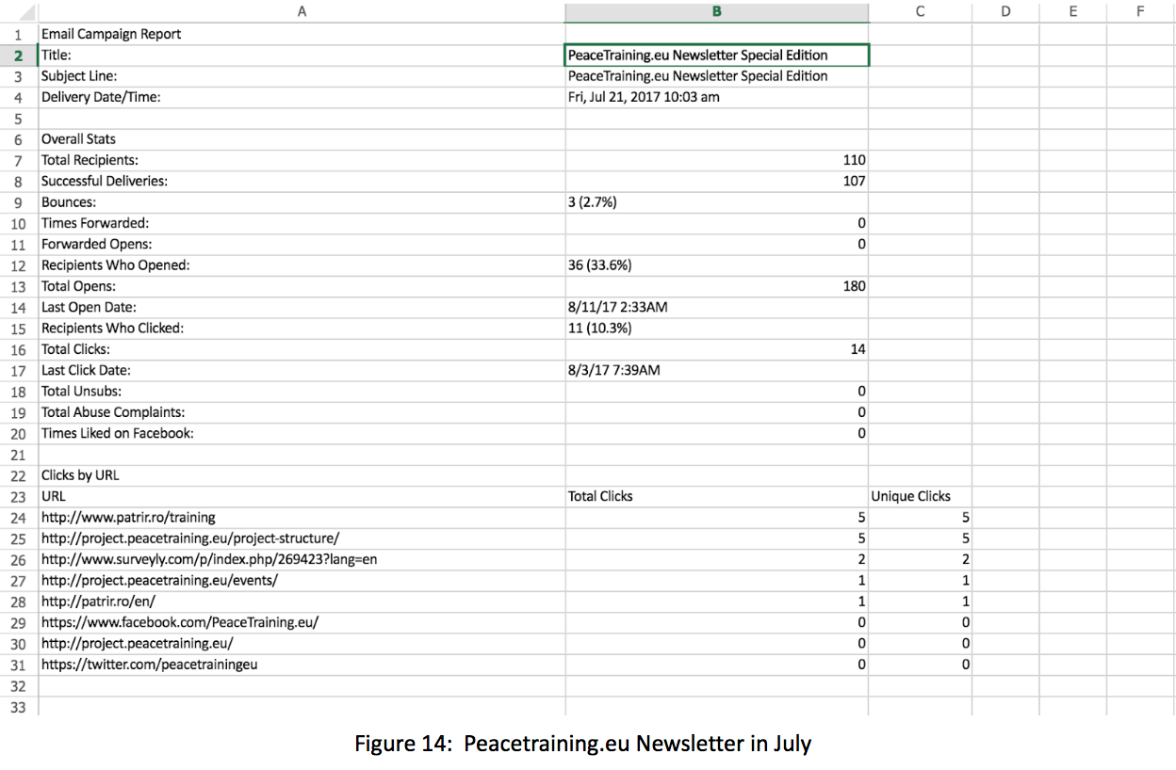Figure 39: Statistics on Peacetraining.eu Newsletter Special Edition

Project Website
The PeaceTraining.eu project website continues to serve as the primary resource for dissemination, where scholars, researchers, experts, stakeholders, and the interested public and potential participants can quickly find important, relevant and updated information about the project.
The website is constantly updated with pertinent information such as announcements on workshops and webinars, factsheets, key tweets, and information on relevant projects and resources, which are valuable to the whole community of stakeholders and interest groups.
The pictures below are examples of this constantly updated information:
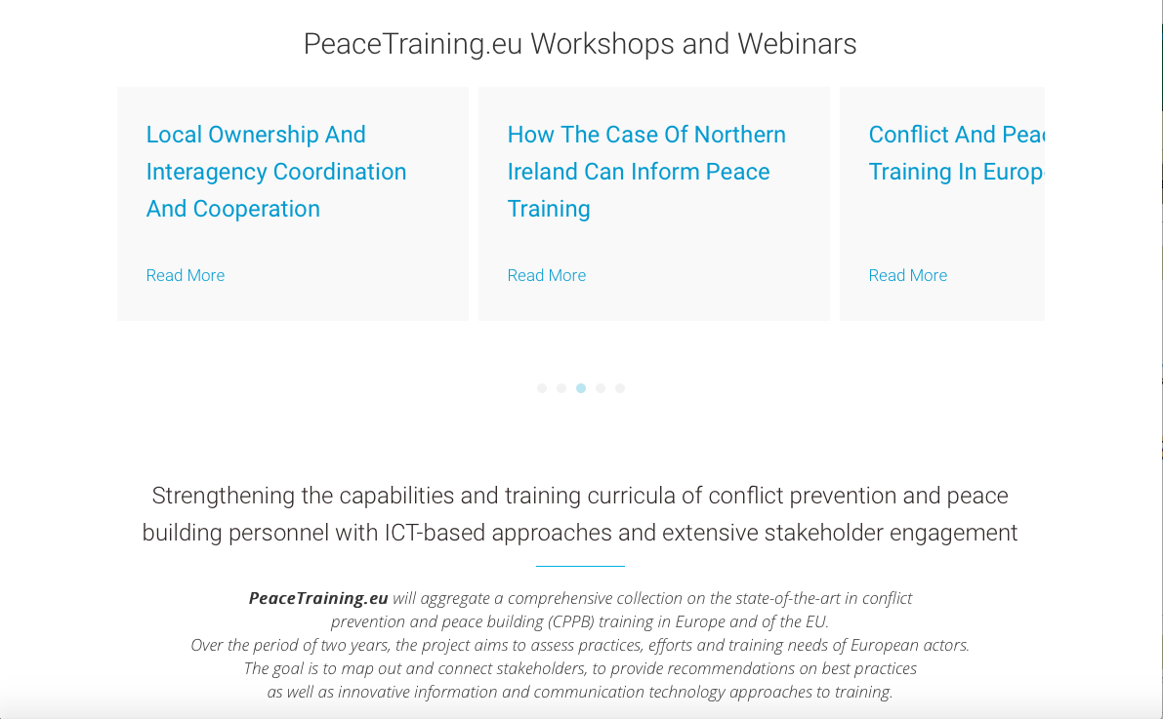Figure 40: Workshop and Webinar Information

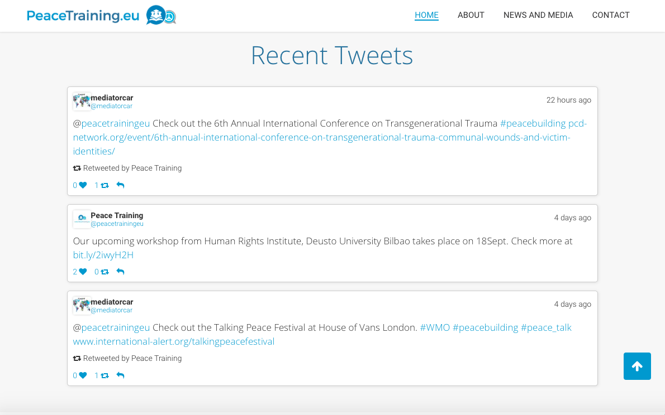Figure 41: Recent Tweets Information

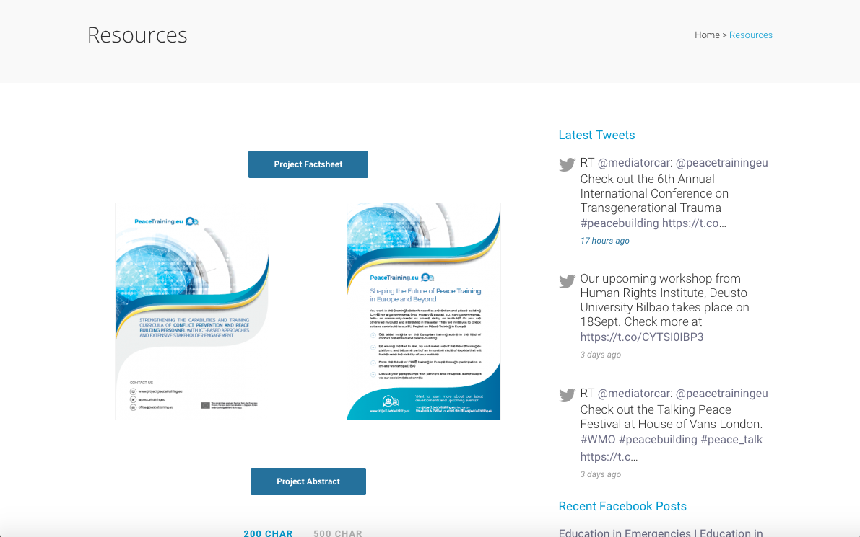Figure 42: Resources Information

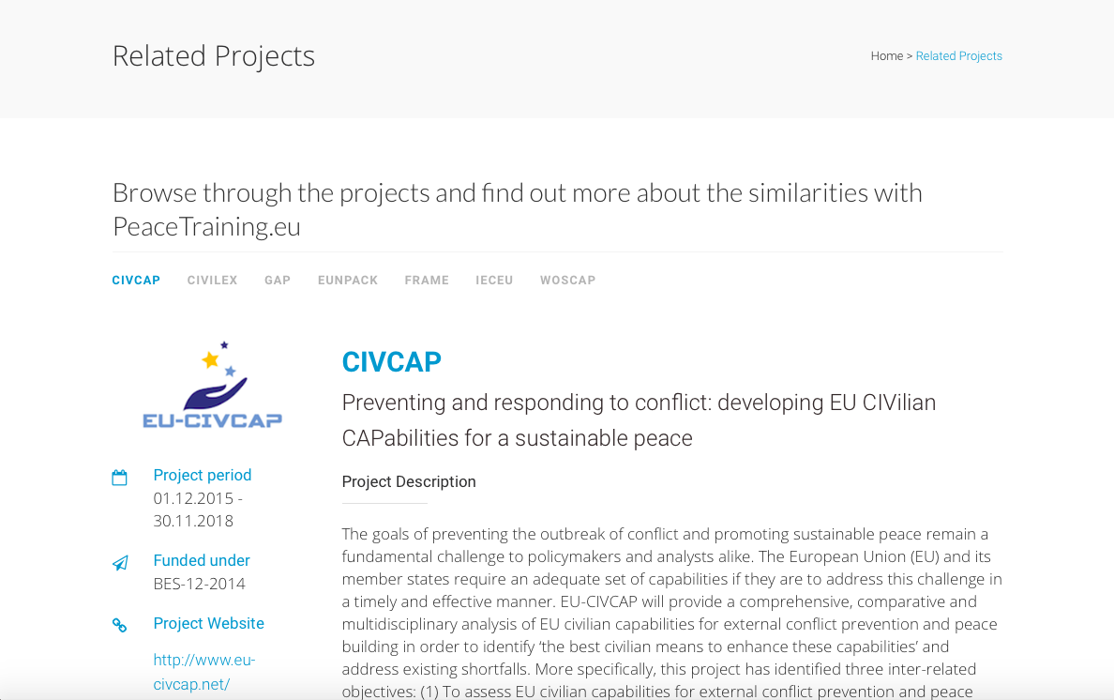Figure 43: Related Projects Information

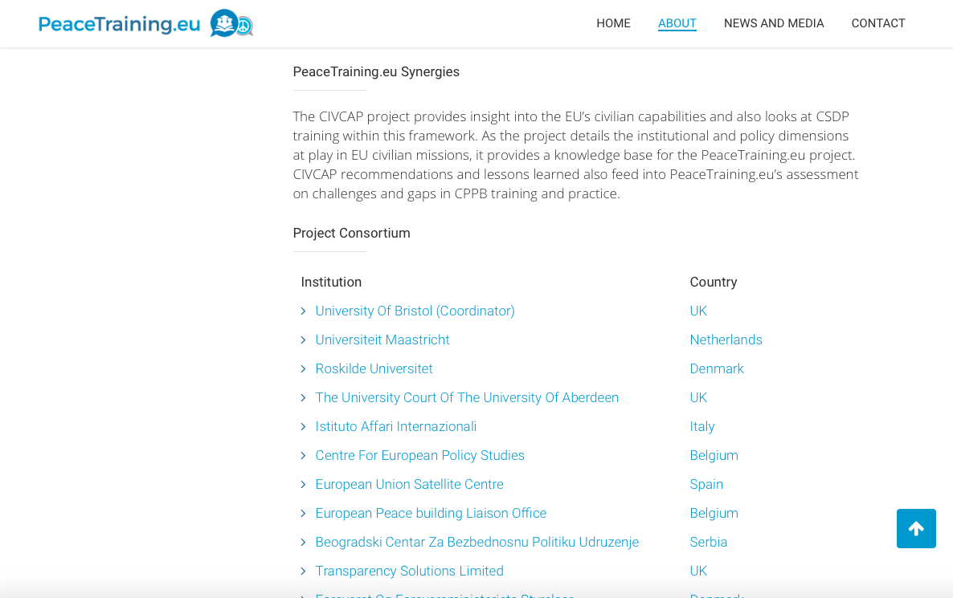Figure 44: Related Project Information

Factsheets
Another effective way of reaching relevant stakeholders is through newsletters. In this sense, the PeaceTraining.eu consortium releases one regularly. Here are some showcases below.
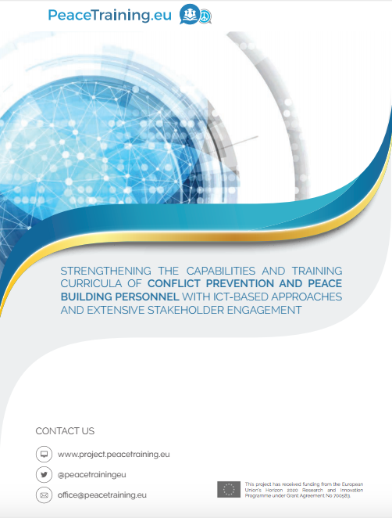Figure 45: Project Factsheet Information

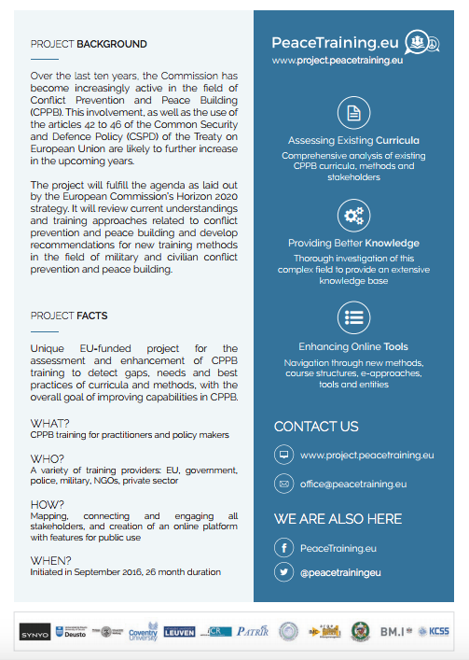
Figure 46: Project Factsheet Information
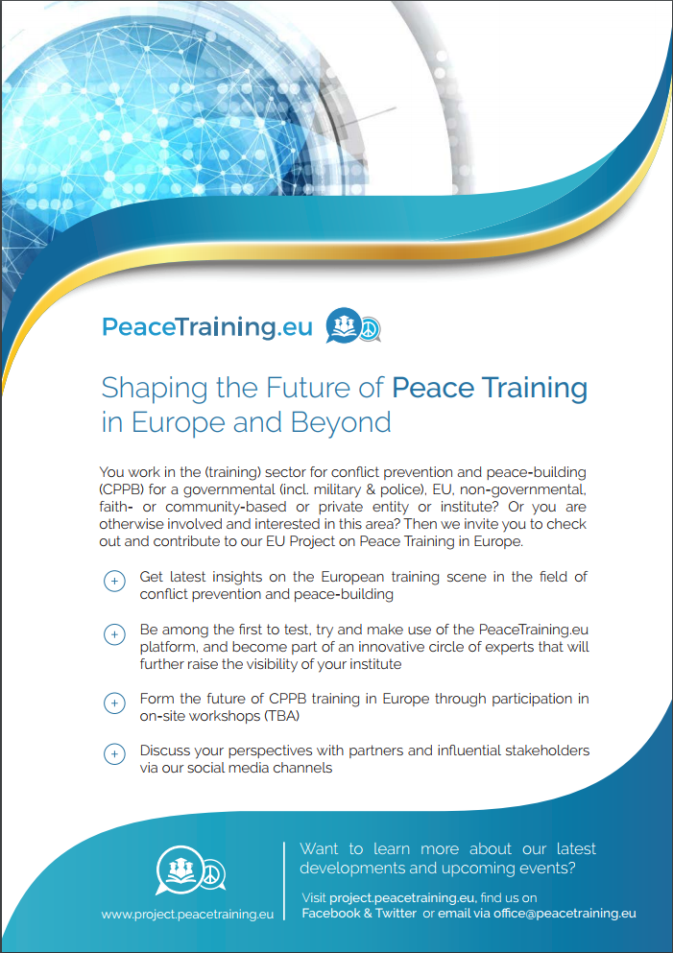
Figure 47: Project Factsheet Information

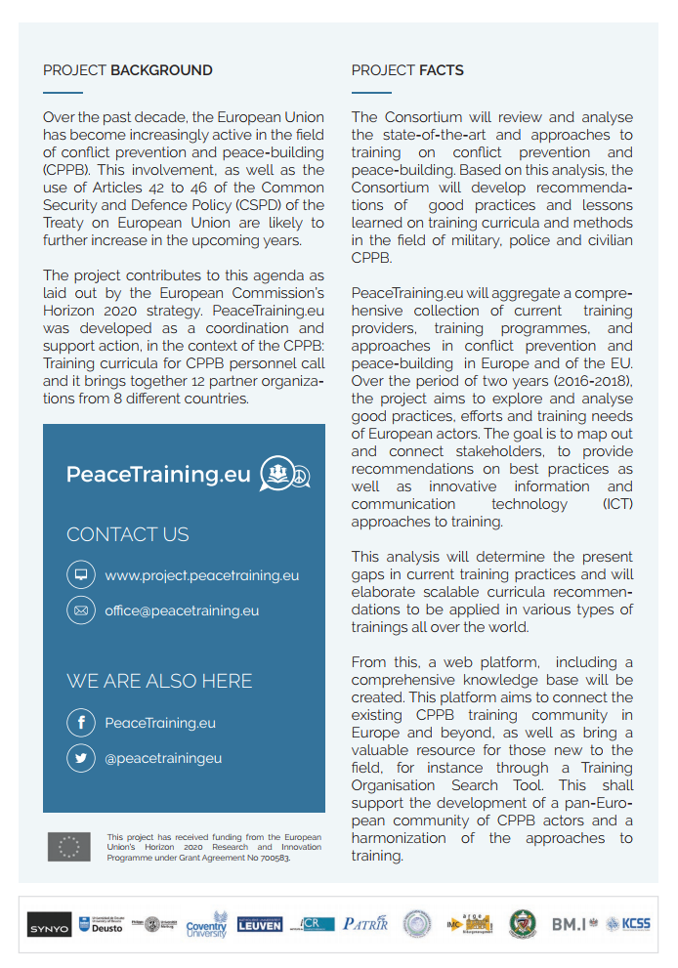
Figure 48: Project Factsheet Information
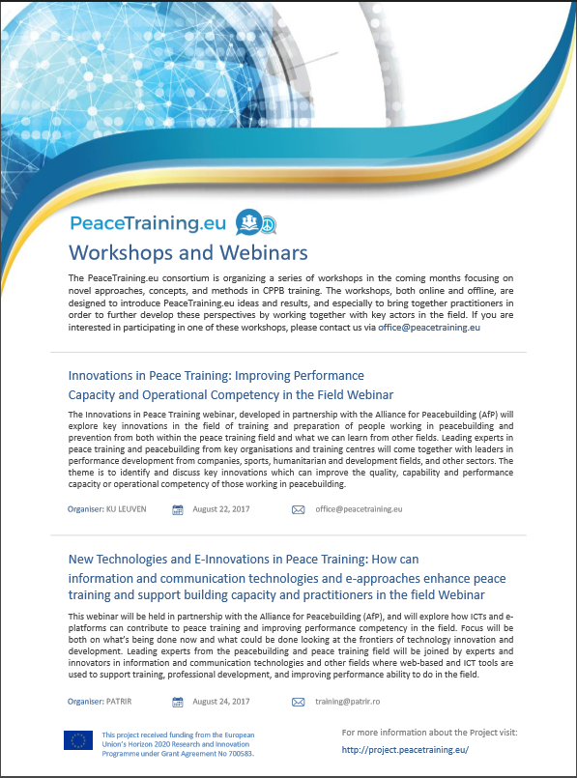
Figure 49: Project Factsheet Information

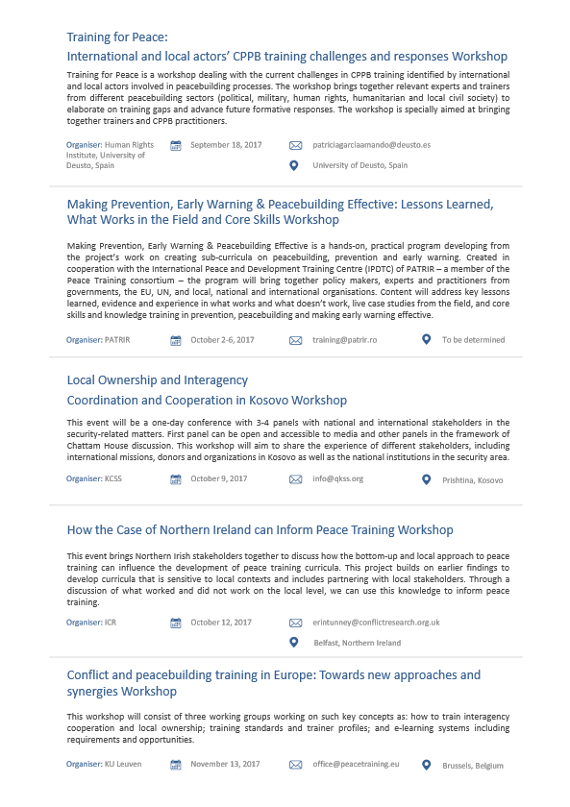
Figure 49: Project Factsheet Information

Conclusion
As has been described in this report, the current dissemination plan for the project has been successful. The project website, primary social media platforms and the secondary ones will continue to serve as an important resource for dissemination, where researchers, experts, stakeholders, the interested public and potential participants can find the relevant information about the project.
In addition, further dissemination channels and activities are being considered including YouTube. Finally, the consortium will continue to work together to develop other unique dissemination materials such as templates, which can be used for flyers and brochures to help with further distribution efforts.

