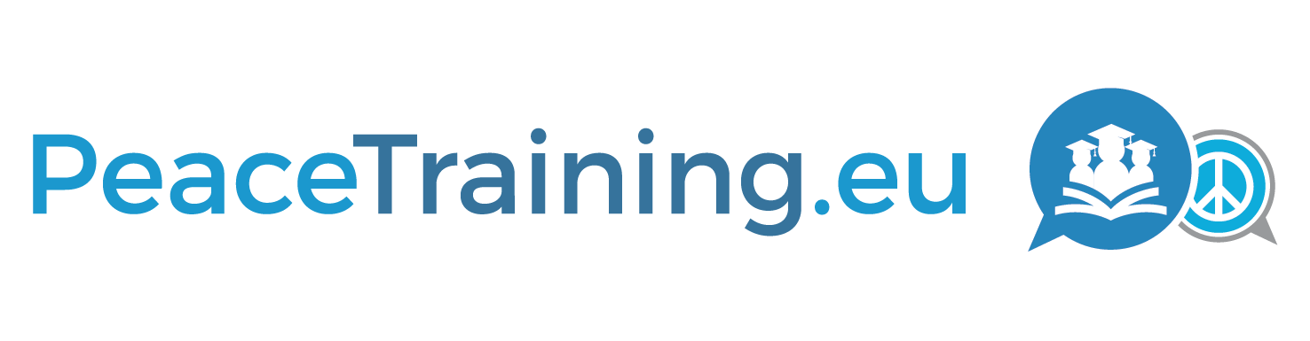
Strengthening the Capabilities and Training Curricula of conflict prevention and peace building personnel with ict-based collaboration and knowledge approaches
D7.5
Dissemination Package Two (Additional Report)

Project

Acronym: PeaceTraining.eu
Title: STRENGTHENING THE CAPABILITIES AND TRAINING CURRICULA OF CONFLICT PREVENTION AND PEACE BUILDING PERSONNEL WITH ICT-BASED COLLABORATION AND KNOWLEDGE APPROACHES

Coordinator: SYNYO GmbH

Reference: 700583
Type: Coordination and Support Action
Program: HORIZON 2020
Theme: Conflict prevention and peace building topic 2: Training curricula for Conflict Prevention and Peace Building personnel

Start: 01. September 2016
Duration: 26 months

Website: project.peacetraining.eu

Consortium: SYNYO GmbH (SYNYO), Austria
University of Deusto (UDEUSTO), Spain
University of Marburg (UMR), Germany
Coventry University (COVUNI), United Kingdom
Katholieke Universiteit Leuven (KULEUVEN), Belgium
Institute for Conflict Research (ICR), United Kingdom
Peace Action, Training and Research Institute of Romania (PATRIR), Romania
ARGE Bildungsmanagement (ARGE), Austria
Baltic Defence College (BALTDEFCOL), Estonia
Federal Ministry of Interior (BMI), Austria
Kosovar Center for Security Studies (KCSS), Kosovo
Deliverable

Number: D7.5
Title: Dissemination Package Two
Lead beneficiary: SYNYO
Work package: WP7
Dissemination level: PU
Nature: Other / Additional Report

Due date: 31.10.2018
Submission date: 31.10.2018

Authors: Stela Shiroka, SYNYO

Contributors: Nancy Annan, COVUNI
David Curran, COVUNI
Edin Agbabic, SYNYO
Iulia Luca, SYNYO
Carmen Munteanu, SYNYO
Bernhard Jäger, SYNYO

Acknowledgement: This project has received funding from the European Union’s Horizon 2020 Research and Innovation Programme under Grant Agreement No 700583. | Disclaimer: The content of this publication is the sole responsibility of the authors, and in no way represents the view of the European Commission or its services.

Executive Summary
This report presents the communications and dissemination materials and activities created and carried out in the second half of the project. The first report of this line (Deliverable 7.2: Dissemination Package One) presented the creation of the first dissemination materials, and the communication activities in the first half of the project with a view to identifying barriers and best practices in attracting a broader audience of practitioners. This report follows up on this, showing how the reflections and recommendations from Dissemination Package One have been taken up and implemented for a broader dissemination in the second project period. The report focuses merely on online communication through social media channels, newsletters, project website and ultimately the PeaceTraining.eu web platform. Additional activities organised to raise awareness on the PeaceTraining.eu project’s outcomes (events, publications and final conference) are presented by Deliverables 7.4 and 7.6.

Table of Content

1 Introduction 6
2 Key Performance Indicators (KPIs) 7
3 Social Media Platforms 8
Twitter 8
Facebook 15
LinkedIn 18
YouTube 21
4 Newsletters 23
5 Project Website and PeaceTraining.eu platform 33
6 Factsheets and Conference Materials 41
7 Conclusion 54

Introduction
This report covers the communication materials and activities in the second project period starting on August 2017 until October 2018, marking also the end of the project. Similar to the first period, the second half of the project continued with the implementation of the project communication strategy, making use of the established communication channels, creating and distributing additional materials to raise awareness on project outputs. Since the second half of the project matches with the achievement of more objectives and release of more project outputs, in terms of dissemination this period was also more fruitful and led to a considerable increase in audience and general engagements.
The document starts by presenting the Key Performance Indicators for dissemination materials and activities, describing how social media campaigns ran in the owned social media platforms, the communication through newsletters, creation of factsheets, the update of the project website, and ultimately how the deployment of the PeaceTraining.eu web platform replaced the project website on awareness raising.

Key Performance Indicators (KPIs)
The following figure illustrates the Key Performance Indicators set-out for both project periods. The third column described the achieved results by the end of the project. The types of dissemination activities and outputs mentioned in the figure below and also described further on in this report, regard the social media activities and overall web presents together with the dissemination materials created to support the awareness raising on the web as well as in the physical event. The achieved KPIs in physical and scientific dissemination activities (events, publications etc.) are described in other reports.
As observed in Figure 1, most of the set KPIs for the 1st and the 2nd period were achieved. In terms of Social Media, Twitter is the platform that seems to be outperforming, failing to achieve 1000 followers by the end of the project. Nevertheless, as the Twitter analytics (described below) show, twitter post reached up to 34,400 engagement for a three-month period, with an average lying at around 26,000 engagements, showing the in spite of the higher number of followers, the attractiveness and impact of the post was already big. Facebook on the other hand surpassed the expectations by reaching more than 1100 followers. Similarly, also later-added social media channels such as LinkedIn and YouTube also contributed to increasing the overall impact.
The second KPI which was not fully achieved was the registration of the training providers on the PeaceTraining.eu platform. It is worth mentioning that before the final conference in Vienna, the number of registrations on the platform was rather low, and the event helped increasing the number considerably, reaching around 85 registrations. The discussions and the presentations of the platform during the conference and the CivComm meeting (described in Deliverable 7.6) helped in raising awareness on the platform to a broader circle of training providers which showed great interest and commitment on creating profiles and using it regularly. Formal and informal discussions – combined with strong social media campaigns – thus indicated that the number of the registrations on the platform will be on the rise.
Achieved KPIs
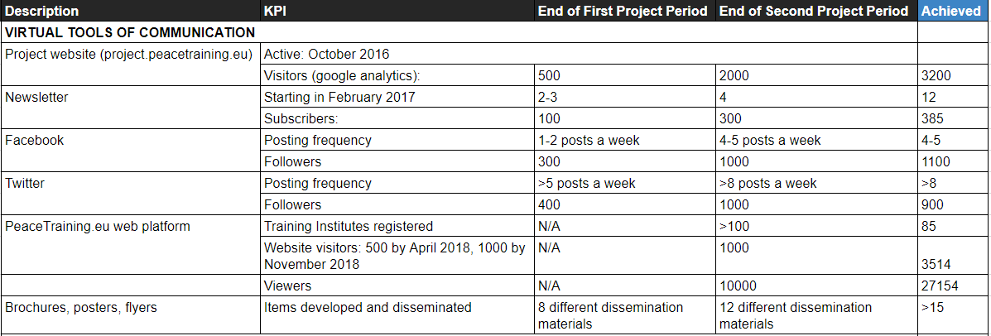Figure 1: KPIs

Social Media Platforms
Social media platform represents an integral part of the dissemination activities carried out in both project period. In accordance to the social media plan, as part of the overall communication and dissemination strategy, the communication through the social media channels was carried out similarly throughout the entire project duration. The second period, matching with the achievement of more objectives and release of more outputs, led to the expansion of the online audiences on all channels and an increase in the engagement of the users towards the content produced from the project results.
The type of content shared on all owned social media channels includes output of the project (reports and publication and extracts from them), awareness raising and recruitment of participants for the project activities (events, trainings, webinar and ultimately the final conference in Vienna), and related content from external sources that is relevant for the practitioner community and serves the training purposes (e.g. policies and research publications, upcoming events and trainings, and generally important knowledge for the field).
Ultimately, in the last project months, the main focus of the social media campaigns was placed on communicating the final conference and the PeaceTraining.eu web platform. The later, as the major output of the project, constitutes the main focus of the dissemination activities in the last project months and the future strategies.
The collection and posting of content for social media campaigns in the second half of the project, was made also in a collaborative manner by different consortium members ensuring that the continuous updates and a broad variety of content is shared.
Besides the social media channels owned in the first project period, a YouTube channel was created towards the end of the project. The YouTube channel hosts recorded events to make them available for the community, with a focus on the final project conference in Vienna.
The following sections show some types of posts and campaigns on all owned social media channels, and related analytics if provided by the social media platform.

Twitter
Twitter was one of the first platforms to have been created which had a steady increase in the number of followers and engagements, reaching around 900 followers by the end of the project. As Twitter has a wording limit, it was mainly used to share related content for the community (retweets from relevant knowledge providers e.g. European External Action Service, United Nations Peacebuilding, United States Institute for Peace, Conciliation Resources, PeaceDirect, Global Partnership for the Prevention of Armed Conflict, Inclusive Peace etc.), and post links to publications, reports, and other pieces of knowledge acquired in the project. As it can be seen from the analytics, several Twitter posts (e.g. Post introducing the PeaceTraining.eu curricula architecture) were particularly successful and involved more that 7,000 engagements.
The following screenshots show the types of posts with the highest number of impressions in the period August 2017 – October 2018.

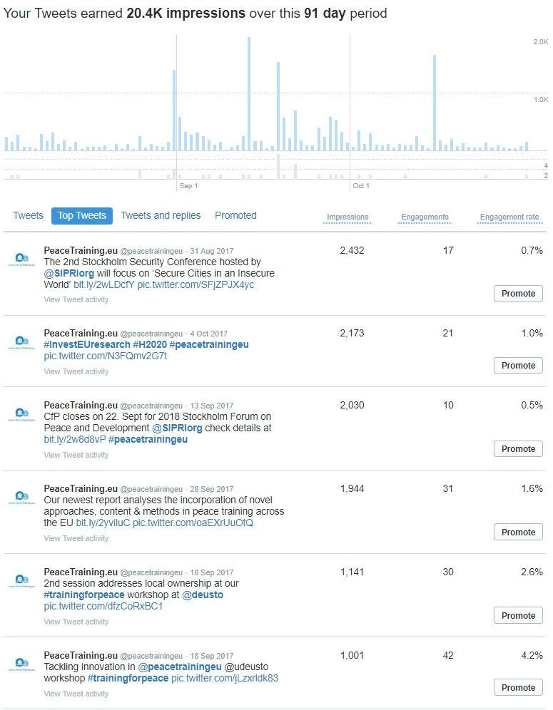
Figure 2: Tweet Activity Analytics from Twitter (August – October 2017)
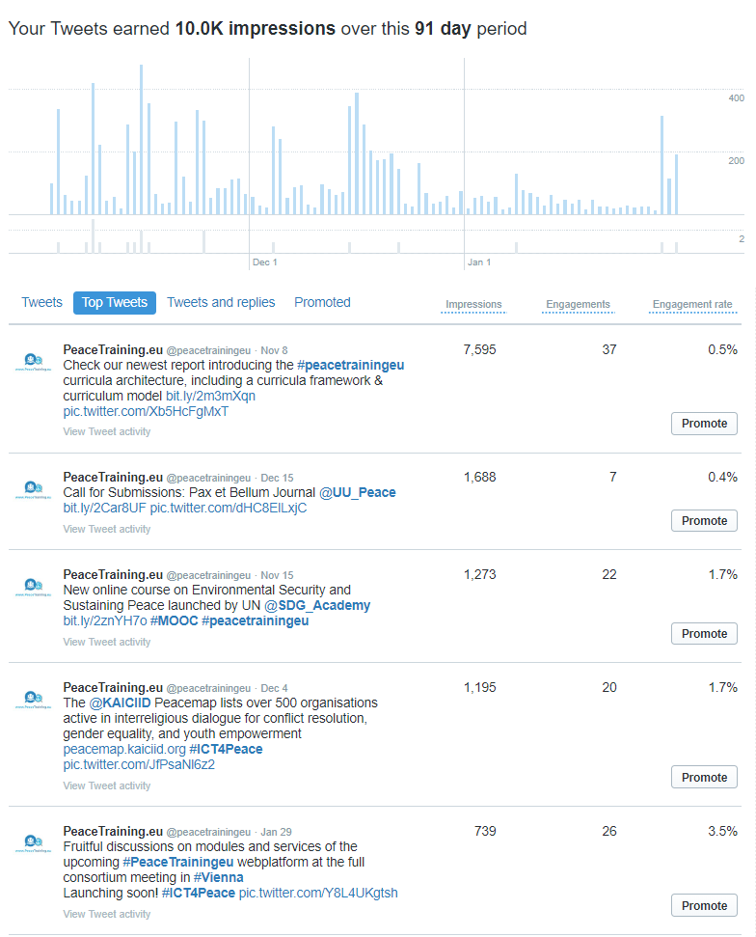
Figure 3: Tweet Activity Analytics from Twitter (November 2017 – January 2018)
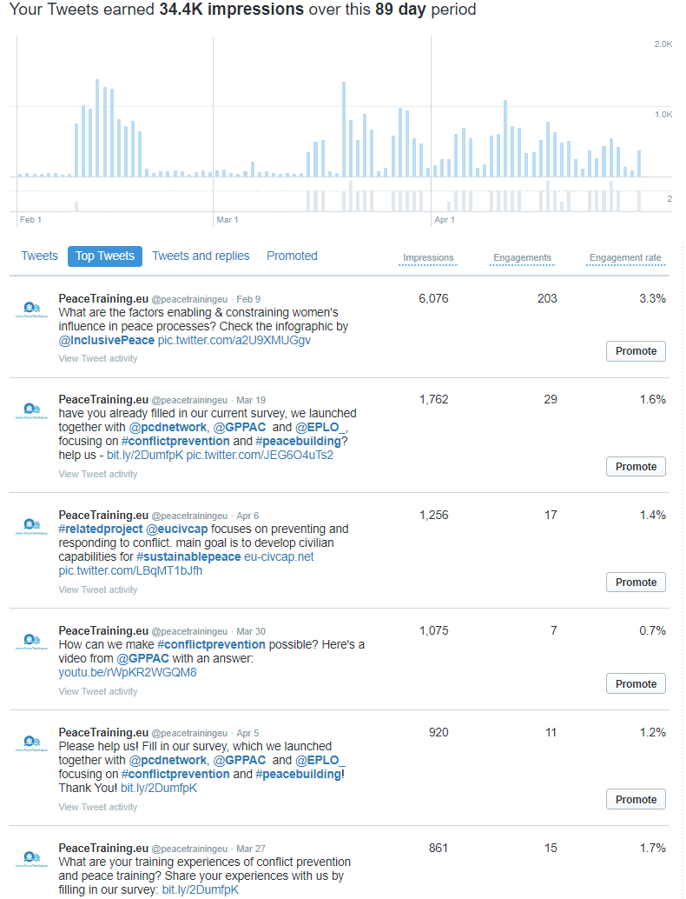
Figure 4: Tweet Activity Analytics from Twitter (February – April 2018)
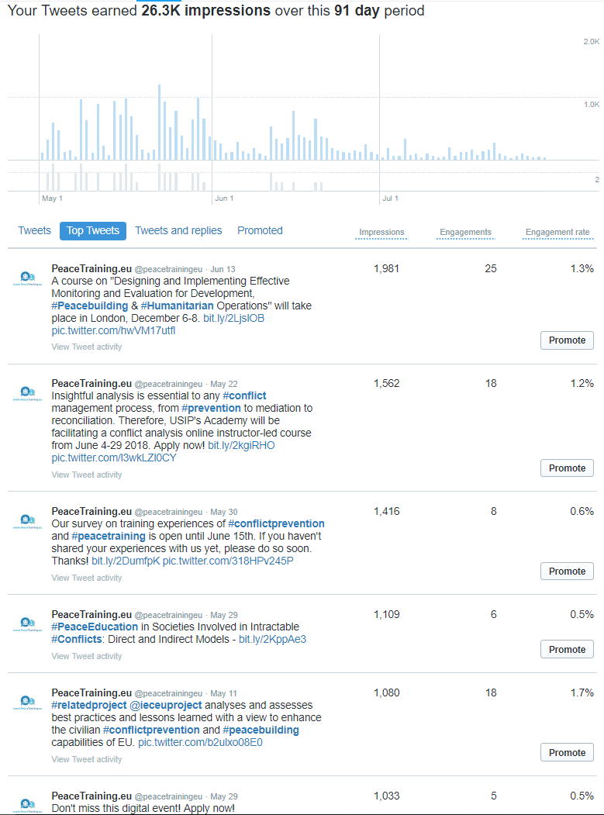
Figure 5: Tweet Activity Analytics from Twitter (May – July 2018)

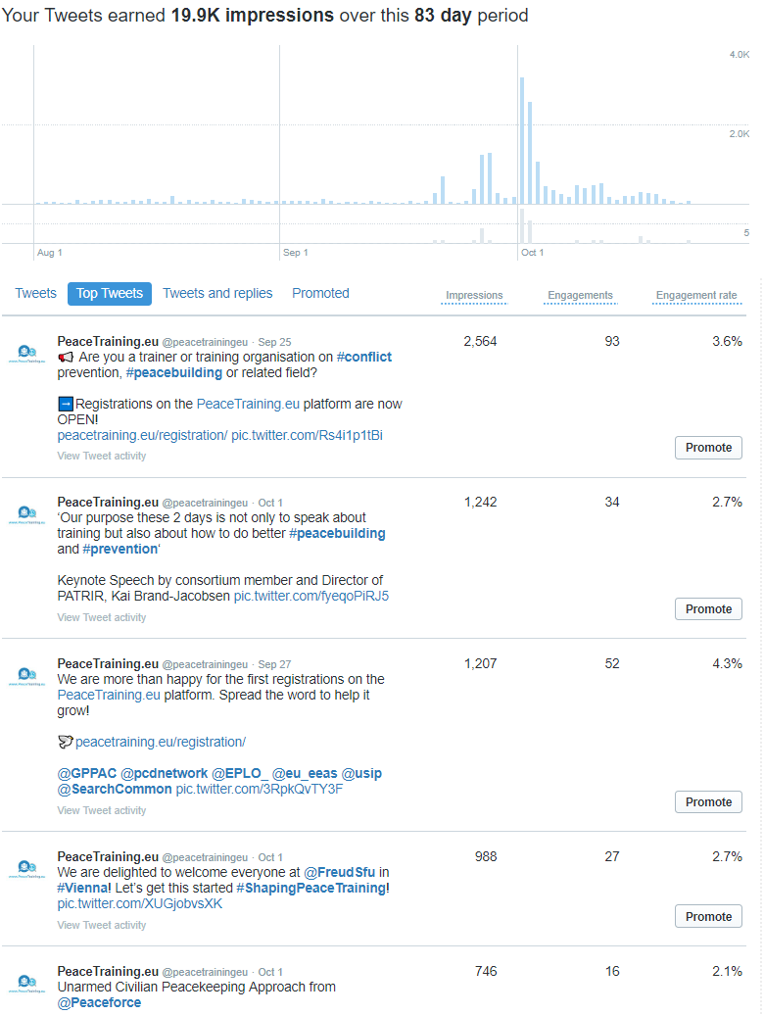
Figure 6: Tweet Activity Analytics from Twitter (August – October 2018)
Besides the rest of the content posted continuously, important content such as major publications, calls to register for the Vienna conference or the platform were highlighted on the top of the page. Figure 7 shows a screenshot of the PeaceTraining.eu Twitter channel, its highlight of the platform registrations and link to the Horizon 2020 programme channel.
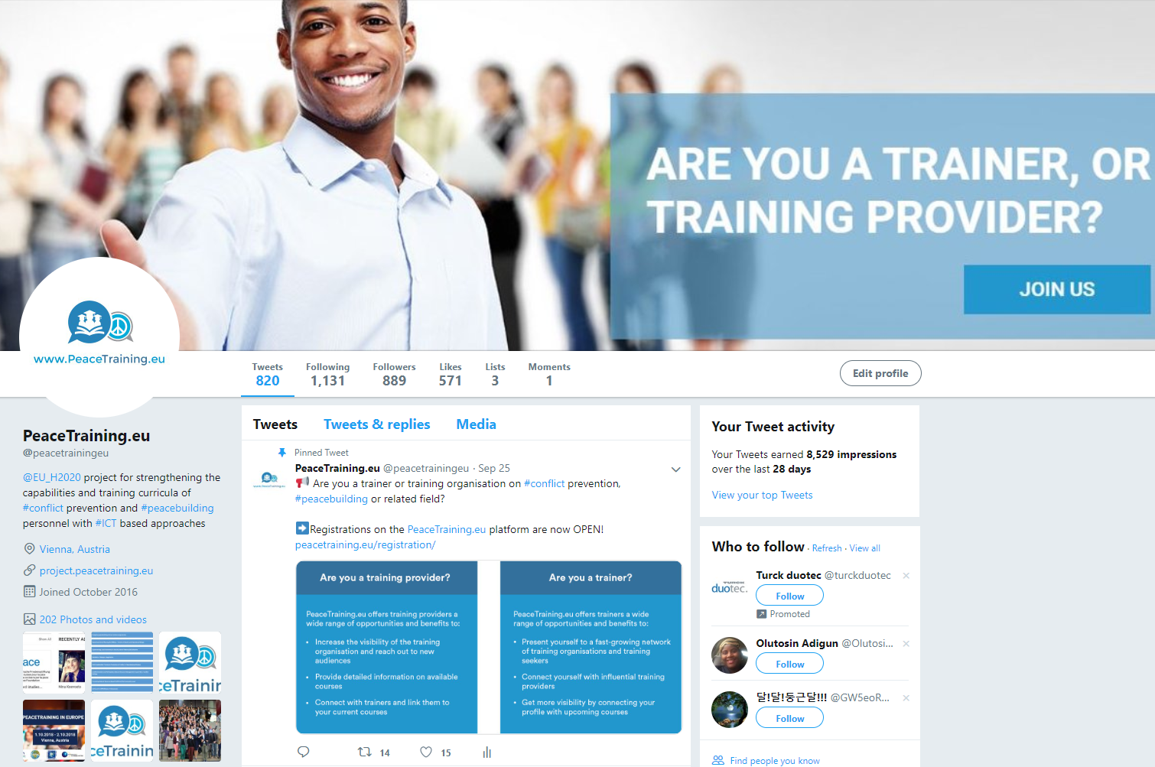

Figure 7: Overview Twitter Channel

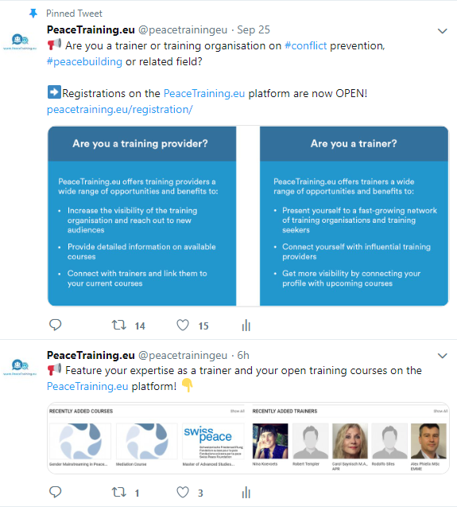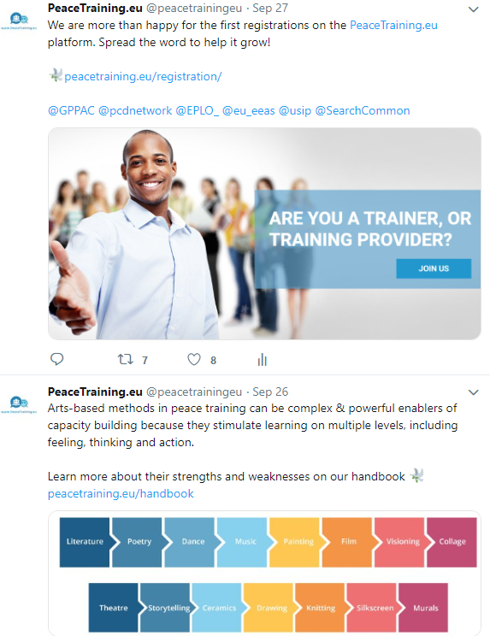

Figure 8: Examples of web platform promotion tweets

Facebook
Facebook is another social media platform successfully exploited for dissemination and communication activities. In comparison to Twitter, Facebook has no word limit to posts which allowed for broader messages to be shared and attract more audiences. Apparently, the community of practitioners is also keen on Facebook as reflected on the number of the followers reaching around 1100.
The content shared on Facebook was mainly coming from the consortium, but recently also included sharing of important knowledge from related pages. The following figures show some types of posts shared recently on Facebook, and content posted from external stakeholders:
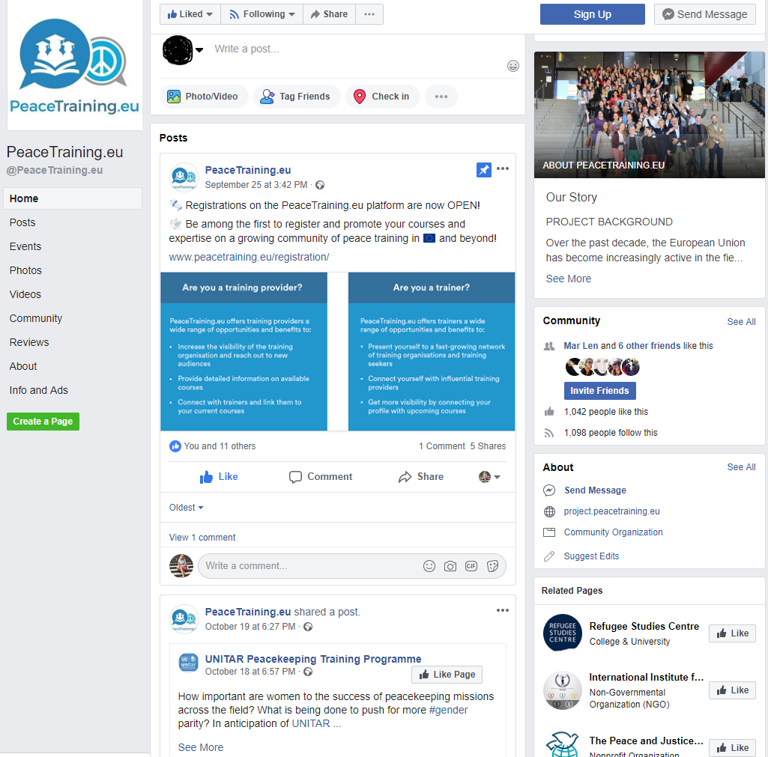
Figure 9: Example of Facebook Activities

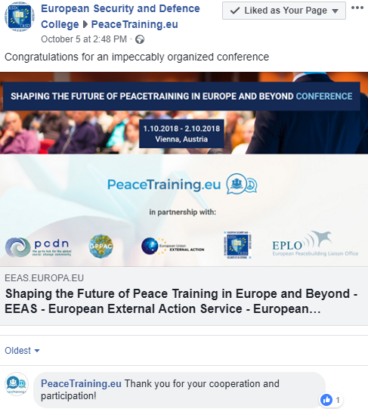
Figure 10: Example of Facebook Activities
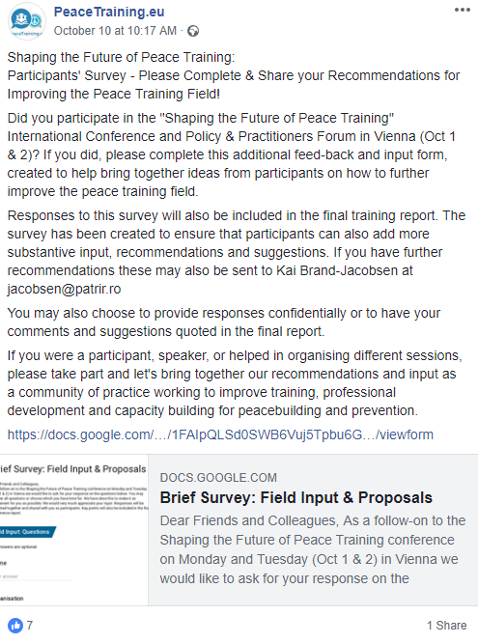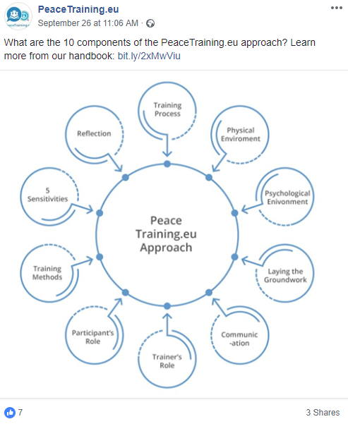
Figure 11: Example of Facebook Activities

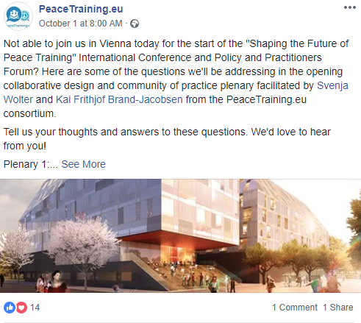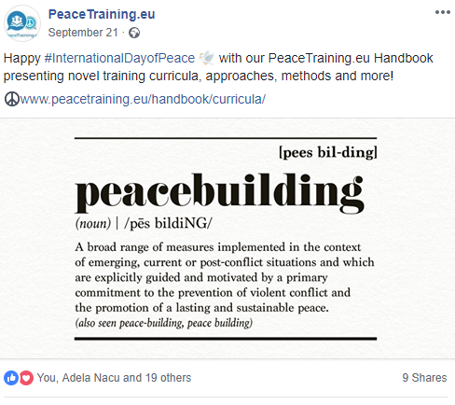
Figure 12: Example of Facebook Activities

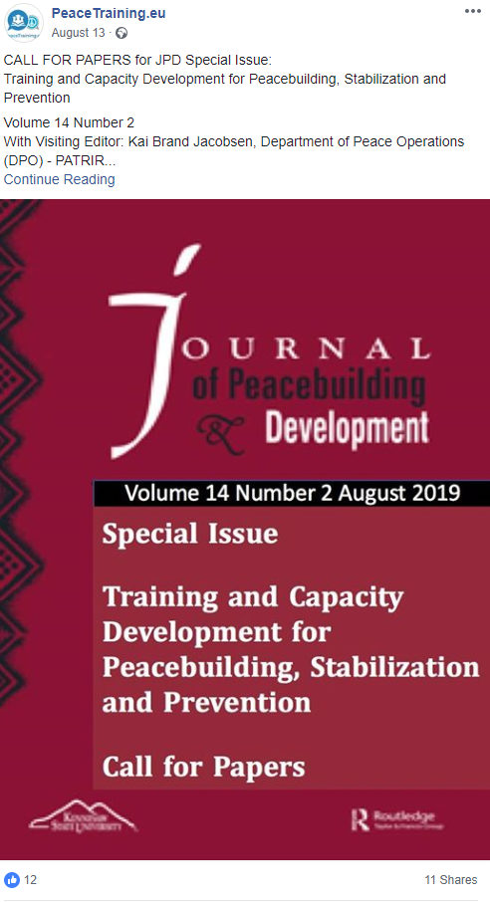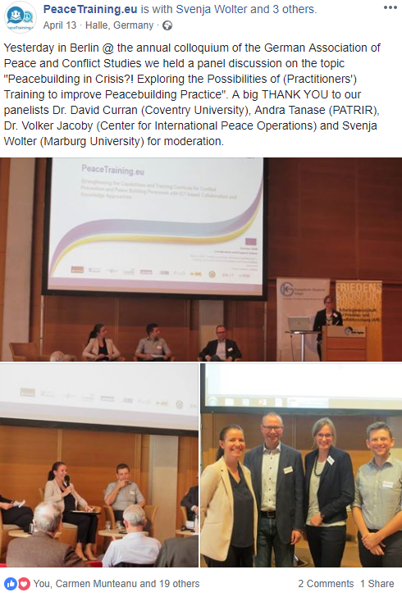
Figure 13: Example of Facebook Activities

LinkedIn
As presented in the previous report (Dissemination Package One), a LinkedIn page was also opened during the first period of the project to make use of an extended professional network for dissemination purposes. Contrary to the popularity on Facebook and Twitter, the official LinkedIn page could not reach a similar number of followers, in spite of a broad variety of content posted (consortium events, calls for registration, videos containing powerful messages for the field and other type of external knowledge).
The following types of content posted in the PeaceTraining.eu LinkedIn page:
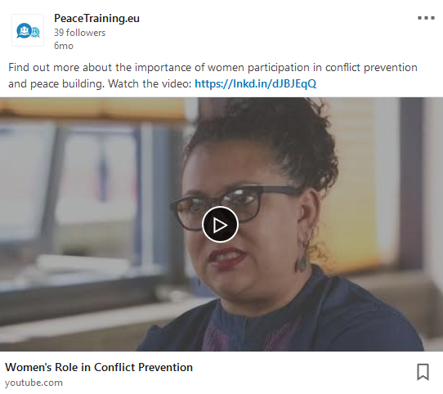
Figure 14: Example of LinkedIn Activities

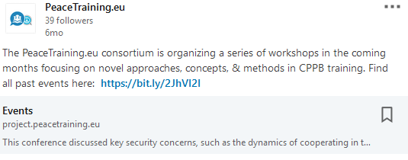
Figure 15: Example of LinkedIn Activities

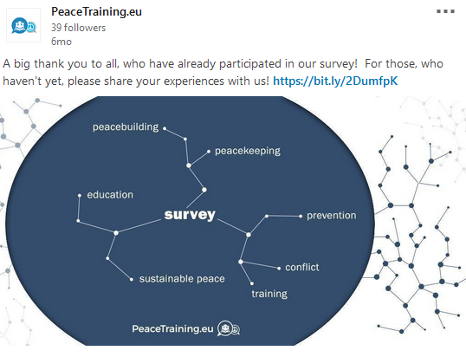
Figure 16: Example of LinkedIn Activities
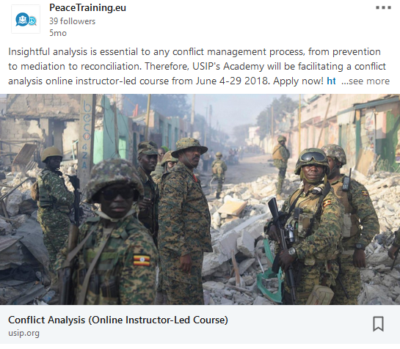
Figure 17: Example of LinkedIn Activities
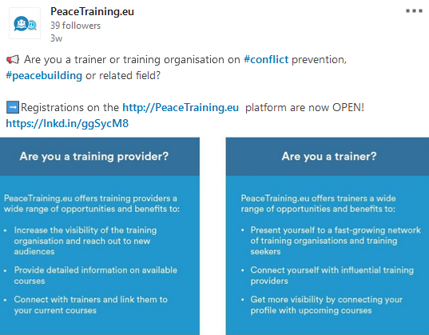
Figure 18: Example of LinkedIn Activities

Although the official project page was not so successful on this platform, consortium members made use of their own channels to raise awareness on key project activities and call for engagement of stakeholders. Due to their broad networks, the project could thus be well disseminated also on LinkedIn.
The following figures show examples of LinkedIn posts on social media by project partners:
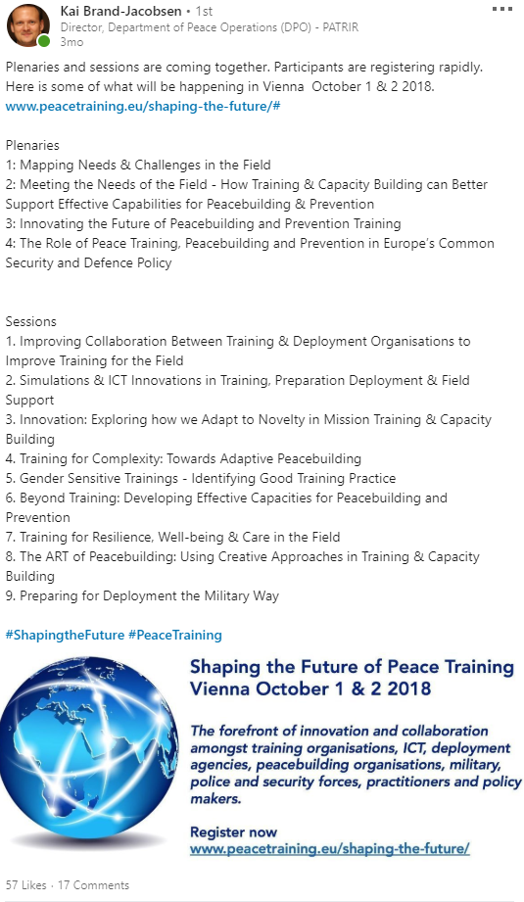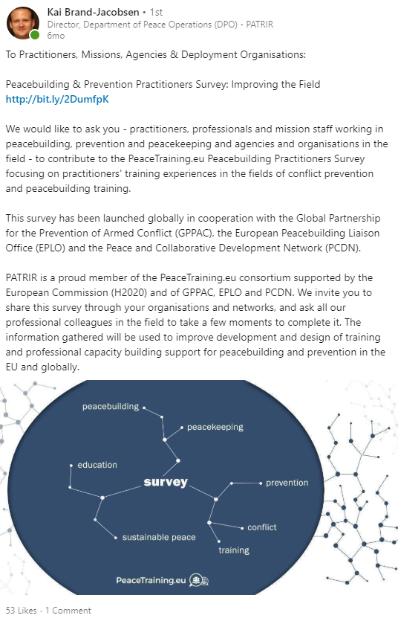
Figure 19: Example of LinkedIn Activities

YouTube
In addition to the social media channels owned in the first project period, a YouTube channel was created in during the second project period to upload all video materials created from the consortium activities. The first video uploaded on the YouTube channel is the recording of the workshop ‘Is mediation an appropriate tool for peace training?’ organised by BMI and ARGE in Vienna. A conference video was created and uploaded in the last month, putting together the main highlights of the final project conference. More video materials from sessions and workshops of the conference and a platform explaining and promoting video are being uploaded until the end of the last project month.
Figure 20: YouTube channel: Final Conference Video
Figure 21: YouTube channel: Final Conference Video

Newsletters
Newsletters summarising the main achievements and outputs of the project and relevant external content were also distributed regularly. Content of the newsletters was also chosen and agreed upon by the whole consortium, giving this type of communication a highest priority. The main types of content distributed through newsletters include results of the research and analysis part, the announcements and reports of the consortium events, attendance at external events, as well as news on important trainings, call for papers or major contributions in the field.
In total during the entire project duration eleven newsletters were sent, including a last one distrusted end of October summarising the main takeaways from the final conference in Vienna and giving impulses for the future steps towards increased cooperation within the practitioner community. The total number of subscribers, together with the conference attendants reached nearly 385 subscribers.
All sent newsletters can be found at the project website (project.peacetraining.eu/newsletter/). Examples of the recent newsletters are also provided below:
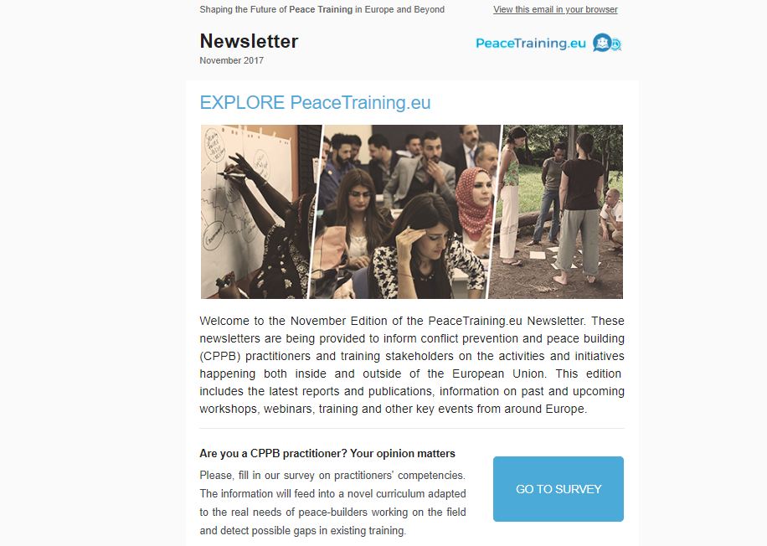
Figure 22: Peacetraining.eu Newsletter Examples

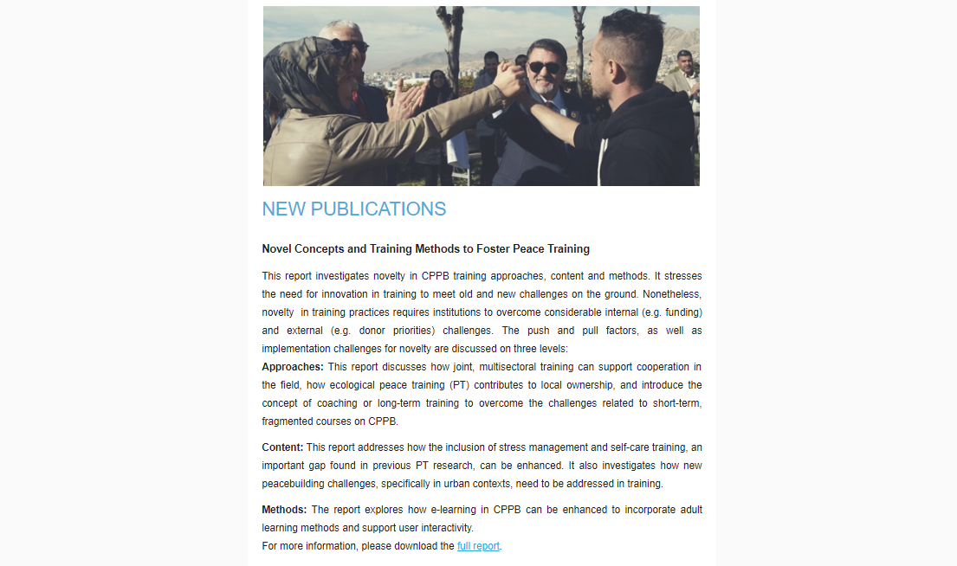
Figure 23: Peacetraining.eu Newsletter Examples

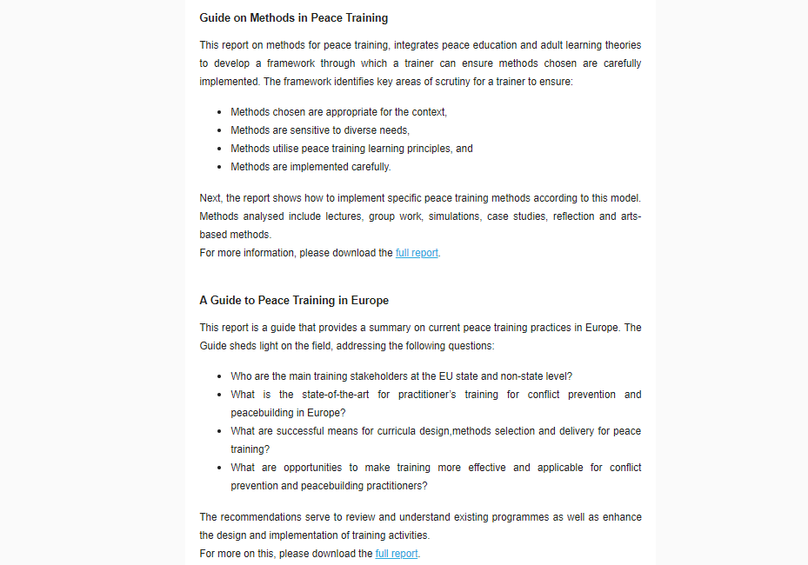
Figure 24: Peacetraining.eu Newsletter Examples

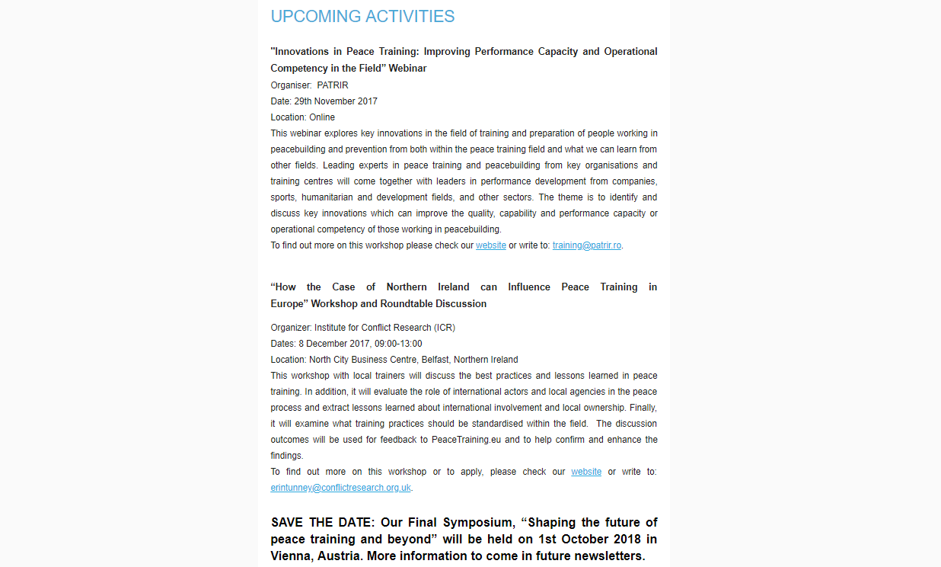
Figure 25: Peacetraining.eu Newsletter Examples

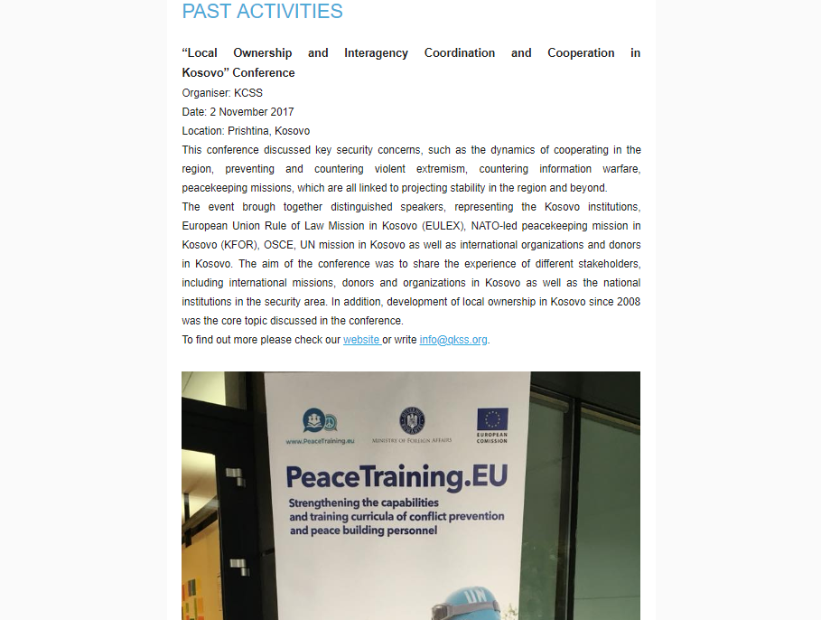
Figure 26: Peacetraining.eu Newsletter Examples

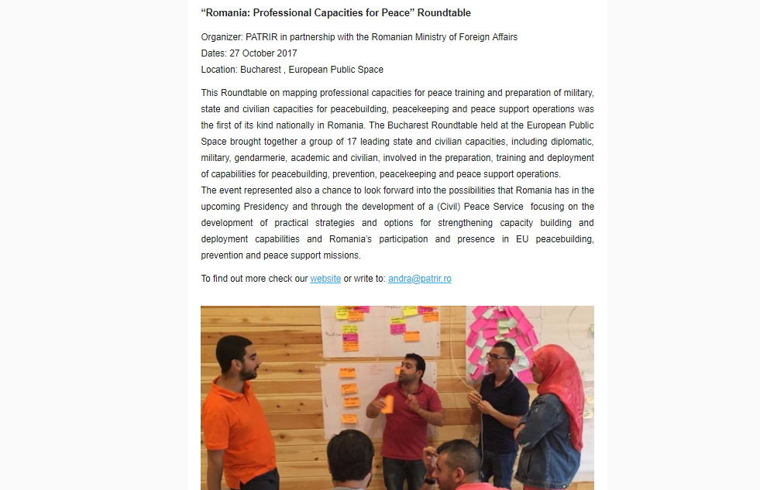
Figure 27: Peacetraining.eu Newsletter Examples
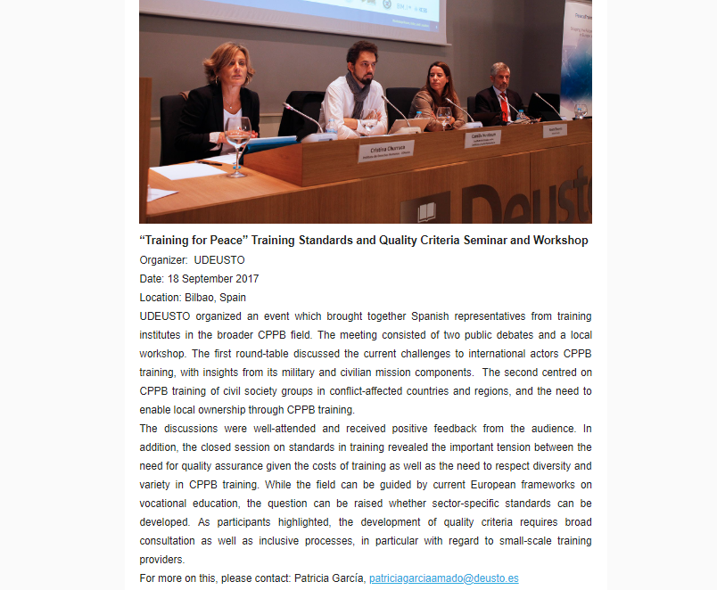
Figure 28: Peacetraining.eu Newsletter Examples

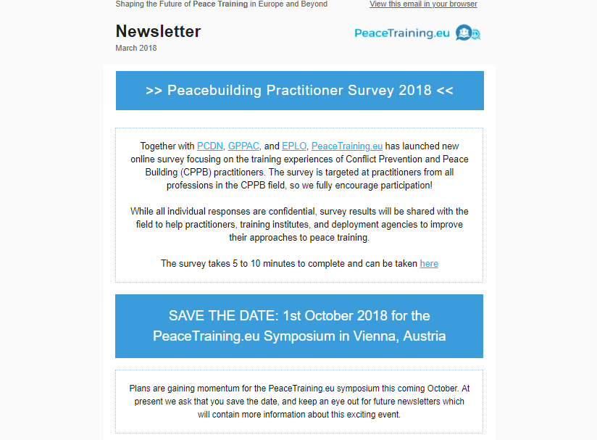
Figure 29: Peacetraining.eu Newsletter Examples

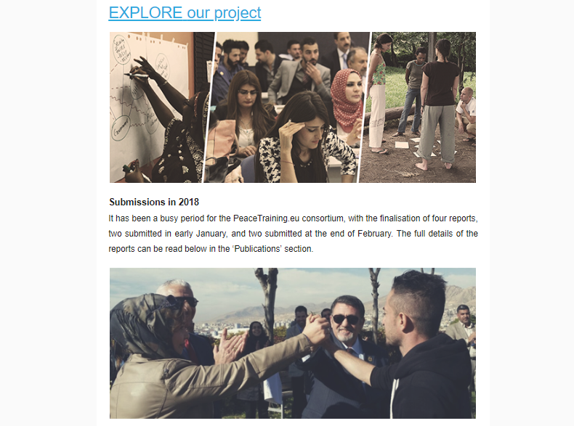
Figure 30: Peacetraining.eu Newsletter Examples

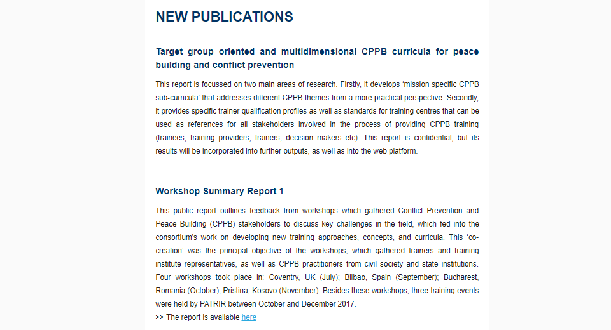
Figure 31: Peacetraining.eu Newsletter Examples

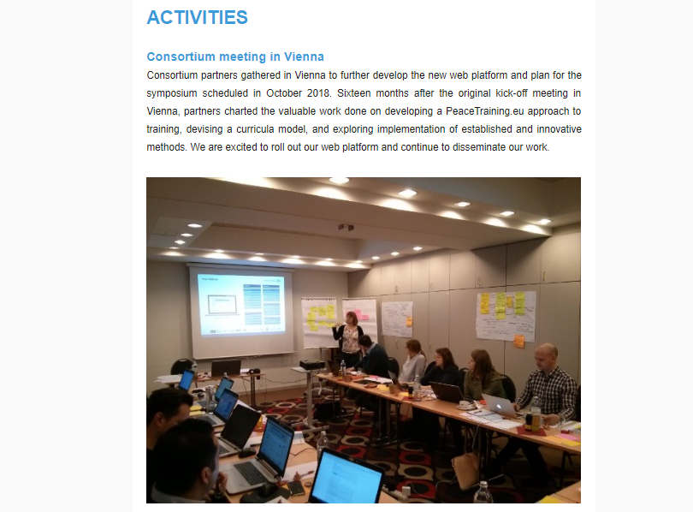
Figure 32: Peacetraining.eu Newsletter Examples

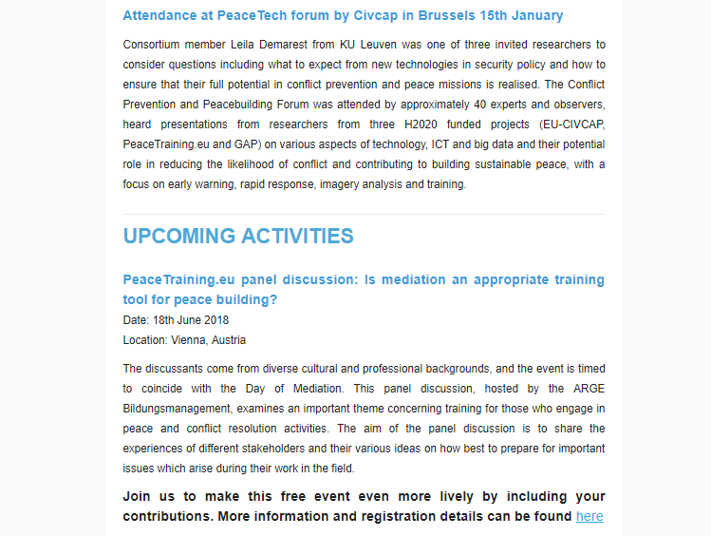
Figure 33: Peacetraining.eu Newsletter Examples
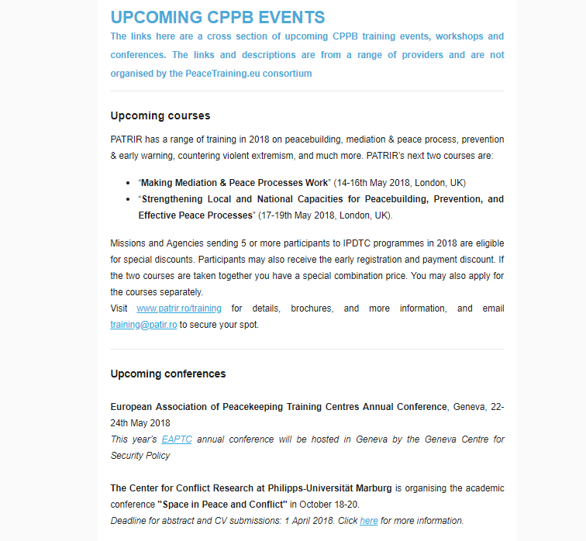
Figure 34: Peacetraining.eu Newsletter Examples

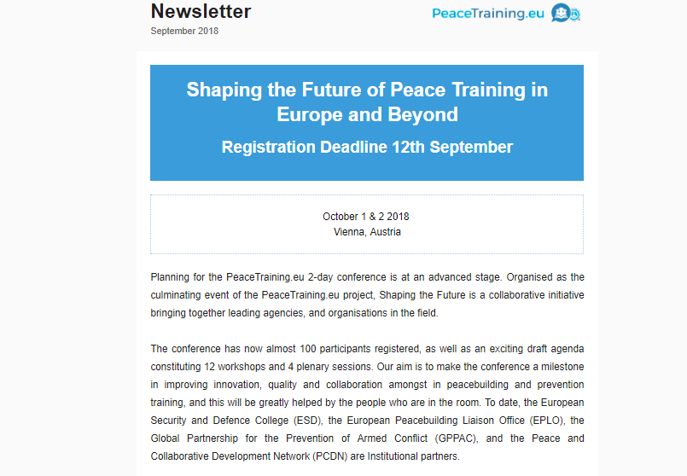
Figure 35: Peacetraining.eu Newsletter Examples

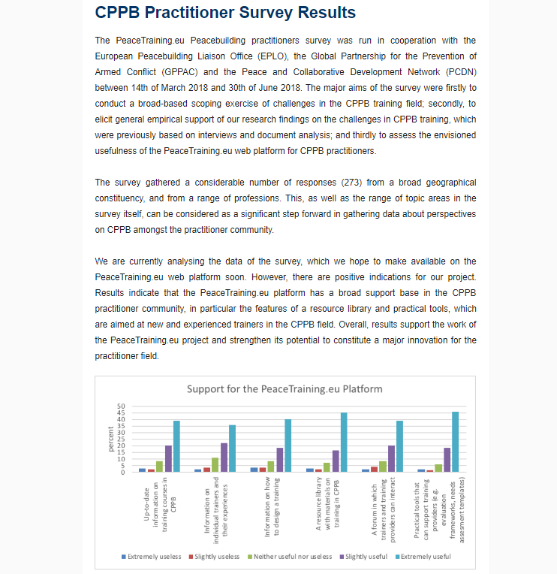
Figure 36: Peacetraining.eu Newsletter Examples

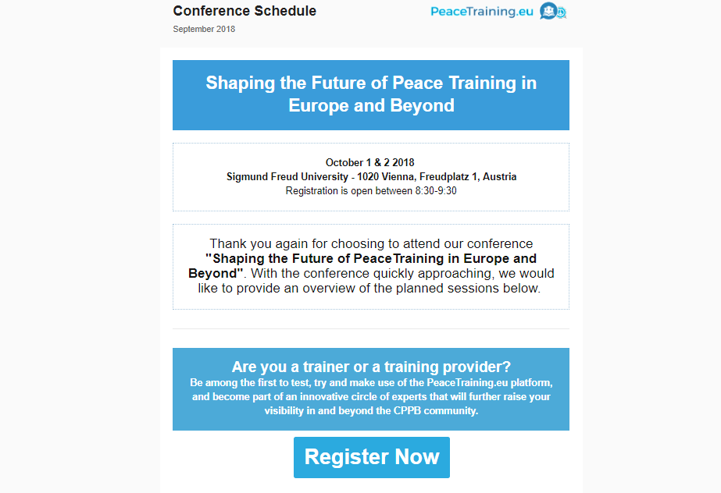
Figure 37: Peacetraining.eu Newsletter Examples

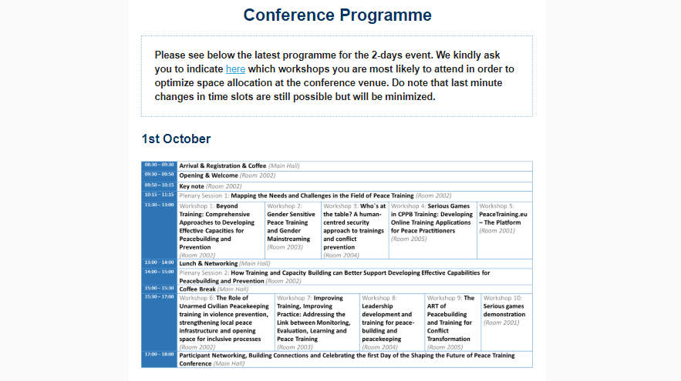
Figure 38: Peacetraining.eu Newsletter Examples
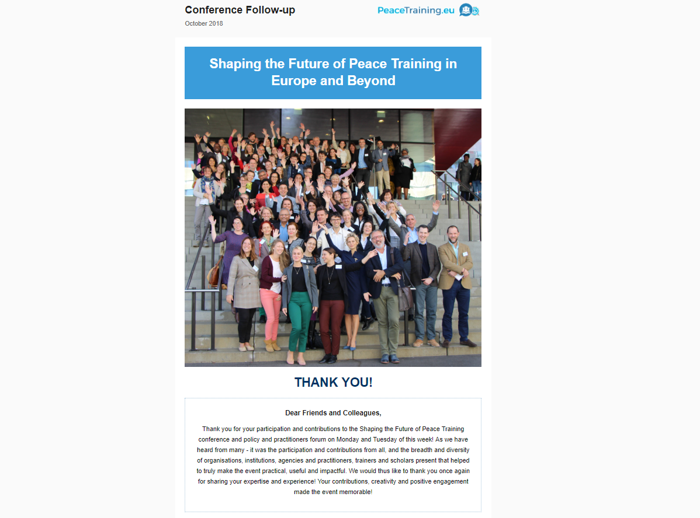
Figure 39: Peacetraining.eu Newsletter Examples

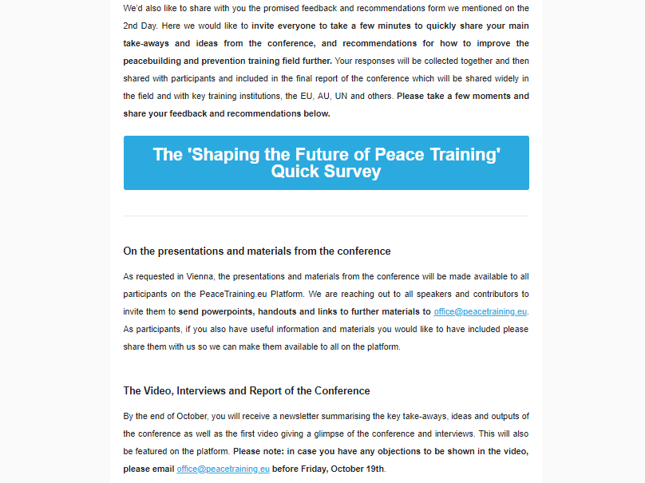
Figure 40: Peacetraining.eu Newsletter Examples

Project Website and PeaceTraining.eu platform
During the first half of the project, The PeaceTraining.eu project website was the primary source of information for all stakeholder groups, including information on the consortium, project objectives, links to practitioner surveys, event announcements, newsletters, links and descriptions to related projects, and clearly the reference to EU funding.
As PeaceTraining.eu web platform was developed in the second half of the project, it also took the primary role for dissemination of all project activities. After the platform deployment, the project website included a reference to the web platform, however its main sections (reports, events, newsletters continued to be updated.
The following pictures show some recent screenshots from the project website.
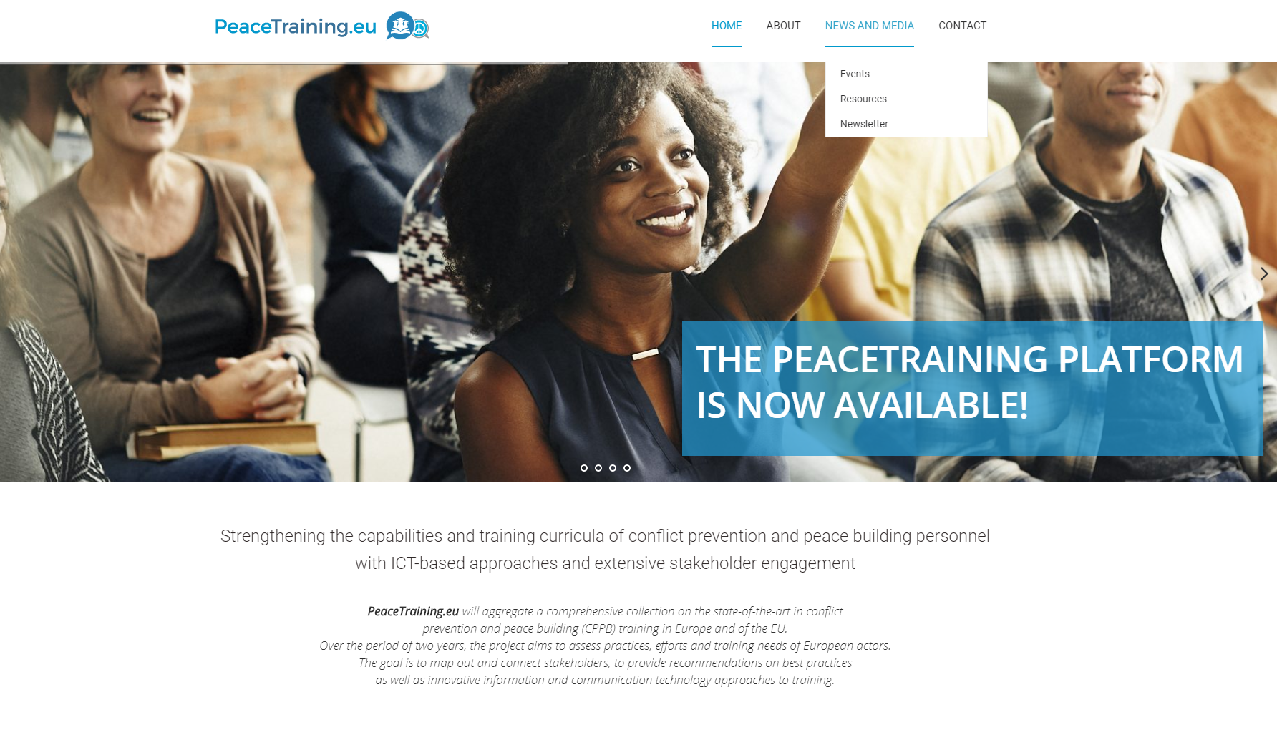
Figure 41: Project website: Homepage 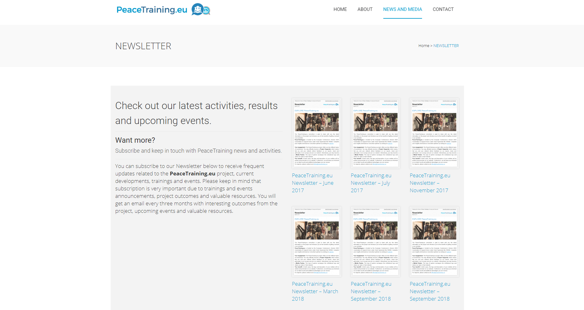
Figure 42: Project website: Newsletters

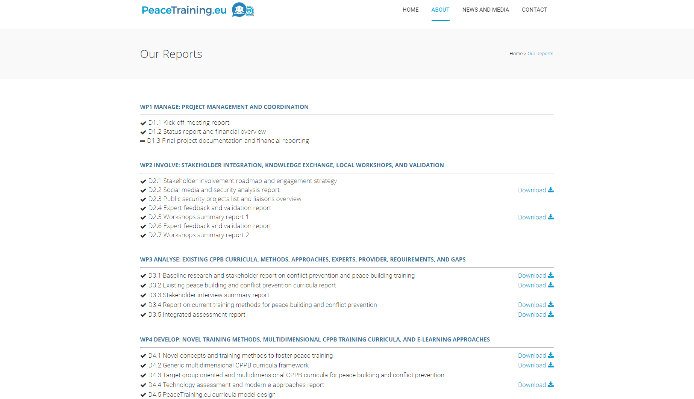
Figure 43: Project Website: Reports

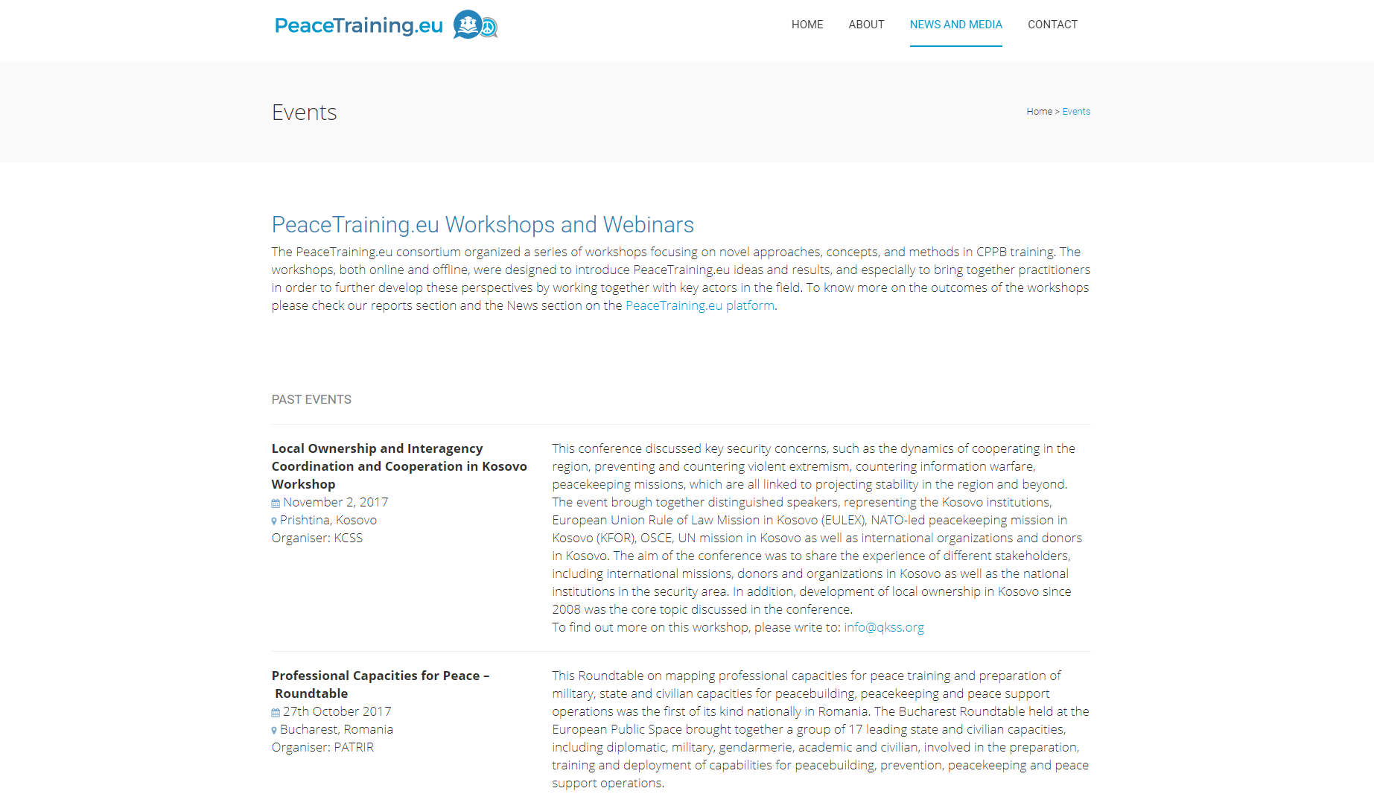
Figure 44: Project Website: Events
As previously mentioned, in the second half of the project, the web platform became the main dissemination hub on the project, containing not only the registration forms and repositories of the training providers, individual trainers etc. but also materials, announcements and news from the project activities.
Conference
One of the main uses of the platform for dissemination purposes included the announcement and registration from for the final project conference ‘Shaping the Future of Peace Training in Europe and Beyond’.
The following figures show how the ‘Conference’ section on the platform.
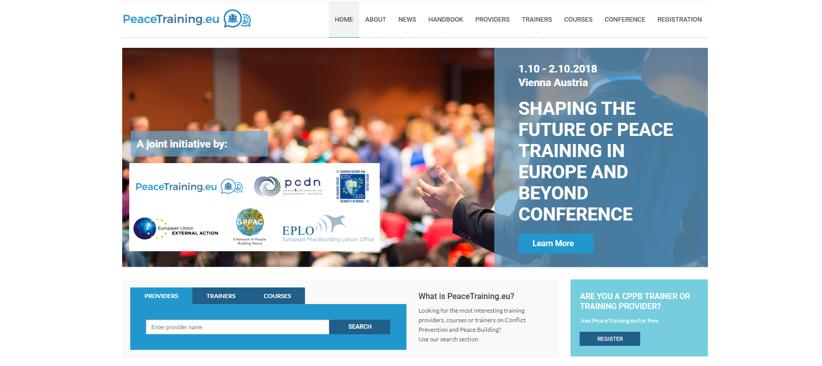
Figure 45: PeaceTraining.eu Web platform: Conference Banner

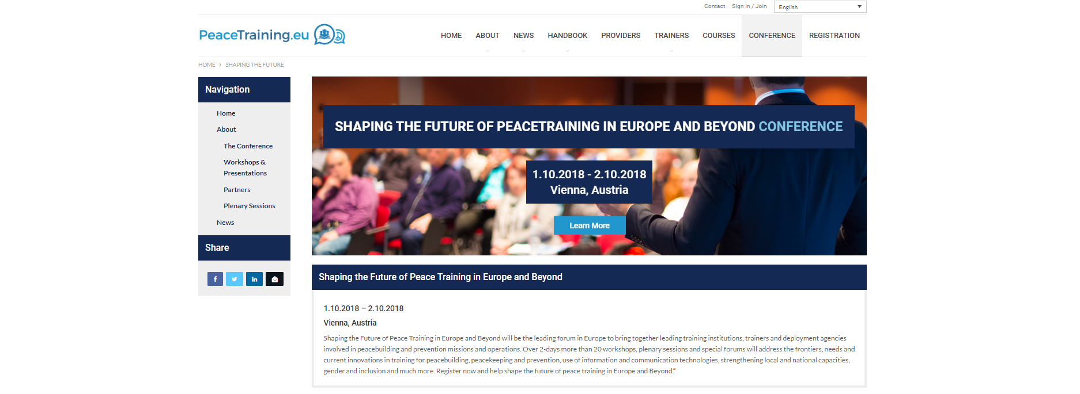
Figure 46: PeaceTraining.eu Web platform: Conference Section

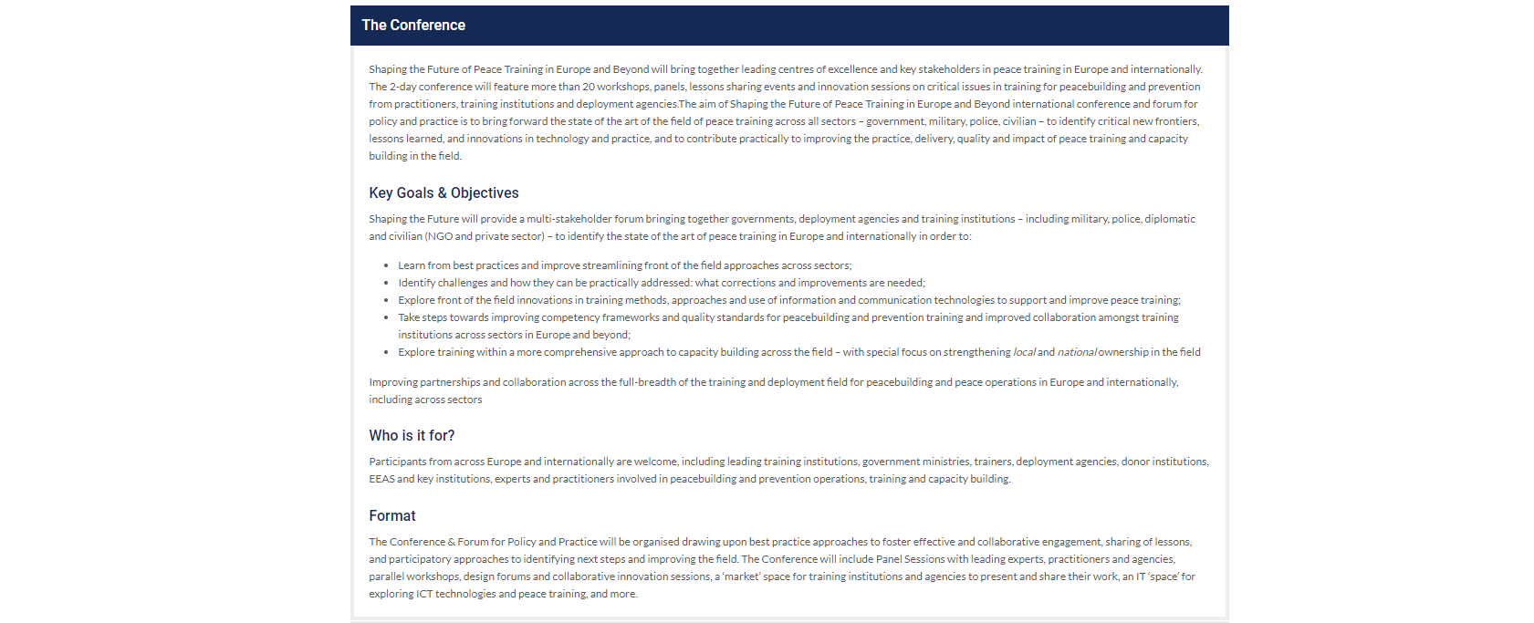
Figure 47: PeaceTraining.eu Web platform: Conference Section
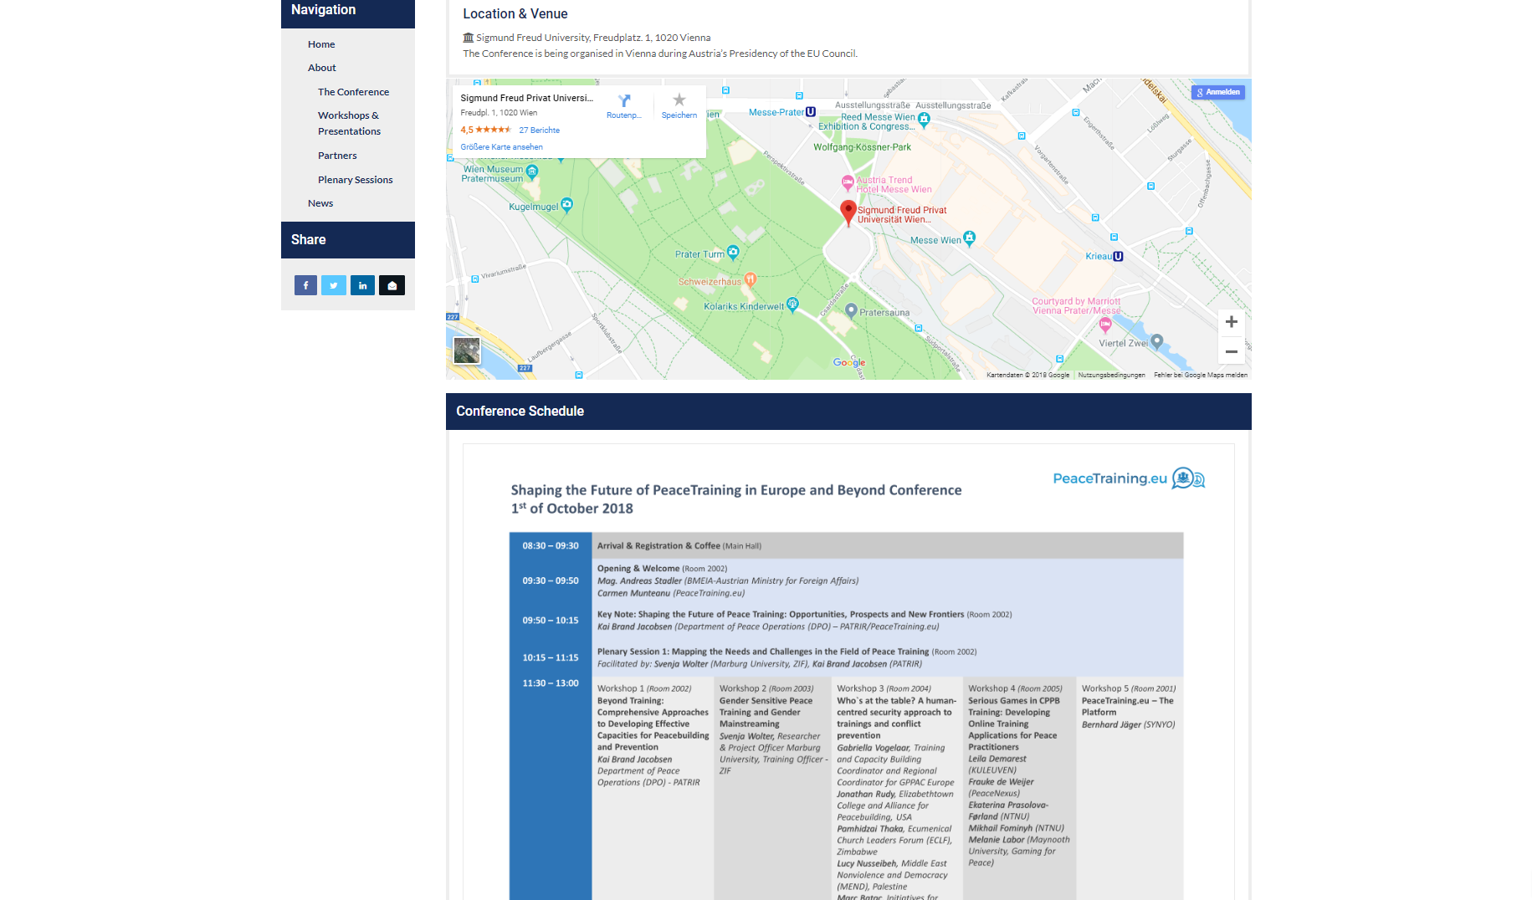
Figure 48: PeaceTraining.eu Web platform: Conference Section
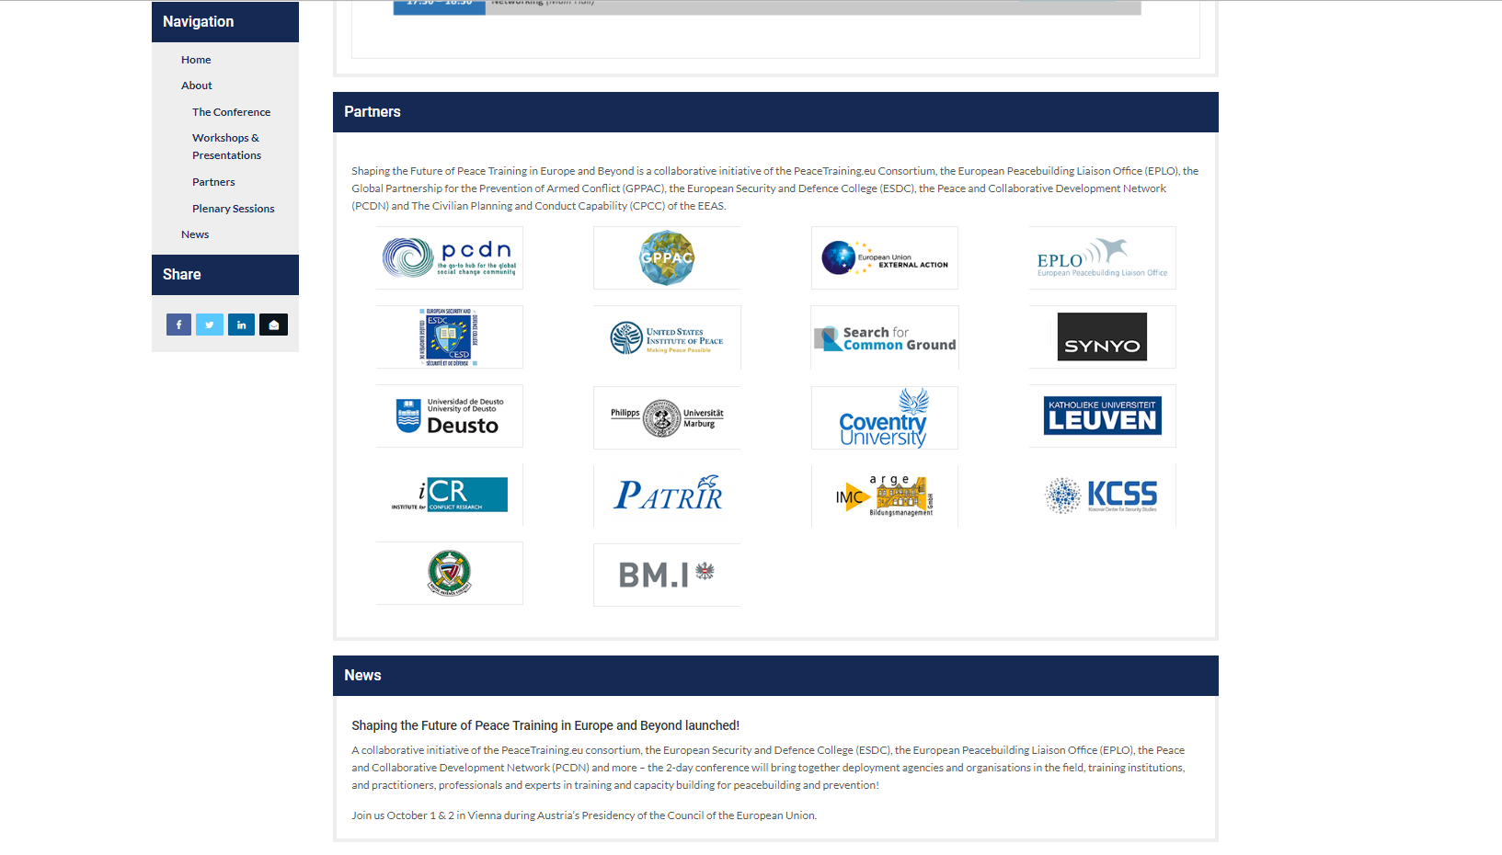
Figure 49: PeaceTraining.eu Web platform: Conference Section
Handbook
Another valuable section that is included on the project website and serves the purpose of dissemination of overall project results is the Handbook section. The PeaceTraining.eu handbook includes a refurbished and rewritten version of the PeaceTraining.eu curricula compendium, coming as a user-friendly package of the main findings from the project. More details on the scope of the Handbook is provided by other reports. The following figures show how it is featured on the web platform. Besides English, the Handbook is also offered in French, German, and Spanish.
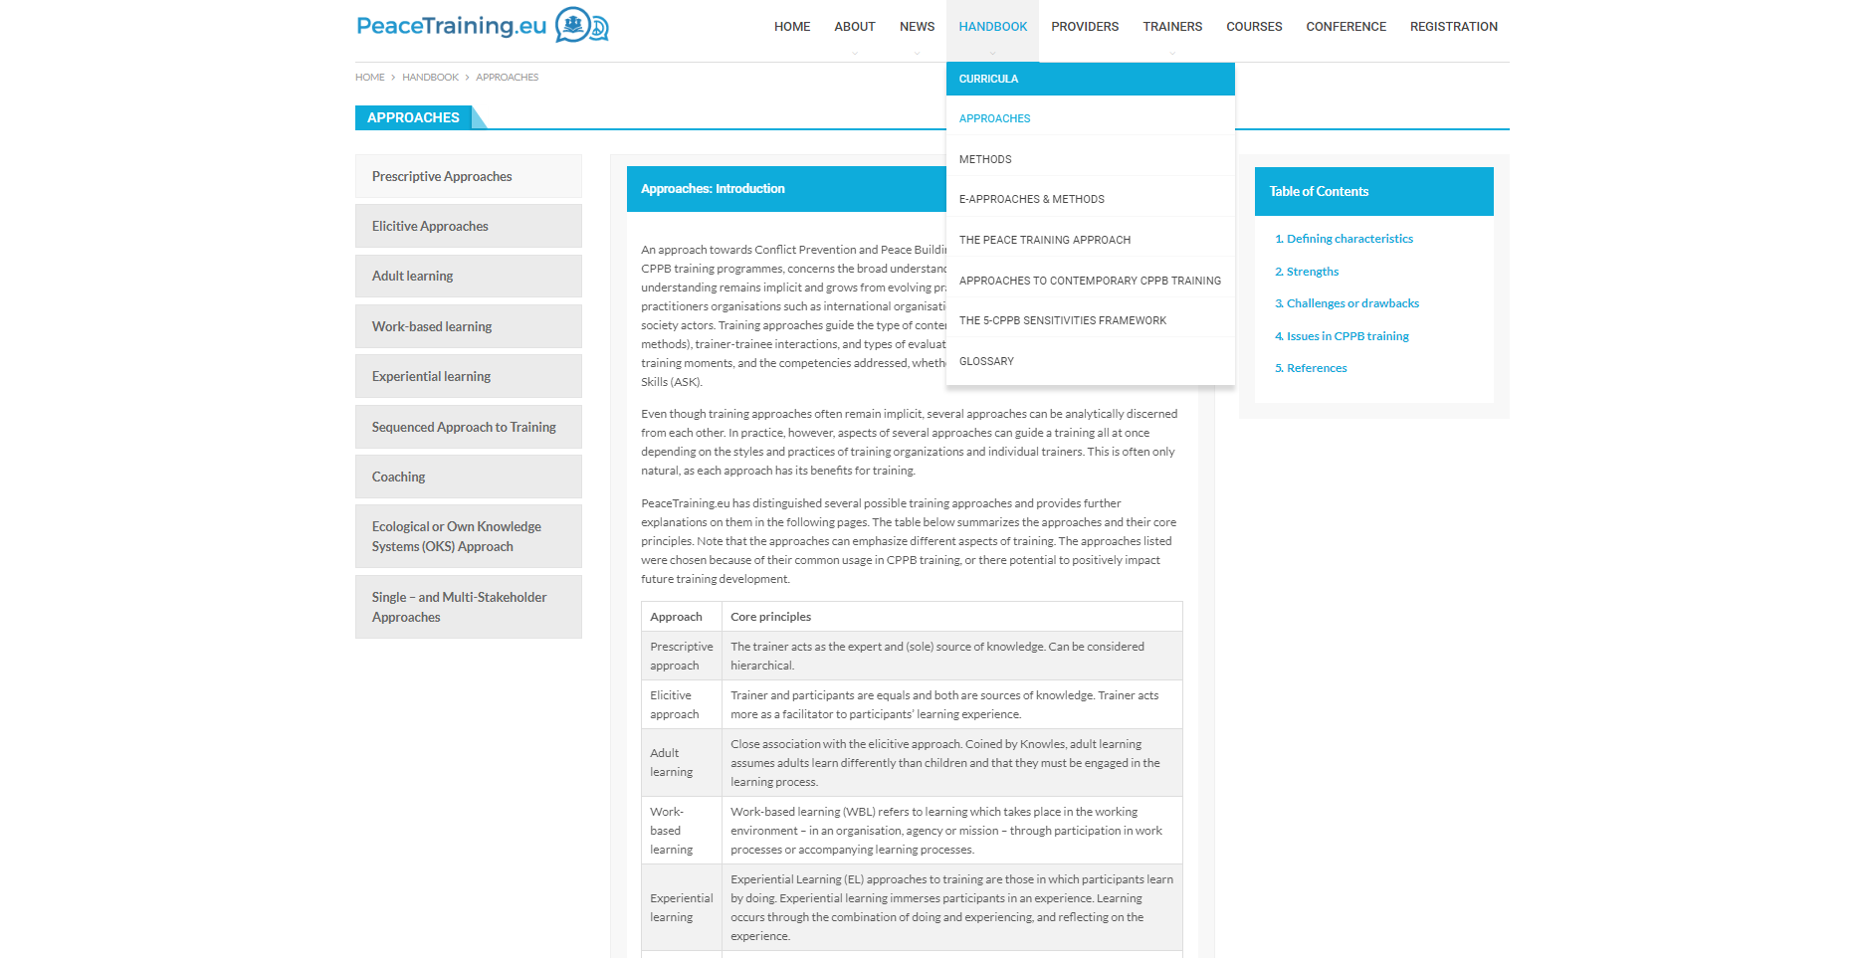
Figure 50: PeaceTraining.eu Web platform: Handbook
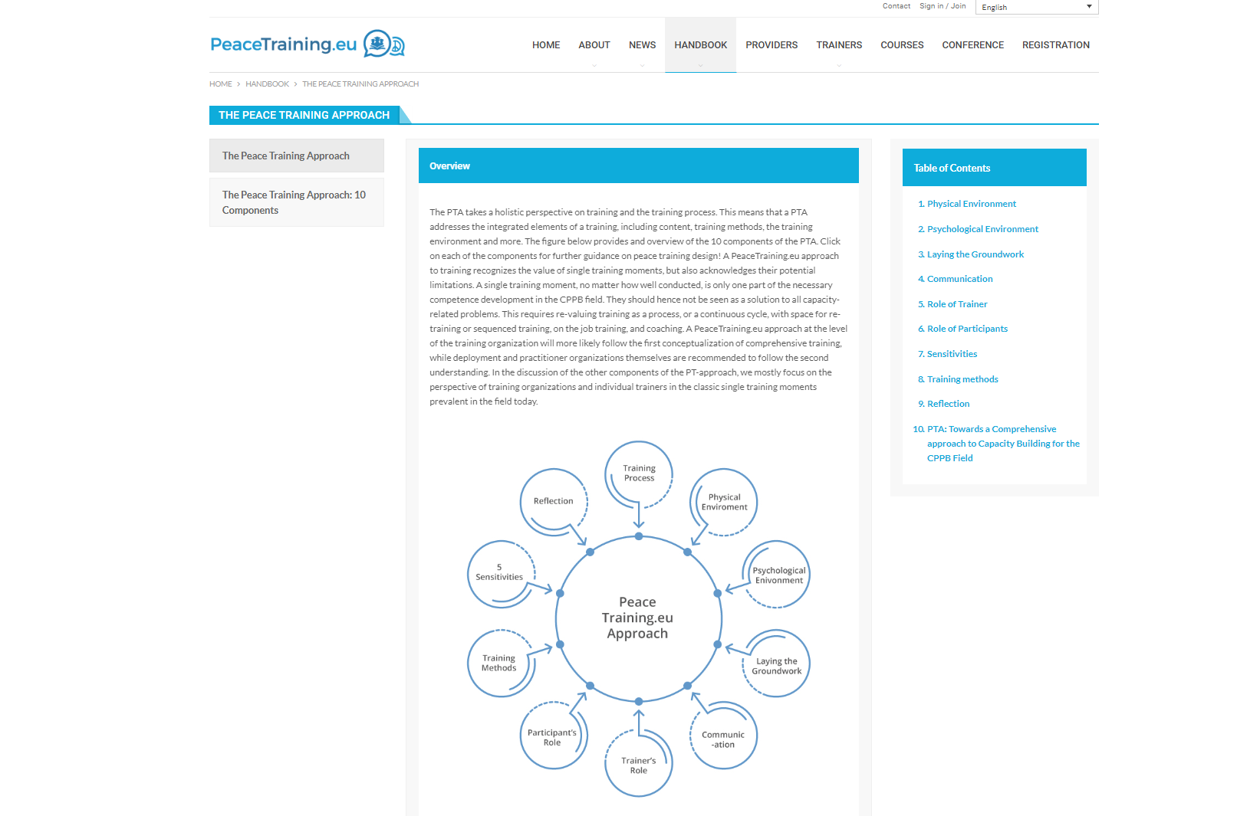
Figure 51: PeaceTraining.eu Web platform: Handbook

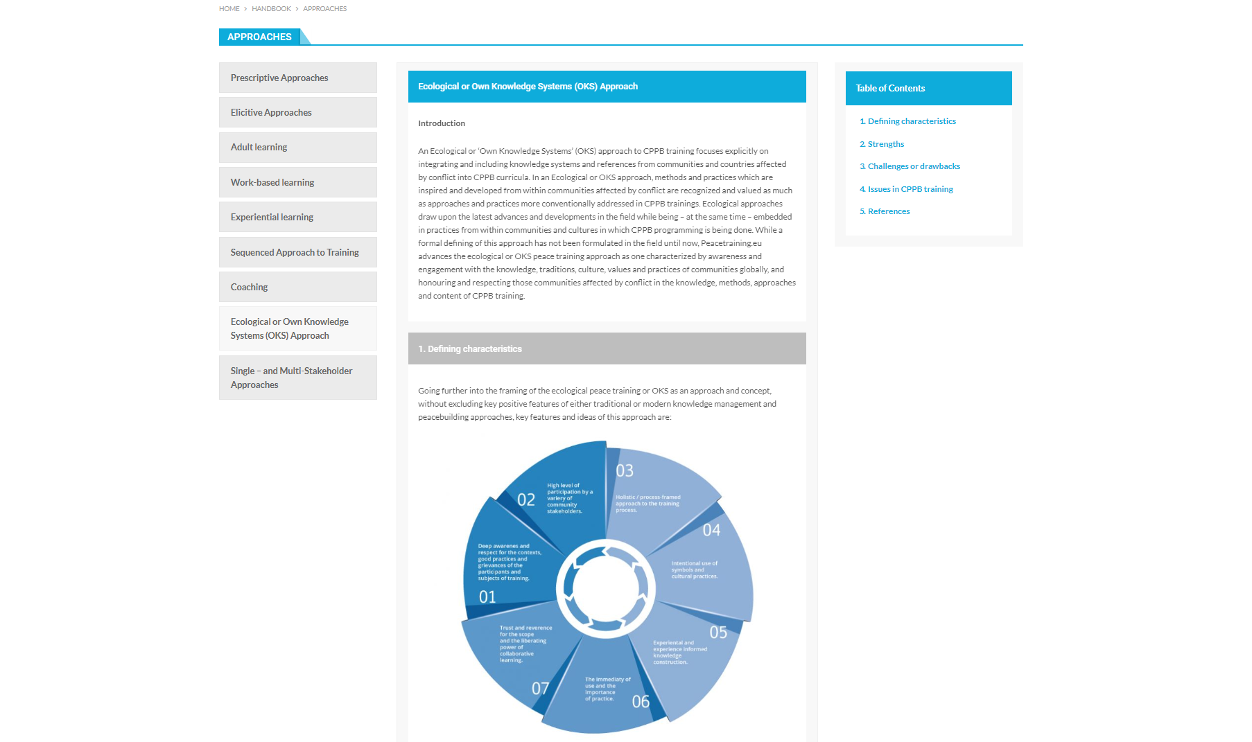
Figure 52: PeaceTraining.eu Web platform: Handbook

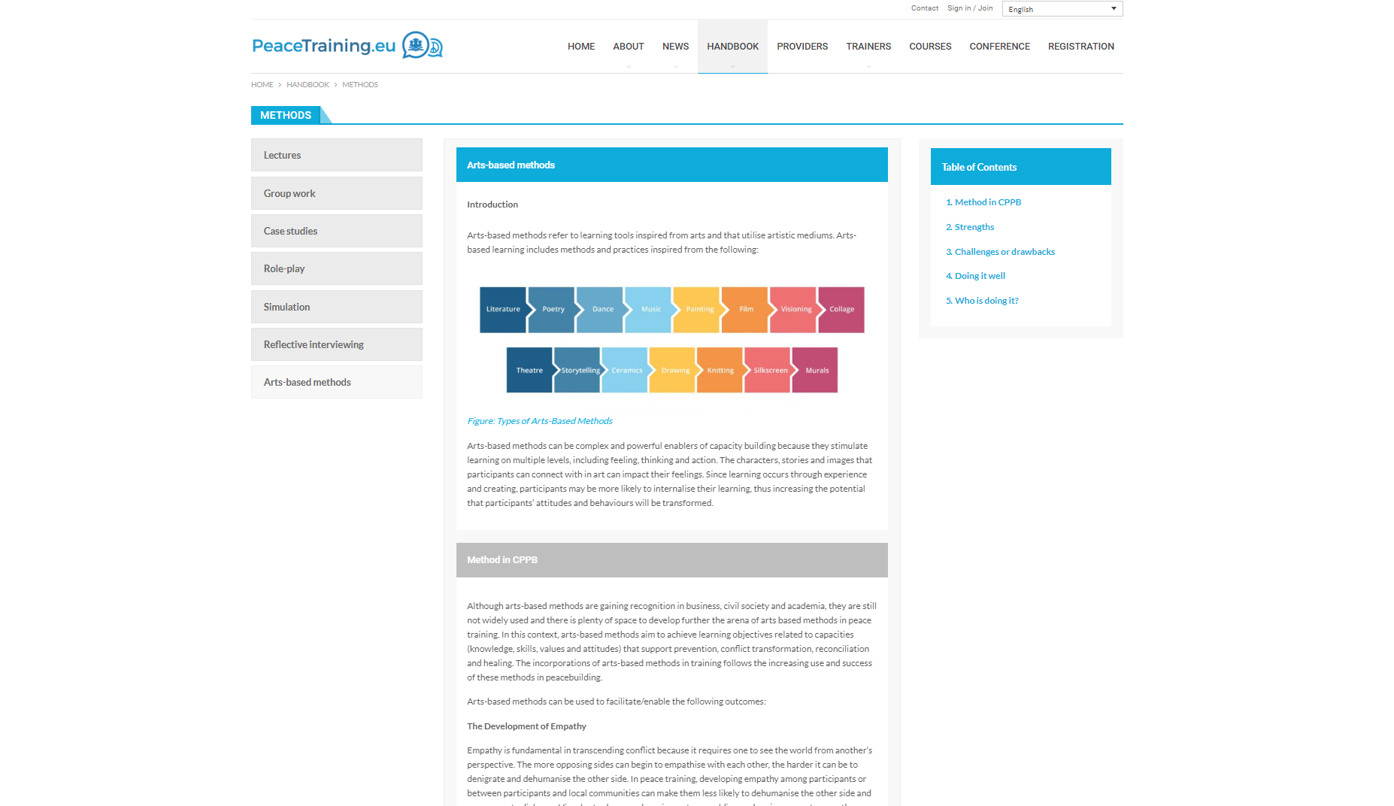
Figure 53: PeaceTraining.eu Web platform: Handbook

News
The last section of the platform serving the dissemination purposes is the News section. In this category all project-related news such as project publications, project workshops, events participation, conference reports etc. were advertised. Besides the project own activities and outputs, we used the News section to also feature important announcement for the field such as upcoming events from related organisations and consortia that are relevant to the field, news related to training etc. the following figures show some of the news examples from the web platform.
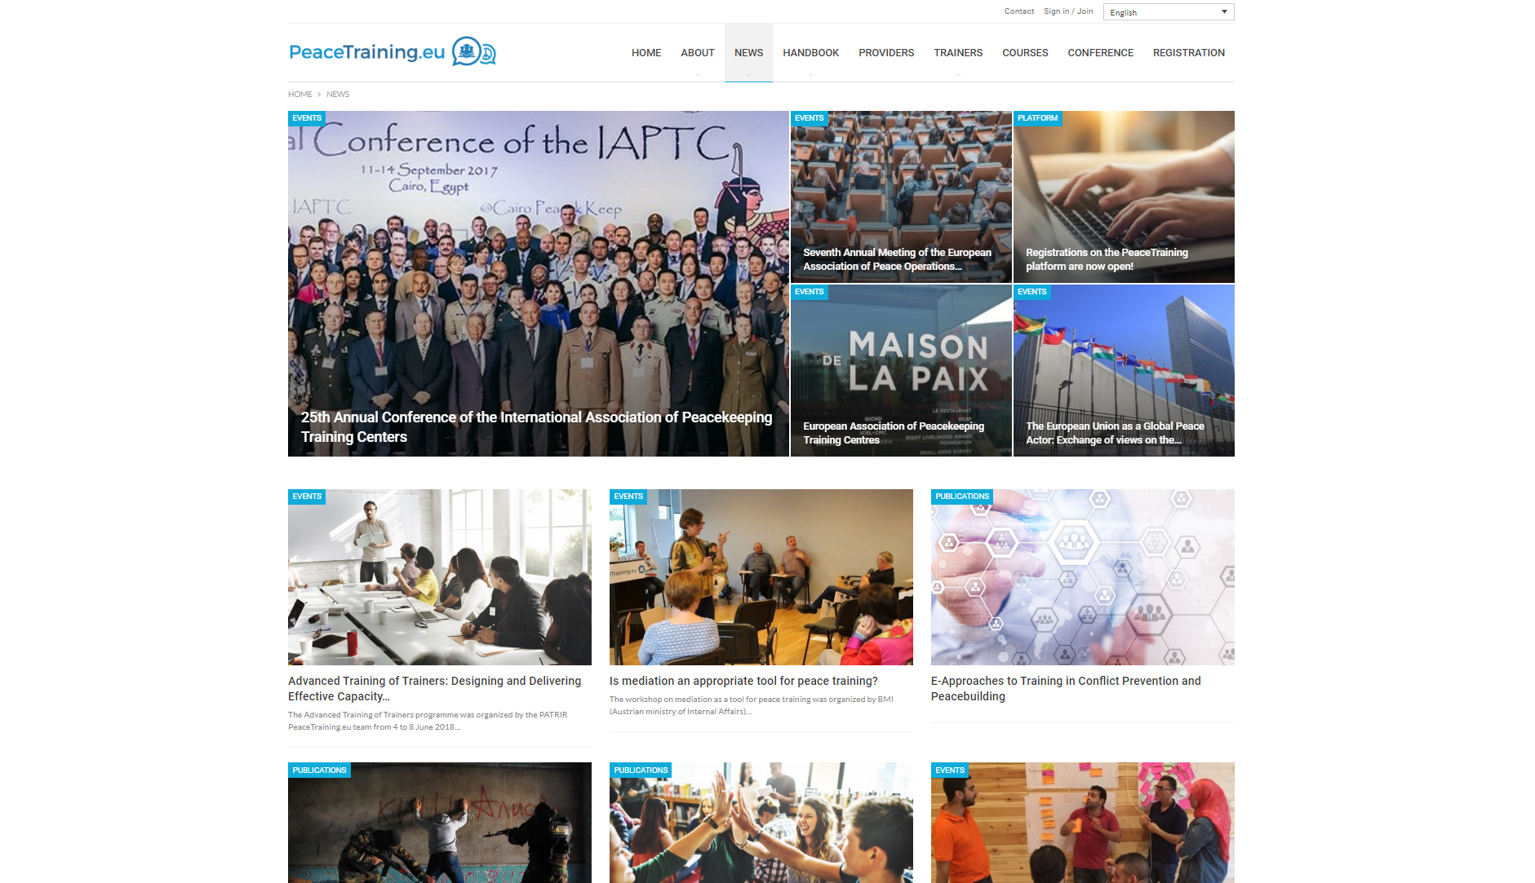
Figure 54: PeaceTraining.eu Web platform: News

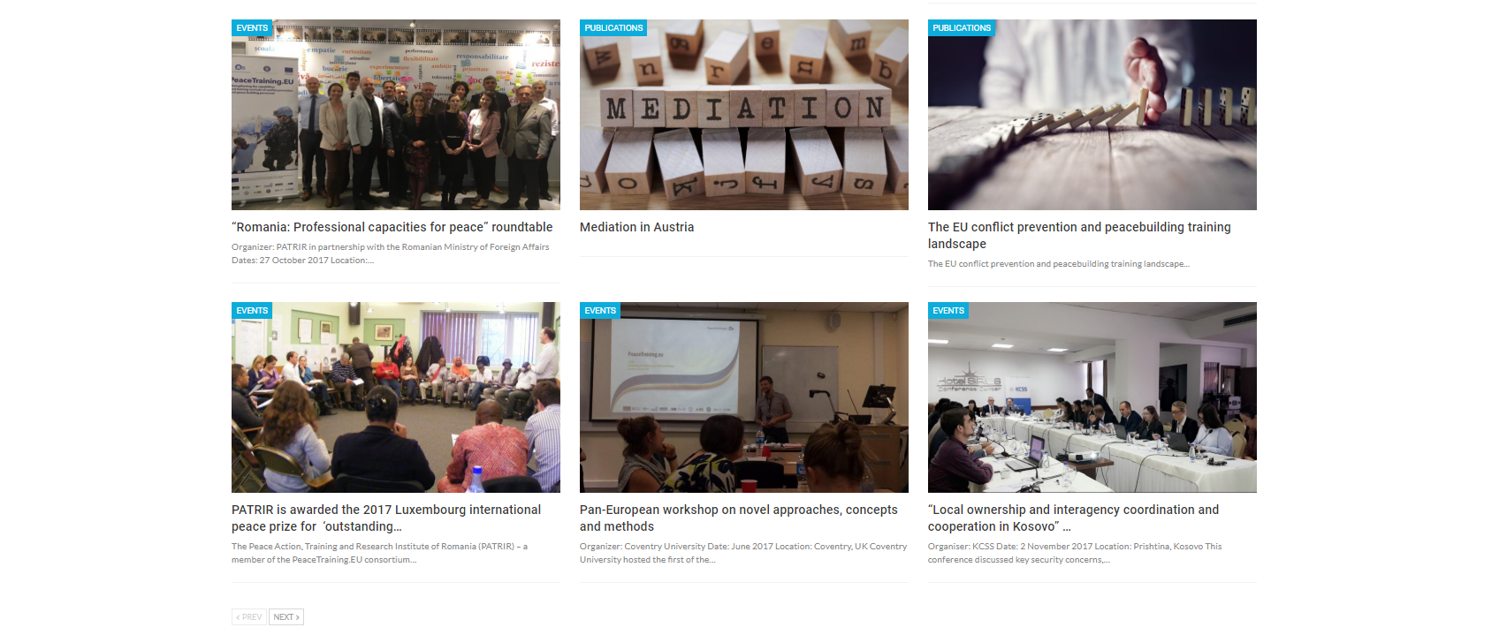
Figure 55: PeaceTraining.eu Web platform: News

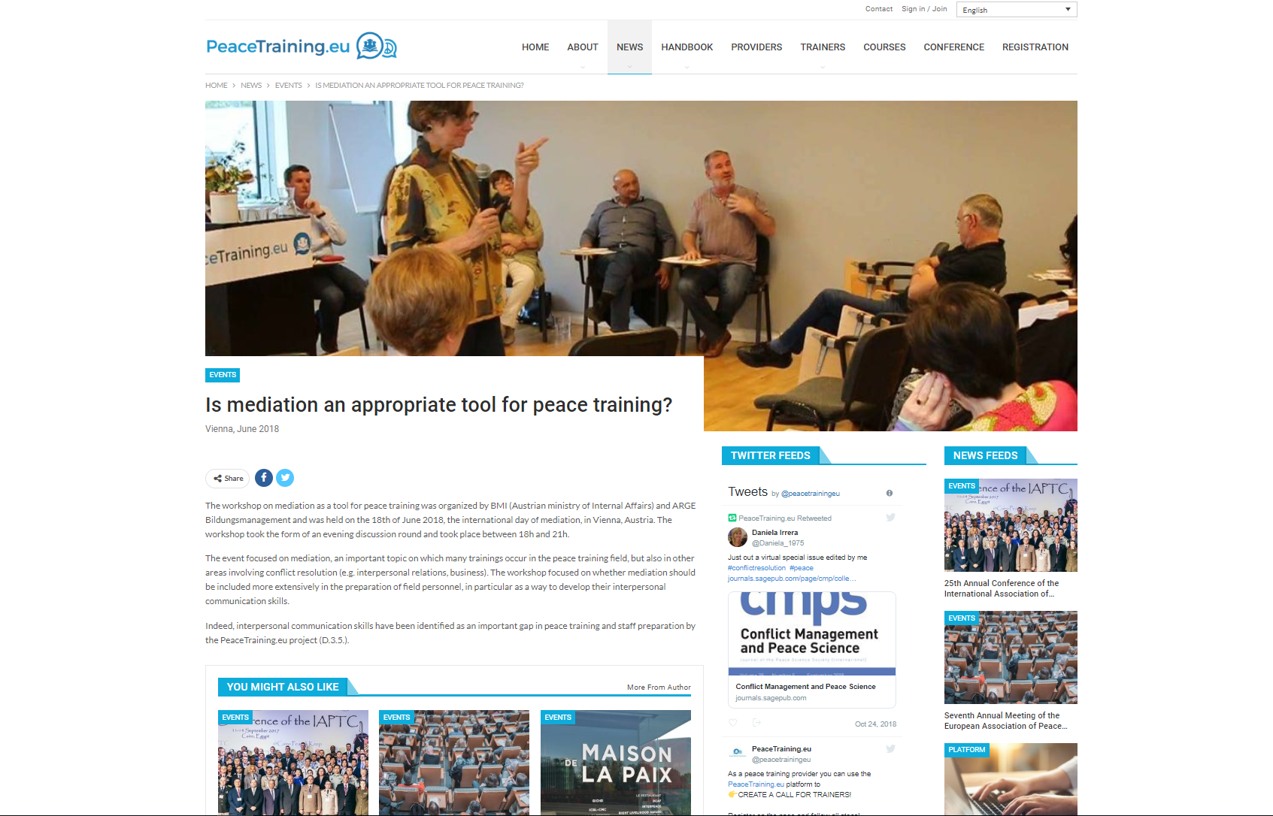
Figure 56: PeaceTraining.eu Web platform: News

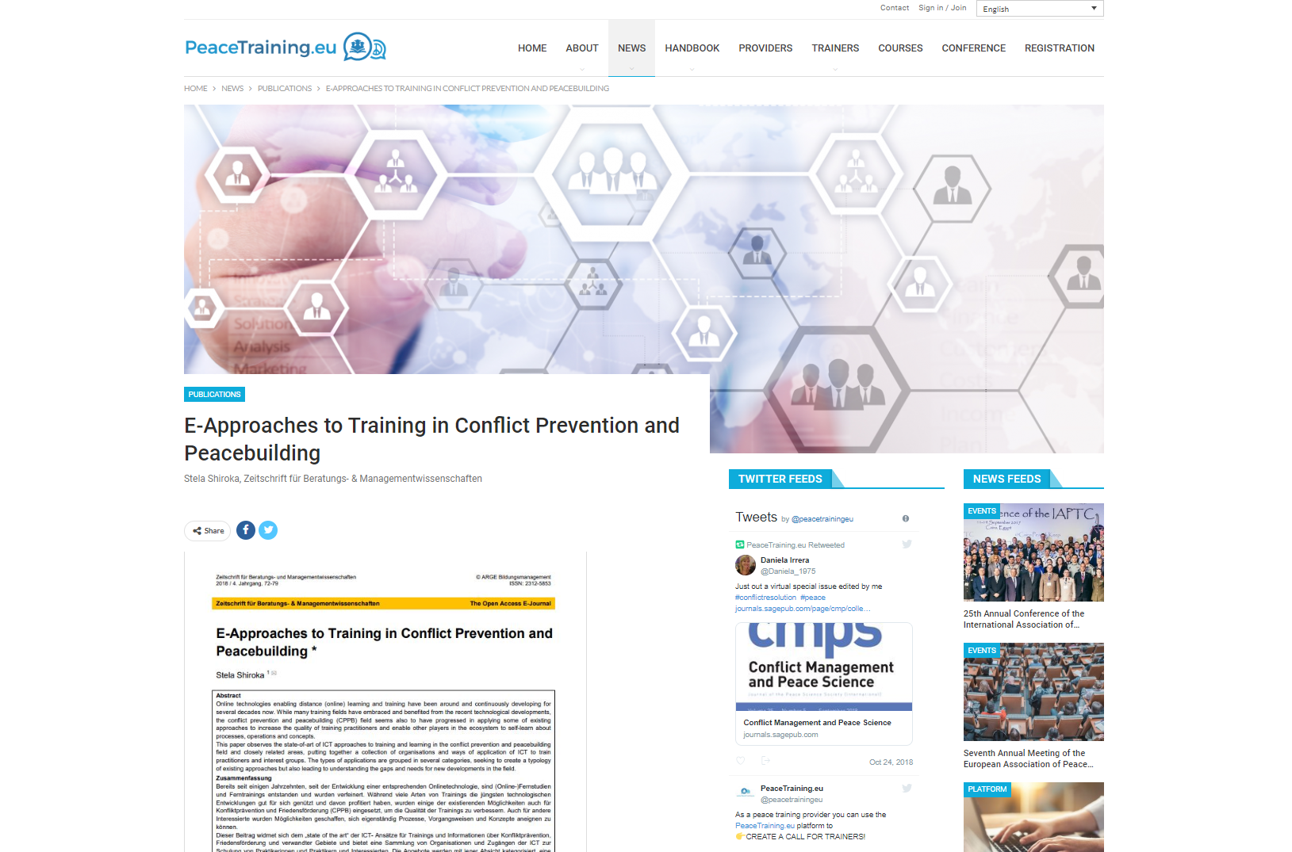
Figure 57: PeaceTraining.eu Web platform: News

Factsheets and Conference Materials
Factsheets and other conference materials also took a considerable part of the overall Dissemination Package delivered in the second half of the project. The materials produced in the second half of the project were created for dissemination purposes on the external events, on the project workshops as well as for the final conference in Vienna. The following figures show some of the created materials.
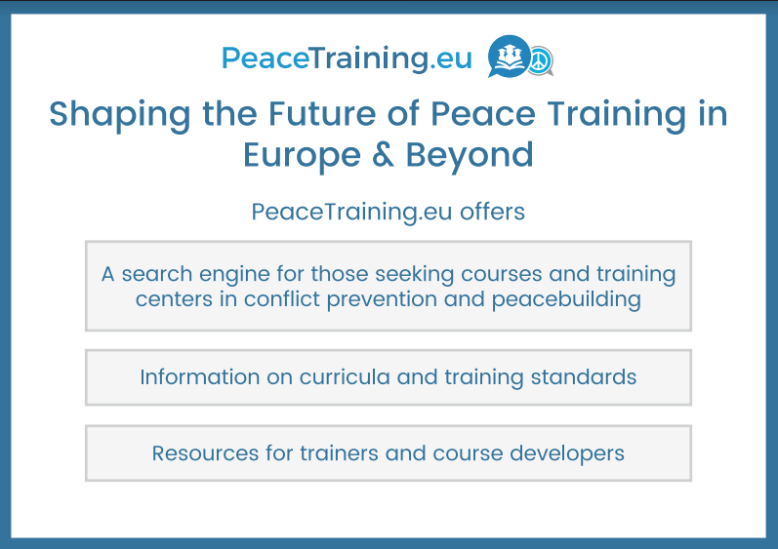
Figure 58: Dissemination Materials
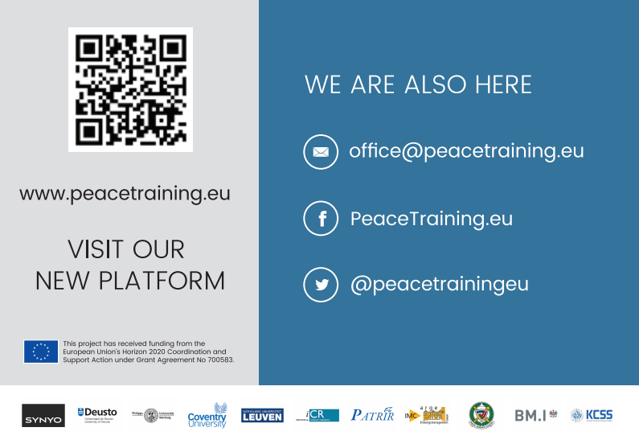
Figure 59: Dissemination Materials

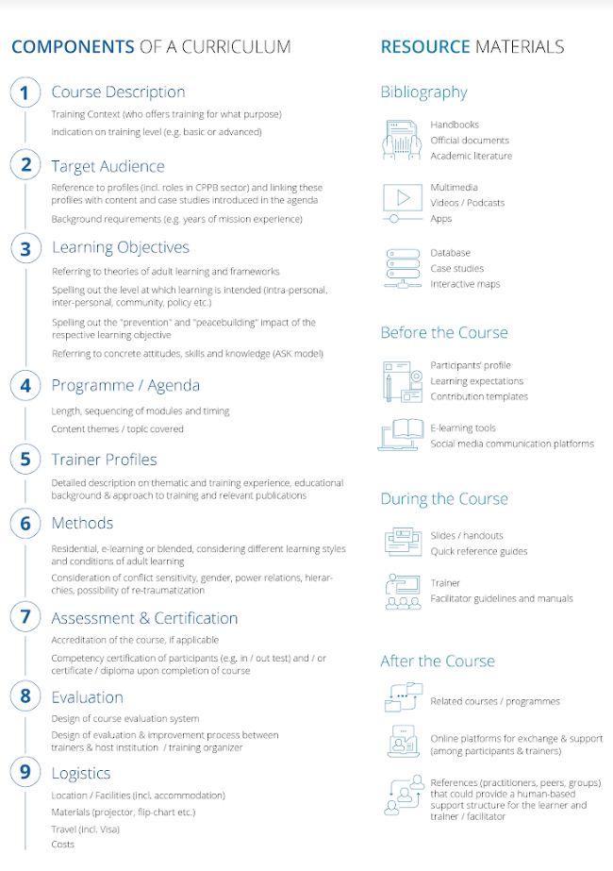
Figure 60: Dissemination Materials

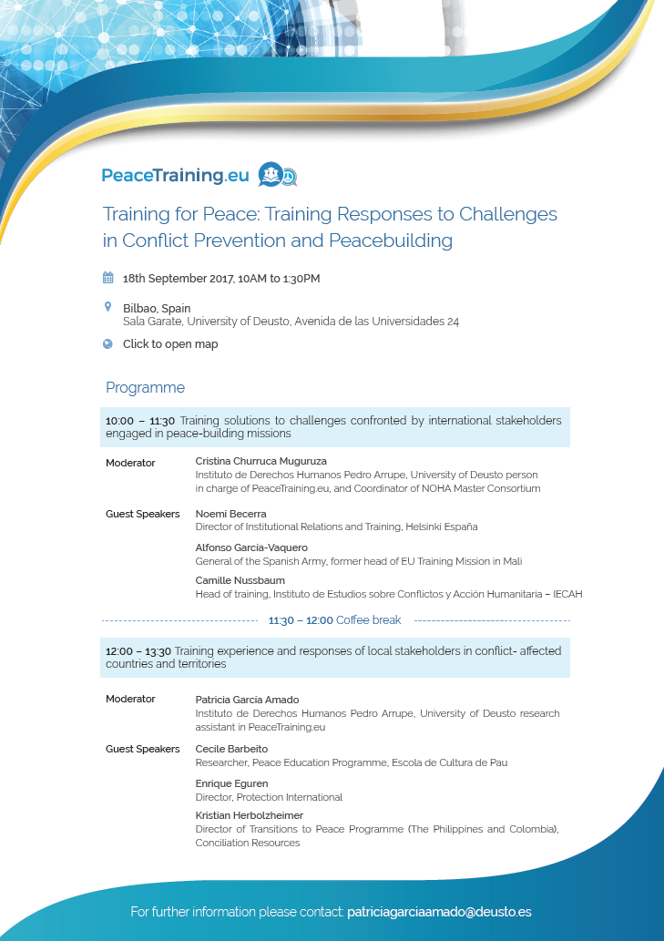
Figure 60: Dissemination Materials

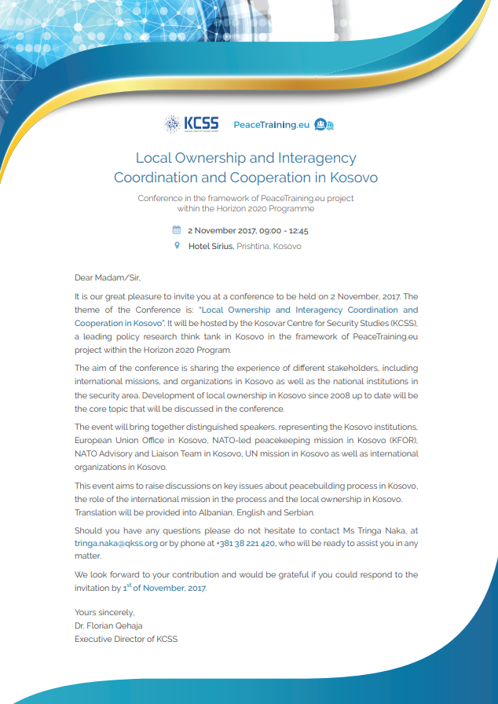
Figure 62: Dissemination Materials
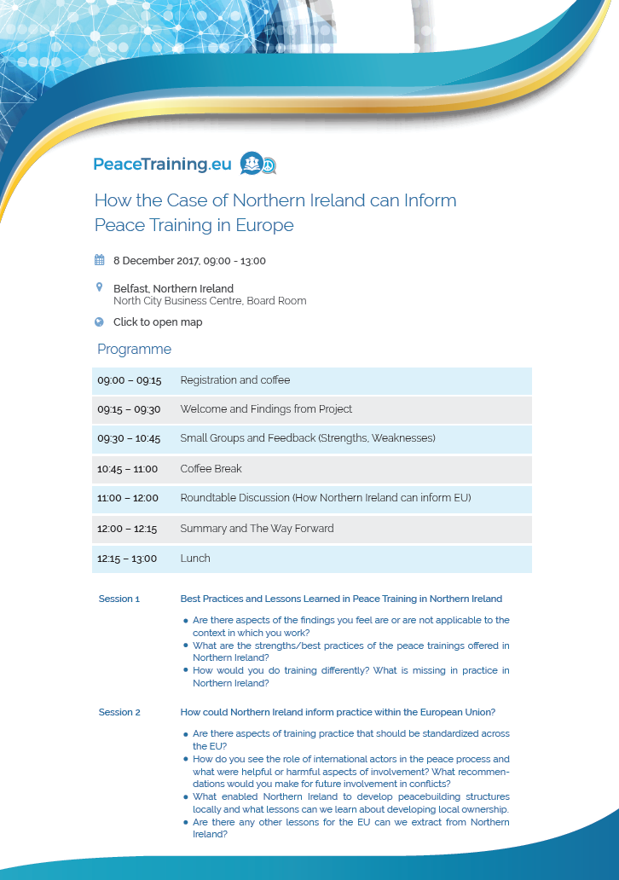
Figure 63: Dissemination Materials

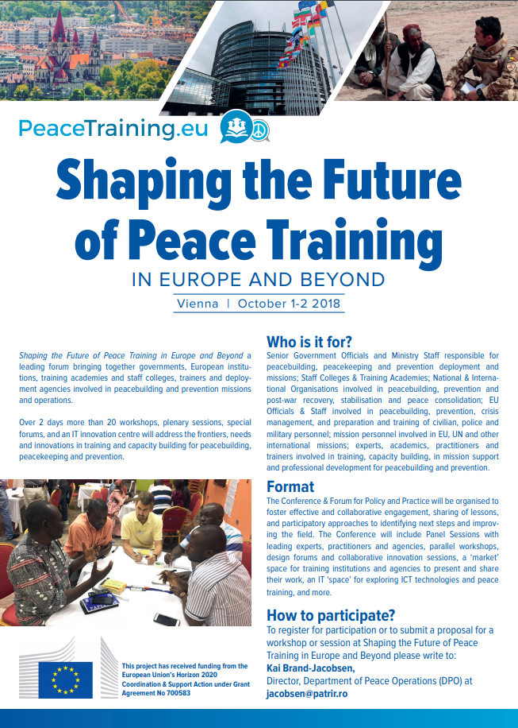
Figure 64: Dissemination Materials

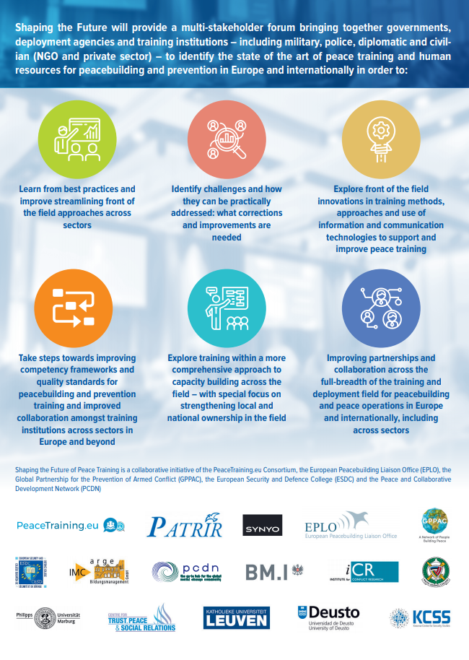
Figure 65: Dissemination Materials

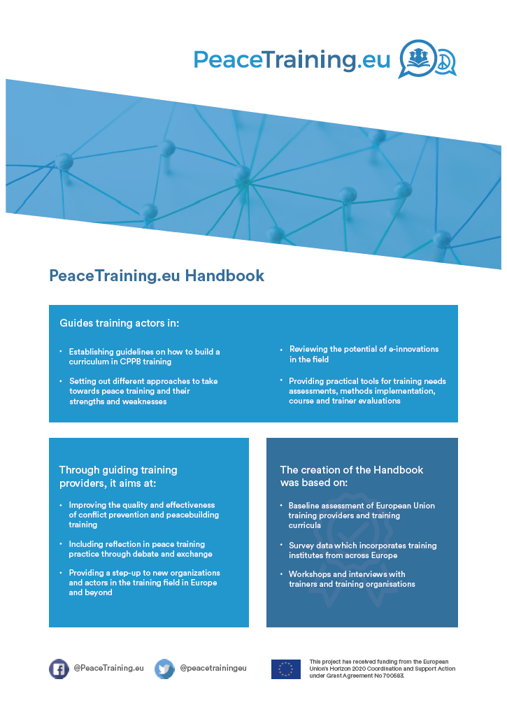
Figure 66: Dissemination Materials

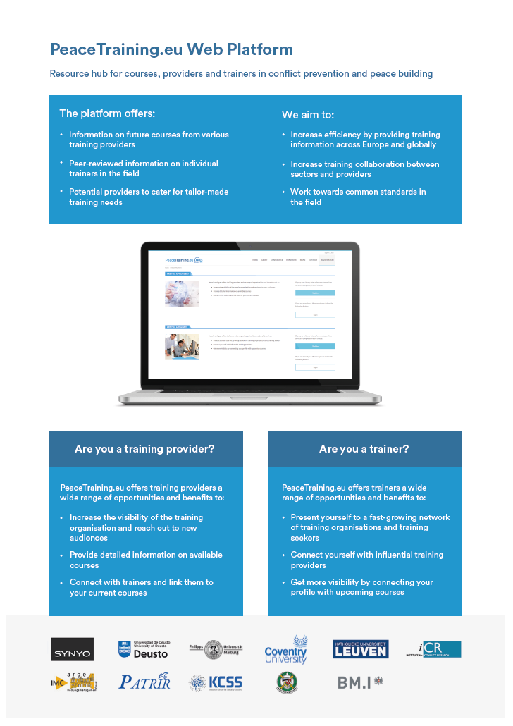
Figure 67: Dissemination Materials

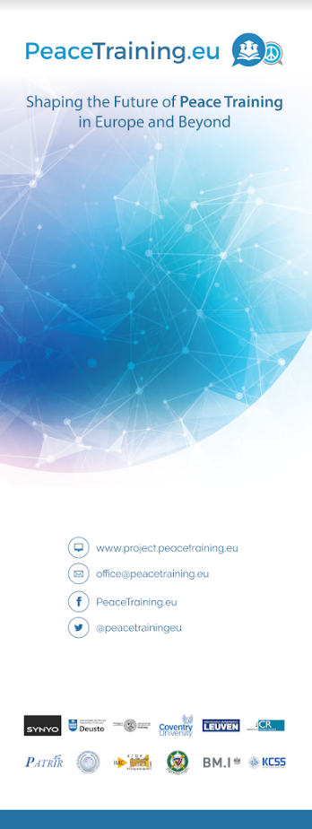
Figure 68: Dissemination Materials

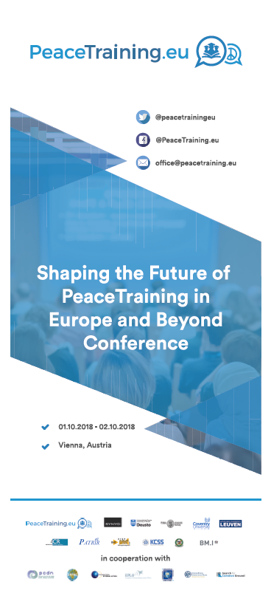
Figure 69: Dissemination Materials

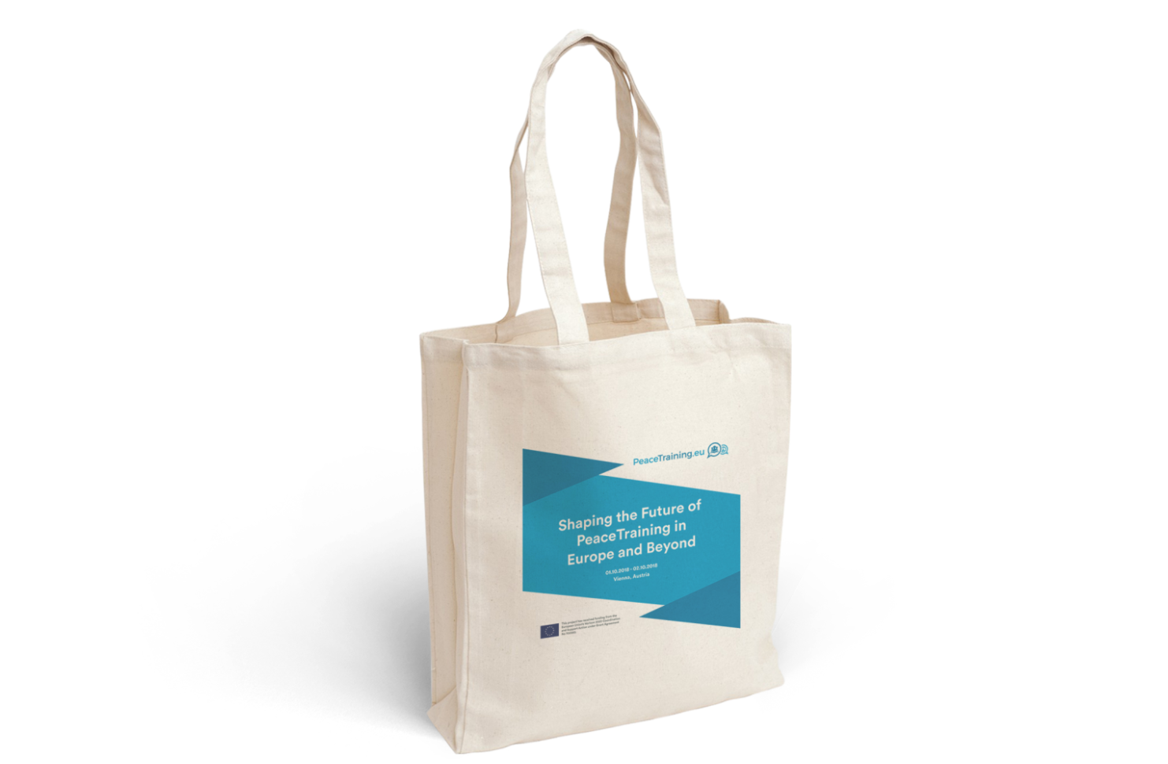
Figure 70: Dissemination Materials

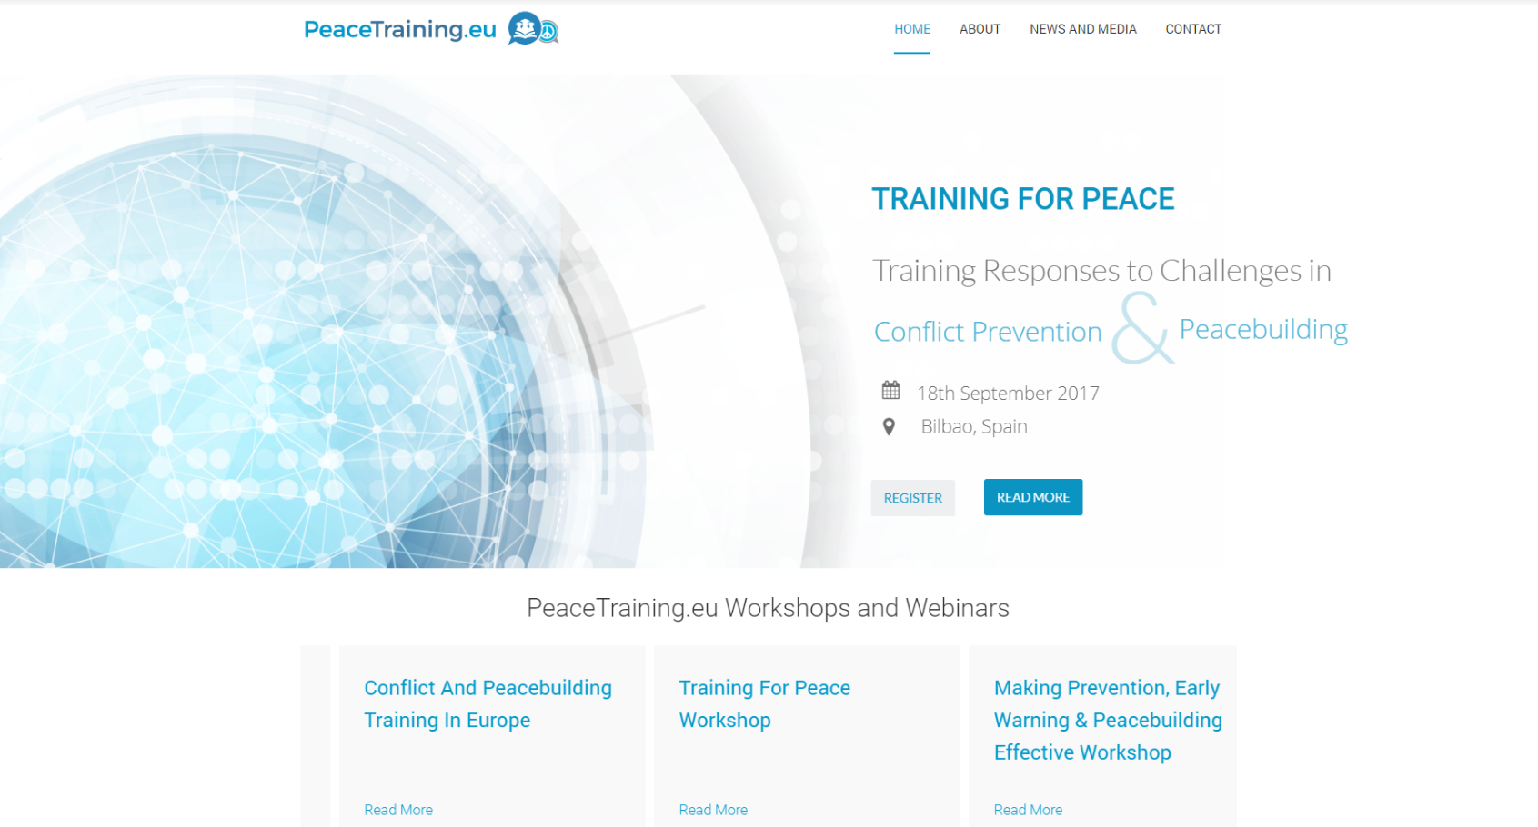
Figure 71: Dissemination Materials

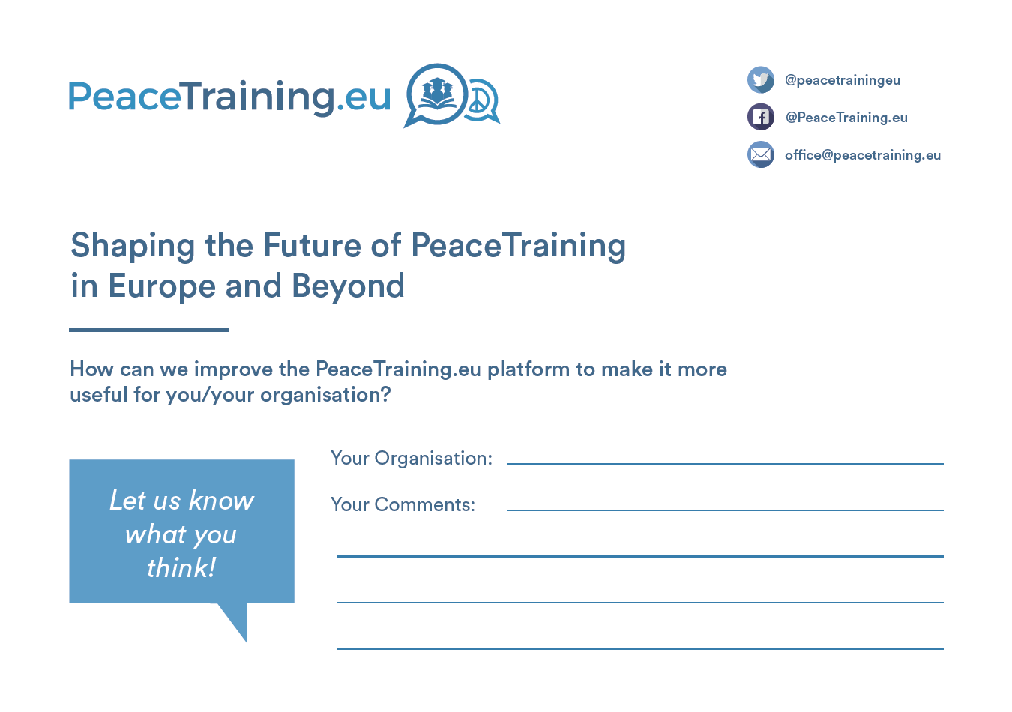
Figure 72: Dissemination Materials
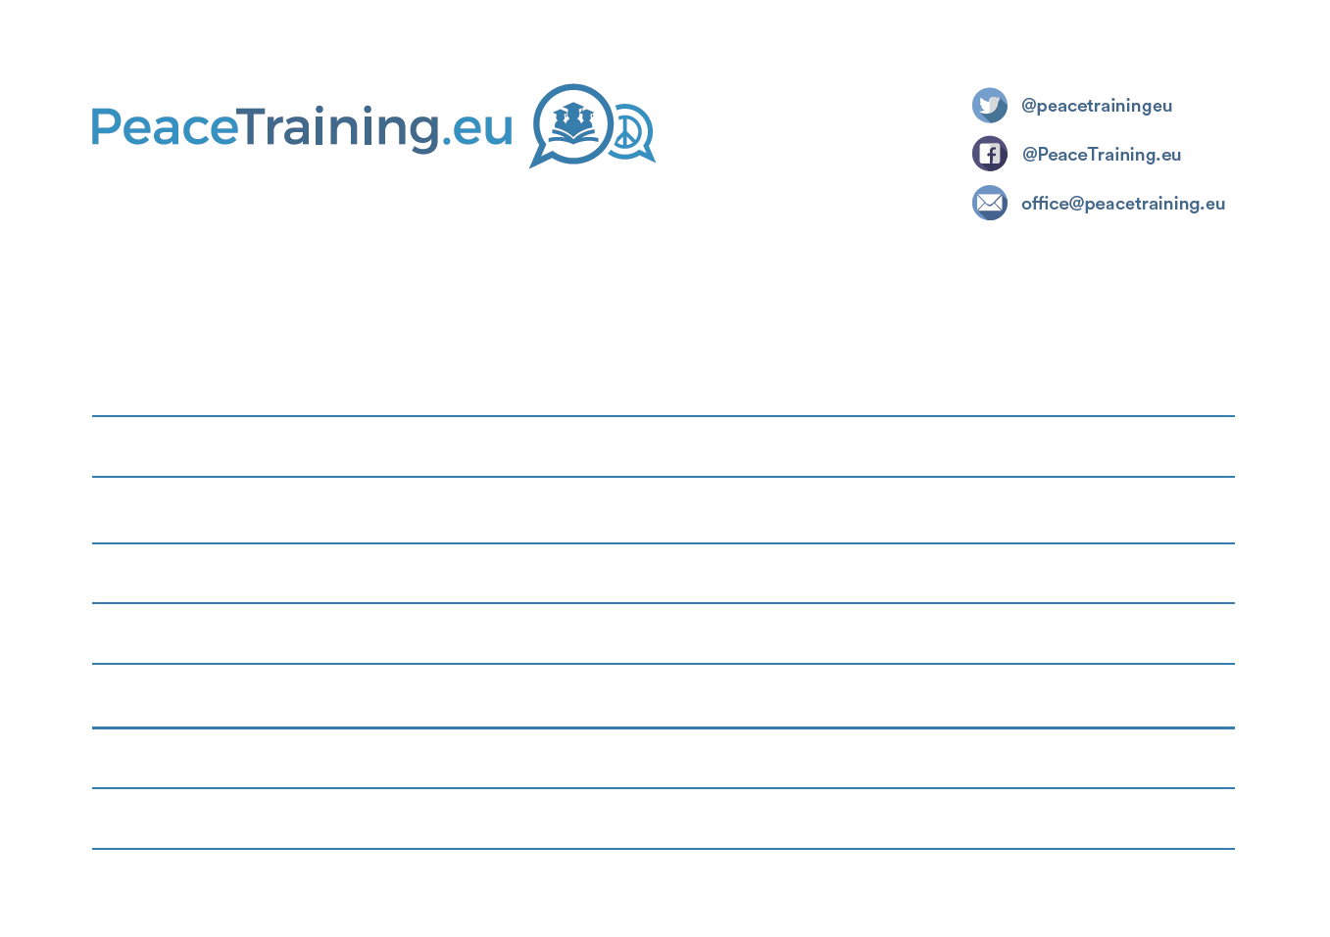
Figure 73: Dissemination Materials

Conclusion
As it has been described in this report, the second project period was marked by the creation of a rich dissemination package including dissemination materials for different purposes and other content spread over different channels such as social media, project website, web platform and physical events. All created materials and activities together contributed to successful awareness raising campaigns and creation of a large community of stakeholders which is reflected by the analytics on the followers, subscribers etc. Almost all Key Performance Indicators set for the second project period were met – with some being a little below and others surpassing the set values.
The broad attendance and feedback at the final conference in Vienna is another indicator for a successful implementation of the project communication and dissemination strategy.

